** **

**FINAL YEAR PROJECT**

**DECENTRALISED FINANCIAL DATA ANALYTICS**

**By**

**Samuel Kapesa Junior**

**TP053916**

**UC3F2202CS(DA)**

***A report submitted in partial fulfilment of the requirements of Asia Pacific University of Technology and Innovation for the degree of***

***B.Sc. (Hons) Computer Science with specialism in Data Analytics***

**Supervised by DR. DEWI OCTAVIANI**

21-September-2022

\

**ABSTRACT**

Within this research paper, the developer investigates the potential risks and rewards that are inherent to applying Deep Reinforcement Learning to solve the portfolio allocation problem in the cryptocurrency markets.Prior to doing so, an exploratory analysis of the data was conducted followed by the necessary preprocessing operations. As a proof of concept, the developer implements and evaluates the performance of 2 Deep Reinforcement Learning Agents (Proximal Policy Optimisation and Deep Deterministic Policy Gradient) in a user-defined cryptocurrency environment. The environment states consisted of OHLC (Open, High, Low, Close ) data of 6 cryptocurrencies as well as 8 technical indicators. The training environment consisted of data observations from the beginning of 2018 until december 2020 , whereas the trade/evaluation environment was from the beginning of december 2020, until mid 2022. The backtest evaluation metrics were generated using pyfolio and indicated that although the PPO Agent produced more returns, both agents had similar results. The DDPG model did however, demonstrate more stability with a slightly lower maximum drawdown.

.

**ACKNOWLEDGEMENTS**

This project would not have been nearly as admissible if not for my supervisor, Miss Dewi Octavani, who guided me through each phase of the project, providing me with relevant advice and information at all times, and therefore thanks are in order. I would also like to thank my father, Samuel Kapesa senior, for not only facilitating my studies, but also showing me that anything that one sets their mind to is possible.Many thanks to my Fyp coordinator, Mr.Dhason Kumar who provided me with damn near 24/7 guidance and assistance. From an even broader perspective, I would like to acknowledge the impact of other parties that have assisted me during the course of my study, including my lecturers who aided me with the necessary information when needed, my fellow classmates who helped me throughout our mutual struggles and agenda, my two brothers, who continue to inspire me to be a better person.Not forgetting my mother, who ignited the entire cosmic reaction that lead up to my being.

**LIST OF FIGURES**

**KEY WORD ACRONYMS**

**De-Fi:** Decentralised Finance

**DRL**: Deep Reinforcement learning

**DDPG**: Deep deterministic policy gradient

**PPO**: Proximal Policy Optimisation

TABLE OF CONTENTS

**CHAPTER 1: INTRODUCTION TO THE STUDY** **9**

**1.1 Project Background** **9**

1.2 Problem Statements 11

1.3 Rationale 12

**1.4 Potential benefits** **13**

1.4.1 Tangible benefits 13

1.4. 2 Intangible benefits 14

1.6 Project Scope and Objectives 15

1.6.1 Project Aim 15

1.6.2 Project objectives 15

1.6.3 Project Deliverables 16

1.6.4 Nature of Challenges 17

**CHAPTER 2: LITERATURE REVIEW** **18**

2.1 Introduction 18

2.2 Domain research 18

2.2.1 Cryptocurrency And The History Of Blockchain Technology 18

2.2.2 Decentralised finance 19

2.2.3 Portfolio management/allocation and the efficient market hypothesis 21

2.2.4 Markov decision process 25

2.2.5 Deep Reinforcement learning for portfolio allocation 29

2.2.5 Deep Deterministic Policy Gradient (DDPG) 32

2.2.6 Proximal Policy Optimization 34

2.3 Similar Systems **35**

3.1 Programming language chosen 37

3.1.2 Justification of Programming Language Chosen 40

3.2. IDE chosen 40

3.3. Implementation tools And Libraries 41

4.1 Introduction 42

4.2 Business Case Understanding 44

4.5 Data modelling 45

**4.6 Evaluation** **46**

4.7 Deployment Phase 46

4.3 Summary and Justification of Data mining methodology 46

**CHAPTER 5: DATA ANALYTICS** **47**

5.1 Introduction 47

5.1.1 Implementation Overview 47

5.2 Initial Data Analytics 50

5.2.1 Data Summary 51

5.2.1.2 Data Acquisition and loading 51

5.2.1.3 Metadata 51

5.2.1.4 Attribute Data Types 52

5.2.1.5 Data Summary 53

5.3 Data cleaning and Preprocessing 58

5.3.2 Data Type conversion and Variable Renaming 60

5.4 Data Visualisation 63

5.4.1 Univariate Analysis/Visualisation (Global) 64

5.4.2 Univariate Time-series Analysis 76

5.4.3 Multivariate Time Series Analysis 91

5.5 Data Extraction 96

5.6.1 Cryptocurrency Portfolio Allocation Environment 98

**CHAPTER 6: RESULTS AND DISCUSSION** **112**

**6.1 Introduction** **112**

6.2 Model Evaluation 112

**REFERENCES** **121**

**APPENDICES** **133**

FYP Poster 133

Project log sheets 133

First Meeting log (FYP semester 1) 133

Second Meeting log (FYP semester 1) 134

Third meeting log sheet (FYP semester 1) 135

First Meeting log (FYP semester 2) 136

Second Meeting log (FYP semester 2) 136

Third meeting log sheet (FYP semester 2) 136

**PPF** **138**

PSF 148

Project plan 159

# **CHAPTER 1: INTRODUCTION TO THE STUDY**

# 1.1 Project Background

In recent years, practitioners of Artificial intelligence have developed a wide range of intricate technologies with the goal of mimicking the intellectual faucets that define the human being. Using machine learning, for example, patterns can be learned from the data in the form of an optimised objective function. Generally speaking, machine learning techniques can be broken down into two distinct categories; Supervised Learning and Unsupervised learning. The former requires that the data observations are labelled, whereas the latter tries to learn patterns in the unstructured data. The ability to accurately process vast amounts of data is crucial in the modern, ‘click-of-a-button’ world. It is due to the aforementioned that portfolio managers and practitioners have sought to integrate machine learning into their investment strategies.

Portfolio management, like video games, requires that an agent (the portfolio manager) has an interaction with their environment (financial market) to maximise the compounded rewards (profits) of the portfolio(Shen et al., 2021). A purely machine learning portfolio allocation strategy does not suffice in the real-world financial markets as it is unable to fully grasp the inherent characteristics of the real-world markets.Hence, practitioners have since reverted to using Reinforcement learning as an attempt to reduce the simulation-to-reality gap that is inherent to most machine learning techniques(Qiu et al., 2021).

Reinforcement learning, at its core, is the process of training machine learning models(agents) to make a series of judgments(Lyu et al., 2022). Placed in an uncertain, possibly complicated environment, the RL agent learns to attain a specified goal (Bergel, 2021). In this particular case, the RL agent is put in a simulated trading environment, with the goal of learning an optimal portfolio allocation/optimization strategy . Reinforcement learning uses trial and error to find a solution to the problem, hence the 'Reinforcement'(Teoh & Rong, 2022). To perform its intended task, the AI agent is rewarded or punished for the decisions it makes throughout the training process. The acronym AI used here simply refers to Artificial intelligence; a simulation of human intelligence.

The objective of the AI agent is to maximise overall portfolio return, with a rebalanced portfolio as an output. However, using a purely reinforcement learning technique to perform portfolio allocation, the solutions may grow too complicated for the reinforcement learning strategy.Learning from all states and determining the reward path might be overwhelming for the algorithm This gives rise to the need for deep reinforcement learning (Liu,2022). Deep reinforcement learning is a combination of Reinforcement Learning and Deep Learning. DRL allows for more efficient operations with high-level input data. It is because of the aforementioned statement that this project aims to explore the applications of Deep Reinforcement Learning to the portfolio optimization problem. Within the span of this report, the analyst provides an in-depth analysis of the findings of other researchers with the goal of supporting future implementations of a DRL based portfolio allocation system, followed by a section that details the methodology and tools that were proposed by the developer . The order of this report is as follows. In chapter 1 the developer gives a description of the background and problem statement of the project, followed by a literature review of previous research findings in chapter 2. Chapter 3 and 4 provide the technical research and methodology(respectively) that the developer plans to use for the implementation of this project. Chapter 4 contains the methodology, followed by the conclusions and reflections of the developer.

## 

## **1.2 Problem Statements**

When required to invest in multiple assets, the portfolio allocation problem arises. If a certain quantity of resources is to be divided across numerous assets, the portfolio manager is tasked with deciding how to divide the available resources (Mohamadi, 2021) A traditional approach among practitioners is to use a pure Markovitz portfolio selection technique to derive an optimal portfolio of assets.Harry M. Markowitz, the economist and statistician who pioneered the Markowitz theory, began with the premise of ordinary investors' risk aversion and desire to maximise anticipated investment returns with the least risk. Markowitz employed quantitative models to quantify risk and applied mathematics to efficiently choose assets to allocate to a portfolio (Sibirskaya et al., 2017). This paradigm gave rise to the idea of efficient portfolios. An efficient portfolio should produce the best return for a given level of risk or the lowest risk for a given level of return. In reality, a pure Markovitz portfolio optimization, as noted by Benhamou et.al(2021), is insufficient since risk assessments are extremely sensitive to input selections, resulting in very unstable results.

Furthermore, subjective portfolio construction is prone to succumbing to numerous behavioural finance biases or being influenced by emotion rather than logic (Calvo-Pardo et al., 2021). The problem with relying on subjective investment decision making is that it requires a high emotional quotient on behalf of the portfolio manager, therefore rendering it unstable. Emotional intelligence, as defined by Carr (2022), is the capacity to recognise and control one's own emotions as well as those of others. The need for emotional intelligence is amplified when one considers the massive price fluctuations that are inherent to the financial markets(El-Chaarani, 2016). According to the findings of Calvo-Pardo et al.,(2021) in the case of rising markets, investors are less receptive to negative signals; overconfident, whereas in falling markets, they are prone to be afraid of losing money; Fearful. It should then become apparent that subjective investment decisions have the potential to harness an extra layer of volatility to a given portfolio. It is due to the aforementioned statement that many asset portfolio management techniques have historically been approached mathematically by modelling them using stochastic processes and employing stochastic control approaches(Hambly et al., 2021). The caveat is that relatively basic models lead to closed-form or classical quantitative procedures(DePamphilis, 2022). Specifically, it is common practice for portfolio managers to use supervised learning to tackle financial prediction and allocan oversimplify the principles and behaviour of the real financial markets, cation tasks(Pinelis & Ruppert, 2022). The problem, however, is that these models resulting in techniques that are suboptimal in practice and may result in financial losses (Burgess, 2019). Furthermore, during the development of these models, the section of tools used by the developer is prone to cause practitioner-induced biases. Lastly, cryptocurrencies as an asset class, though promising, have extremely volatile prices.

## **1.3 Rationale**

Accurate portfolio allocation and prediction results in profitable outcomes, therefore it is not surprising that investors and portfolio managers are turning to algorithmic trading and machine learning techniques to evaluate and operate in the financial markets(Sak et al., 2018). Subjective investment decision making, as stated in the problem statement, is not very reliable, therefore, automating the portfolio allocation/construction process ensures that investments are made from a purely logical (objective) perspective, which should produce more consistent results(Wang, 2020). More specifically, the use of Deep Reinforcement Learning will ensure that the derived model is as objective as possible, unlike the traditional portfolio management techniques mentioned in the problem statement which inherently possess some level of practitioner-induced biases. Hence, evidence suggests that Deep Reinforcement learning is humanitys’ best chance at attaining artificial general intelligence

Furthermore,the model is trained in a simulated environment that attempts to be as to the real-world cryptocurrency market environment as opposed to using Supervised Learning, which as stated in the problem statement, oversimplifies the real-world cryptocurrency markets.By training the models in a more realistic trading environment, the policy (strategy) that is learned by the model takes into account the real-world risks that are associated with trading cryptocurrencies, as stated in the problem statement. As noted by Sacharny & Henderson (2022), models that attempt to replicate the true environment of financial markets, are far more complicated and are frequently computationally intractable when utilising traditional stochastic optimal control techniques. The portfolio construction model will be provided with historical data as input, allowing it to ‘learn’ an optimal portfolio allocation policy (strategy) from the patterns that are observed in the historic data. To put more plainly, the policy is the portfolio allocation strategy that is learned by the agent. Two Deep reinforcement learning algorithms are used in comparison, namely ; Soft actor Critic, Deep Deterministic Policy Gradient, and Proximal Policy Optimization. The accuracy of the three implementations is then compared to decide which DRL algorithm performs portfolio allocation the best.The best performing algorithm may then be deployed into a web application that, in its entirety, serves as a tool for portfolio managers to use as a portfolio allocation strategy development tool

## **1.4 Potential benefits**

Potential benefits are composed of both tangible and intangible benefits(Kreis, 2011). In the context of this piece of work, an example of the former would be the rate of return, whereas an example of the latter would be an abstraction of market intricacies.

## **1.4.1 Tangible benefits**

* The trading model is not explicitly defined by the analyst, instead, the algorithm learns an optimal portfolio allocation/rebalancing strategy from the market data.This, in theory, should lead to more profit(Aliyev et al., 2021).
* The need for constant market monitoring is essentially eliminated by the automated approach, allowing the analyst to have time to focus on other tasks(Chan, n.d.).
* The cost of hiring multiple traders/portfolio managers is reduced by replacing human labour with algorithmic portfolio allocation.
* Automated portfolio allocation would help unsophisticated investors thrive in the cryptocurrency industry.
* The proposed system is highly scalable since the learned strategy is not market specific
* An automated portfolio allocation system ensures that investments in the cryptocurrency markets, which operate 24/7, are always monitored.

## **1.4. 2 Intangible benefits**

* The project is an application of tried and tested techniques in a relatively immature market, therefore, the analyst can perform with more confidence and conviction (Niszczota et al., 2020).
* Since subjective investment decisions are replaced with objective analysis based on proven mathematics , portfolio managers can operate with more confidence in their portfolios(Niszczota et al., 2020).
* The strategy that is learned by the DRL algorithm is not specific to any particular market in theory, therefore, can be used in any market.
* By implementing this project in the decentralised finance industry, users can have more trust in the project.

**1.5. Target Users**

This implementation of this project targets portfolio managers, finance practitioners, data analysts and traders. The report will be a contribution to the very broad finance and computer science industries

## **1.6 Project Scope and Objectives**

### **1.6.1 Project Aim**

The aim of this project is to improve the effectiveness of traditional portfolio management/allocation techniques in the decentralised finance industry using deep reinforcement learning

### **1.6.2 Project objectives**

1. To train 2 Deep Reinforcement Learning Agents in a simulated cryptocurrency market environment, with the goal of learning an optimal policy/strategy for allocating weights to a portfolio of cryptocurrencies
2. To compare and evaluate the accuracy of the different models and their respective generated portfolios using metrics such as Max drawdown, portfolio returns and sharpe ratio
3. To compare the performance of the best performing DLR strategy to the traditional ‘Buy and hold’ strategy

### 

### **1.6.3 Project Deliverables**

1. A data collection mechanism to retrieve and update OHLC (Open High Low Close Volume) market data of multiple cryptocurrencies using the Binance exchange via application programming interface(API).
2. A data visualisation dashboard mechanism for automated data exploration.
3. Feature generation using covariance matrices and technical indicators with the FinRL library
4. Two DRL models built using 2 different deep reinforcement learning algorithms ( Deep Deterministic Policy Gradient, and Proximal Policy Optimization)
5. Comparison and performance evaluation of the accuracy of the 2 models
6. A portfolio construction web application tool using the best model

### **1.6.4 Nature of Challenges**

Due to the broad nature of topics covered in this project , learning the intricacies of each disciplinary field and gathering their accurate information is notably one of the most significant challenges associated with the execution of this project.Beyond acquisition of valid/relevant information,using the wrong tools can have a negative impact on the overall quality of the project(Lewis et al., 2012) . Since the project involves cross-domain knowledge: Finance,Distributed ledger Technology and machine learning, the selection of the correct tools and techniques is another notable challenge related to the implementation of this project .

As noted by Harvard Business Review(2016), corporations in the United States incur a $3.1 trillion yearly cost due to poor data. H.B.R also noted that data analysts spend the majority of their time on cleaning the data, hence, this is another potential challenge associated with the implementation of this project. It is required that market data of multiple cryptocurrencies is used, therefore, it is crucial that the analyst is constantly implementing the appropriate techniques to ensure that the data is not only available, but also in the appropriate format. Finding the appropriate deep reinforcement learning algorithm for developing the system is another notable challenge that will be faced during this implementation. The analyst is required to deploy the developed model into a web application, therefore, the development and integration of the web application and the model is another challenge that is associated to this project

# **CHAPTER 2: LITERATURE REVIEW**

This section of the report is an in-depth literature review of related works.

## **2.1 Introduction**

This section of the report is an in-depth exploration of existing literature, specifically on the topics of Blockchain technology, Decentralised Finance, cryptocurrencies, portfolio management/optimization, and Deep reinforcement Learning.Using previous research findings, any subsequent implementation by the analyst is supported by the findings of other authors/academics. By leveraging the observed limitations of past researchers, the developer increases the accuracy of the project and therefore, the chances of project success.

## **2.2 Domain research**

### **2.2.1 Cryptocurrency And The History Of Blockchain Technology**

Until a few years ago, it was widely considered that the financial soundness of a centralised financial system made it highly unlikely to collapse. More significantly, it was considered that the large banking institutions and hedge funds were "too large to fail", such that if they did collapse, the government was guaranteed to rectify the problem by printing more moneyGalar(2018). As noted by Nicolás (2018), the Global Financial Crisis of 2007–2008 undermined these assumptions, as many significant banks in the world's most sophisticated nations collapsed or were 'bailed out unwillingly. Roncalli et.al(2021) noted that this problem demonstrates a misunderstanding about the nature of investment decisions and that actions taken in response to economic structural changes should rather be linked to strategic asset allocation. Tactical asset allocation, on the other hand, refers to decisions that adjust the asset composition of a portfolio to reflect the impact of business cycles over the short to medium term. According to the findings of Benhamou et al.(2021), because structural shocks occur less frequently than business cycle changes, adjustments in strategy allocation should be rare.

Sacharny & Henderson( 2022), stated that it is because of the 2007–2008 financial crisis that bitcoin was created. As the first cryptocurrency, Bitcoin was founded in 2009 by a cryptography engineer who goes by the pseudonym Satoshi Nakamoto. With an embedded fixed supply, this decentralised financial system concept was simple yet revolutionary. It promised a decentralised and transparent financial system that would provide an alternative to the traditional fiat currency system which has proven to be non- resilient during tough times. Srivastava(2021), defined cryptocurrency as a form of digital asset that employs encryption to safeguard transactions. Cryptocurrencies operate without a central issuing or regulating body, instead relying on the blockchain to track transactions and create new units. Each cryptocurrency normally has its own native blockchain in which the cryptocurrency can be used as a store of value. As stated byUrquhart & Yarovaya(2020) A blockchain is a decentralised ledger that is distributed among computer network nodes. The blockchain acts as a distributed database , storing uncensored information. Information stored on the Bitcoin blockchain, for example, are transactions such as transfers and deposits of the native cryptocurrency (Bitcoin).

### **2.2.2 Decentralised finance**

The phrase 'Decentralised Finance' is neither legal nor technical. Conversely, it is rapidly being included in conversations concerning the future evolution of finance and its regulation. According to Schueffel (2021) Decentralised finance was created as a result of cryptocurrencies like Ethereum,which is one of the most widely used cryptocurrencies today. Ethereum is the second largest most valuable cryptocurrencies in terms of market capitalization(as at march 2022). At the time of writing, the market capitalization of Bitcoin was above $730 billion dollars, whereas the market capitalization of Ethereum was approximately $313 billion dollars . Even though distributed ledgers and cryptography are at the heart of both the Bitcoin and Ethereum networks, the two are vastly different in terms of technology . According to van Oorschot(2021)Transactions on the Ethereum network, for example, may include executable code, whereas data that is attached to Bitcoin network transactions is often used merely to keep track of transactions on the network.On top of the Ethereum blockchain, there is currently a full digital economy that has arisen, one of which is the DeFi ecosystem(Schoeffel, 2021).

DeFi applications are also referred to as trustless applications, which means they are neither managed or hosted by a third party, such as a bank or the government. Instead, Cryptography, smart contracts, and blockchain technology enable this decentralised monetary system to flourish for the world economy to use(Wood, 2022). Smart contracts are essentially applications that run on the blockchain. According to etheremeum (2021), Smart contracts are a set of code and data stored at a single address on the blockchain. Furthermore, Kabiri & Sharifzadeh (2022) mentioned that the code acts as the function, whereas the data may be used to monitor the state of the application or smart contract. Ethereum makes use of a powerful smart contract programming language called Solidity, which allows all of the essential logic for financial contracts to be integrated in the application code.

The open and irreversible nature of smart contracts that are deployed to the blockchain is what allows for trust among its users. Since the successful implementation of decentralised applications , there have been many projects that have emerged, each with their own use cases. As mentioned by Zetzsche et al.(2020), lending and borrowing services are arguably one of the most important use cases of the DeFi ecosystem.

Users can get a loan against their cryptocurrencies by depositing them inside a smart contract. Other users may lock their crypto assets inside a smart contract with the goal of generating interest by lending their coins to borrowers.In accordance with the work of Singh et al( 2021), the lack of a clear regulatory framework(at the time of writing) is one of the main factors slowing down the industry. Whitbey( 2021), mentioned that a clear regulatory framework would allow large financial institutions to get involved in the space.Kondrat & Drala(2019) mentioned that given the right tools and information, portfolio managers can act as a bridge for unsophisticated investors to get exposure to the promising technology.

### **2.2.3 Portfolio management/allocation and the efficient market hypothesis**

According to the work of Ozili (2018), unskilled investors have more investment options today than ever before. With the increased availability of investment options, it is becoming increasingly crucial for all individuals to understand their alternatives whenever deciding where to invest their earned money.Furthermore, Al-Aradi & Jaimungal (2021), stated that, in general, investors must choose between two main investing strategies: active and passive portfolio management. Certain investors prefer to invest in actively managed funds, whereas others prefer to invest in passively managed index funds. Al-Aradi & Jaimungal(2018), noted that In terms of market efficiency, both techniques are diametrically opposed. Whenever an investor bestows the responsibility of their wealth to somebody else, such as a portfolio manager or financial adviser, who charges fees to manage the capital. Innately, investors who use such a strategy should consider markets as inefficient, because they are paying a fee for managers to find an advantage in the market, or extra return over the market for assets with equivalent risk.

Investors who passively invest in index funds have a distinct perspective on market efficiency. their assumption is that markets are efficient and, as a result, that there exists no additional profit to be discovered (Seneque, 1979) . Such individuals choose to invest in index funds that replicate certain market indexes, such as the Russell 1000 index. This leads to their returns being equivalent to the returns generated by the market index, therefore, Jones (2017), stated that their risk profile is similar to that of the market index. Furthermore Pinelis et.al,(2020), argued that if markets are efficient, this method produces a greater return since passive investing allows investors to invest at a low cost and obtain the returns of the index without incurring the significant fees and charges involved in actively managed funds

Portfolio managers have the ability to provide alpha if markets are inefficient. states that this is achievable by accurately curating a risk adjusted portfolio(Ang, 2020). Alpha in finance, as noted by Schoenmaker & Schramade (2019), simply refers to the ability of a portfolio allocation strategy to generate excessive returns from the market, that is, ‘beat the market’.According to Kyriazis (2019), the theoretical work of Markowitz (1952) is arguably one of the most popular portfolio allocation methods among practitioners.

Weak-form efficiency, according to Bajtelsmit (2015) measures whether prices reflect the information contained in previous price series, has previously been assessed by many academics. Furthermore,the work of Pinelis et.al,(2020), indicated that the majority of academic studies reviewed argue that the EMH is inaccurate. As dependency on prior returns is shown, long-term memory in the time series is identified.

The portfolio allocation problem can be modelled by assuming a portfolio of *n* assets through a specified period t, which is then split into discrete time periods labelled t= 1, t=2,t=3.I should be noted that the time intervals do not have to be evenly spaced or of equal duration in reality ( Boyd, 2017), t. The researcher gave the example of representing trade days where the periods are one day through the week and three days through the weekend. The term *t* is used to refer to both a particular moment in time, the start of a timeframe, and the time interval from time *t* to *t+ 1.* The considered model time span was arbitrary, that is, the assets in the portfolio might have been updated on a daily, monthly, or hourly basis, for example. The implementation involved capital allocation among a universe of n assets. Hence, the initial portfolio at the start of the time period is $ht ∈ R ^{n+1}$, where *($h$ t)a* is the initial asset value of asset *a* at time = 1, where $(ht)a < 0$ denotes a short position on assets through a given time period.

When the collection of assets is positive, the portfolio is considered to be 'long-only'; (vt)a >= 0 for a = 1,..., n. The cash reserve is represented by $(ht)n+1$, with $(ht)n+1$ < 0 indicating that revenue is being borrowed. Furthermore, the researcher noted that exposure, compound value and leverage are all factors to consider. The net asset value of the portfolio (vt ) at time t equals vt = 1T ht, where 1 represents the vector containing all elements. The research assumed that vt > 0; the entire portfolio value is non-negative. The total exposure may thus be calculated by adding the modulus of the asset positions.Below is the formula that the researcher used to calculate the net exposure:

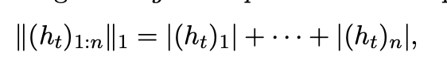

Figure 1:Portfolio Leverage formula

The portfolio leverage can be formulated by k(ht)1:nk1/vt, which is simply the net exposure divided by the value. Therefore, the researcher noted that a fully invested long-only portfolio has a leverage of one. The return of a portfolio can be calculated using;



Figure 2:Portfolio return Calculation

Where vt represents the portfolio value at time, t, and vt+ 1 represents the next period portfolio value and. The next period portfolio value can be calculated using ;

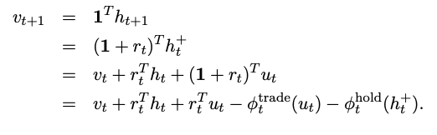

Figure 3:Portfolio Value Calculation

The way in which resources are divided in the portfolio is determined by the portfolio weightings. Given that this research aims to perform a prediction task, the portfolio weights of the next period may be computed as;

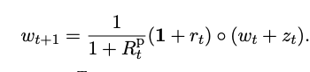

Figure 4:Portfolio Weight Calculation

According to Guan & Liu( 2022), this can further be reduced to wt+1 = wt + zt assuming the normalised return is 0. The performance of a cryptocurrency-only portfolio using naïve diversification compared to Markowitz diversification, and an advanced Black–Litterman model was analysed by Platanakis, E., & Urquhart, A. (2018) . The findings reveal that a diversified portfolio based on an advanced model delivers improved returns while posing minimal risk. . Furthermore, Ram (2019) contends that Bitcoin presents a number of promising investment options due to its minimal correlation with other traditional assets. Following that, Briere et al. (2015) examine Bitcoin from the perspective of an American investor using weekly data from 2010 to 2013.

The portfolio included traditional assets such as global equities, bonds, and currencies e.tc. During the examined time, Bitcoin was distinguished by its high yields and volatility.Weekly BTC/USD exchange rates from July 23, 2010 to December 27, 2013 were used to carry out the procedure. The findings indicate that the correlations between Bitcoin and other securities is minimal. Briere et al. (2015) found that only gold and bonds that are related to inflation have a meaningful correlation with Bitcoin. Furthermore, high risk is linked to low correlations with other assets. Bitcoin has the potential to boost both the rewards and the risk of an investment.

### **2.2.4 Markov decision process**

Markov decision processes arose as a result of the topic of stochastic optimal control (Bellman, 1957) and has thus far remained a central issue in the field of machine learning, specifically reinforcement learning. As Sadriu, L(2022). stated, A Markov Decision Process is a form of mathematical model that enables computers and agents to decide the optimal behaviour in a given environment in order to optimise the model's capacity to reach a specified state in the environment, depending on the defined goal. The number of states is assumed here to be finite and therefore can be defined as;

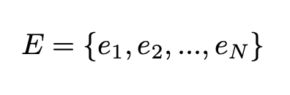

Figure 5: State Space

Where E denotes the state space and its constituents *e1, e2…en* are the possible states of the environment. The environment is simply the world with which an agent interacts. .... give the example of robotics, where the robot can interact with the real world environment or with a simulated environment. The state space of the robot would contain all the possible movements that it can make. According to Bellman (1957), a process is said to be a Markov process if it satisfies the markov property. A tupule is used to map the states to state transition matrices. In accordance with the findings of Bellman(1975), the Markov decision process is predicated under the assumption that the future does not depend on the past at any given present moment. This property can be formally defined as:

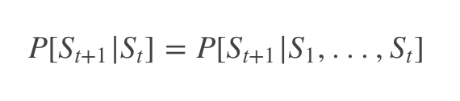

Figure 6: MDP assumption formula

The *S* denotes the current state of an agent.. The current state is assumed to capture all the information that is relevant to the problem, therefore, a known state suffices as an alternative to the history.That is, given a current state *s,* the future state $s^{|}$ can be determined using the state transition probability. The state transition probabilities are computed using the above formula. According to … The state transition probabilities from all states to their respective successor states are represented using a state transition matrix.Furthermore , ….. reported that the state transition matrix is what ensures that the environment of the agent is constantly learning from its environment.

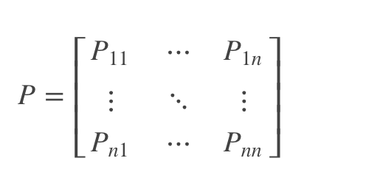

Figure 7: State transition matrix used to represent state transition probabilities

The agent adopts a mapping of its present state to the probability of picking each available action within that state at each time step().. Thus, the goal is to optimise the policy by performing actions in the environment. According to Sutton (1997), this is accomplished through a reward feedback mechanism, in which the different actions taken are evaluated based on the projected state they will yield. As noted by the researcher, MDP assumes a start state, *s*, in which the agent performs an action,denoted by *a*, in its environment. Throughout the process the agent detects the current state of the environment, denoted by *st*, and chooses an action to take at each of a series of discrete measurement points; t = 1, 2, 3,tn. The environment continuously shifts to an updated state, st+1, and generates a scalar reward, with respect to the performed action and the updated environment state. The reward is computed using the reward function;

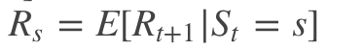

Figure 8: The reward function

The Markov reward process ensures that the agent is constantly learning the optimal behaviour from its environment, which mitigates the shortcomings of traditional portfolio allocation strategies that were mentioned in the problem statement. It should be noted that the *R* in the above formula is used to denote the immediate reward and nor the overall reward. The overall reward is represented using a tuple containing a finite set of states, S, a state transition probability matrix, P, the reward function, R, and 𝛄, the discount factor.The tupule can be represented as:

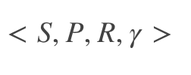

Figure 9: MRP (Markov Reward Process)

Through interacting with its environment, the agent constructs a mapping between states onto the probability of choosing a feasible action at each time step.This mapping is what is referred to as the policy in MPD. Hence, as reported by Sutton (1997), that the agent's policy can be represented as:

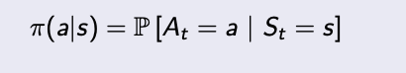

Figure 10: Agent Policy formula

In other words, the agent must determine ,at each time step, the optimal mapping of states to the probability of choosing an action. Figure 11 below is a visual representation and formula of the Markov decision process;

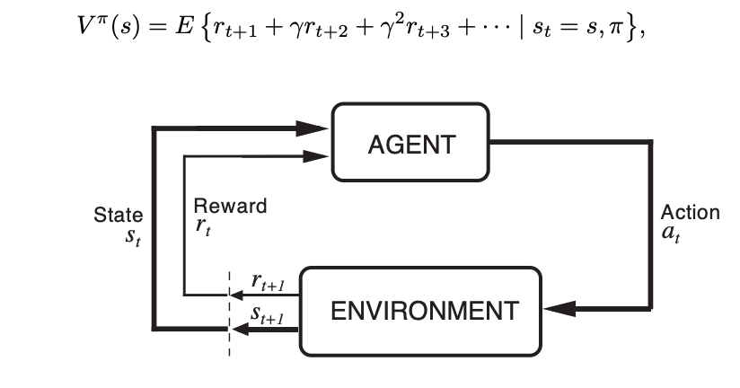

Figure 11: MPD visualisation(Sutton, 1997)

Wherefrom 𝛄 represents the parameter that is used as a discount rate, which, according to … is used to model the uncertainty of the agent in an environment.That is, the discount factor regulates how much learning agents considers on future rewards compared to the present rewards.

In accordance with Shin (2008), the formula in the above figure is commonly referred to as the Bellman equation and is used to calculate the value of the state $V^{π}(s)$ given a policy π. This function may be used to calculate the long term value of a given state, hence it is also referred to as the state values function. The state value of a markov reward process is the expected return, beginning at state *S*. Reyes et.al,(2020) noted that the propensity to generate a control scheme that assumes stochastic input is MDPs' primary benefit. Therefore, making it suitable for solving the portfolio allocation task, which is stochastic in nature. However, Bookstaber(2005) concluded that the dependency upon value estimations throughout the state space reduces the effectiveness of Markov decision systems.

### **2.2.5 Deep Reinforcement learning for portfolio allocation**

As reported by Izquierdo & Izquierdo (2012), Reinforcement learning, a subset of machine learning, employs a formal framework that defines the interaction of a learning agent with their environment in terms of states, actions, and rewards. Chen & Chen(2022), defined the state as the information that determines what the next action of the RL agent should be, whereas the action space is simply the possible actions that the agent can take in its environment.The reward is the scalar feedback signal that reflects how well the agent is performing at the current step time t.According to Bajtelsmit (2015), this framework is designed to provide a precise approach of illustrating key aspects of the artificial intelligence challenge; a perception of cause and effect, a sense of ambiguity and non-determinism, and the existence of clear objectives(Hambly et al., 2021).

According to Pinelis & Ruppert(2020), There are two major strands in the history of RL that were followed independently before merging into current RL. One thread is on trial and error learning, which began in the psychology of animal learning. The other thread is on the challenge of optimum control for a growing system and how it may be solved using value functions and dynamic programming.Despite the fact that this thread does not explicitly include learning, the Bellman equation produced from this line of study is regarded as the cornerstone of several major current Deep reinforcement learning algorithms, such as DDPG and PPO(Folkers, 2019), both of which are discussed later in this report. Deep reinforcement learning, as the name implies, combines reinforcement learning and deep learning technique.

According to Yu & He (2019), the intuition behind reinforcement learning is essentially a markov decision process. Furthermore, Odermatt et al.(2021) reported that the recent success of Deep Reinforcement Learning has piqued the interest of the financial industry, which is always looking for effective approaches from other fields, such as computer vision and natural language processing, to improve financial market modelling. Furthermore, Lyu et al.( 2019) discussed how Deep Reinforcement Learning best solves sequential decision making issues by directly interacting with the market environment in an ephemeral fashion. Benhamou et al.,( 2020) argues that traditional portfolio allocation techniques possess a myriad of limitations. The first limitation pointed out was that traditional portfolio management techniques do not dynamically integrate the portfolio allocation task with the market conditions. This is further supported by the findings of Jarvis et al.,(2009), who noted that despite the fact that the inclinations of investors are considered to remain constant, they are bound to change every once in a while, hence, the market opportunity changes with time. The second stated limitation is that the traditional portfolio allocation techniques make unrealistic risk assumptions. Jarvis et al.,(2009) argued that in order to be successful in the markets, risk estimates should be revised on a frequent basis to incorporate new data. Hence,a dynamic portfolio allocation approach that integrates more market information is required if portfolio managers wish to remain competitive. Based on the various publications, the researchers propose deep reinforcement learning as a solution to the existing limitations. Below is a simplified visual representation of the proposed architecture for implementing DRL based portfolio allocation

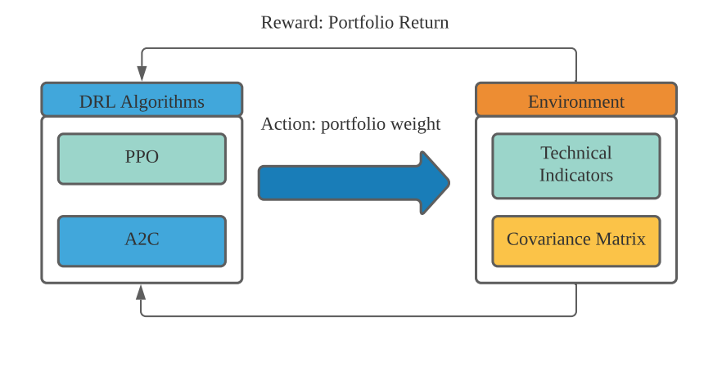

Figure 12 : Visual representation of DRL for portfolio allocation (Guan & Liu, 2022)

As reported by Qiu et al.( 2021), a DRL portfolio allocation strategy typically involves three main stages. To begin with, a group of candidate assets are selected based on predefined criteria. For example, sportfolio managers typically assess the volume of traded shares to determine how liquid an asset is. Hence, asset liquidity would be the criteria in the aforementioned. Second, the state space, action space , and reward function of the deep reinforcement learning agent are defined. Finally, the model is trained.. The goal of the agent is to learn an optimal portfolio allocation strategy by performing actions in the market environment. The work of Zhang(2020) suggests that in the context of portfolio allocation, the actions of the agent are the inferences of capital allocation at a given state; deciding the optimal weights to assign to the portfolio in a given state ,whereas the environment would consist of technical indicators (as shown in the above figure). A common approach is to integrate a covariance matrix as the initial state that the agent receives from the environment. The covariance matrix is typically used to determine the coupled standard deviation of a portfolio. When constructing a portfolio, the covariance matrix can assist in determining which assets to add to the portfolio by gauging the direction in which said assets move. When the covariance of two assets is positive, they move in the same direction. A negative covariance indicates that the assets move in opposite directions. Furthermore, the closing price is another commonly used state feature.

Since this research partly aims to oppose the efficient market hypothesis in regards to the use of only historical price performance as an indicator, the closing price is of great significance to this research. Each environment state can be represented by the state tensor (Sadriu, 2022). A tensor is a mathematical entity that is similar to a vector but is more broad( Li et al., 2016),. The tensor of order 3 with form (d, n, f) is the input to the model at the end of period t, where d is a fixed quantity specifying the duration of the observation in days, the n is the number of asset (cryptocurrencies) in the environment, while f denotes the number of features. The tensor is an array of components that are functions of a space's coordinates.

In the context of policy based DRL implementations, the reward function guarantees that the policy learned by the agent is optimal.The policy in the context of portfolio allocation is simply the portfolio allocation strategy derived by the agent. The derived policy is dependent on the action-to-state mapping and the defined reward function. According to Sutton (1997), the reward function needs to be based on a formulated hypothesis, commonly referred to as a reward hypothesis. The overall problem of portfolio allocation needs to be defined in the context of the reward hypothesis. For every action performed, the agent receives feedback in the form of a reward. The portfolio return is among the most commonly used rewarding mechanisms(Guan & Liu, 2022).However, as reported by Sadriu (2022), the shape ratio is a more suitable reward to maximise.

### **2.2.5 Deep Deterministic Policy Gradient (DDPG)**

According to Jia et al.( 2021), Deep Deterministic Policy Gradient is an actor-critic, model-free algorithm based on the deterministic policy gradient that can operate over continuous action spaces. Continuous space problems can be represented using singular real-world values. Using DDPG requires four neural networks;

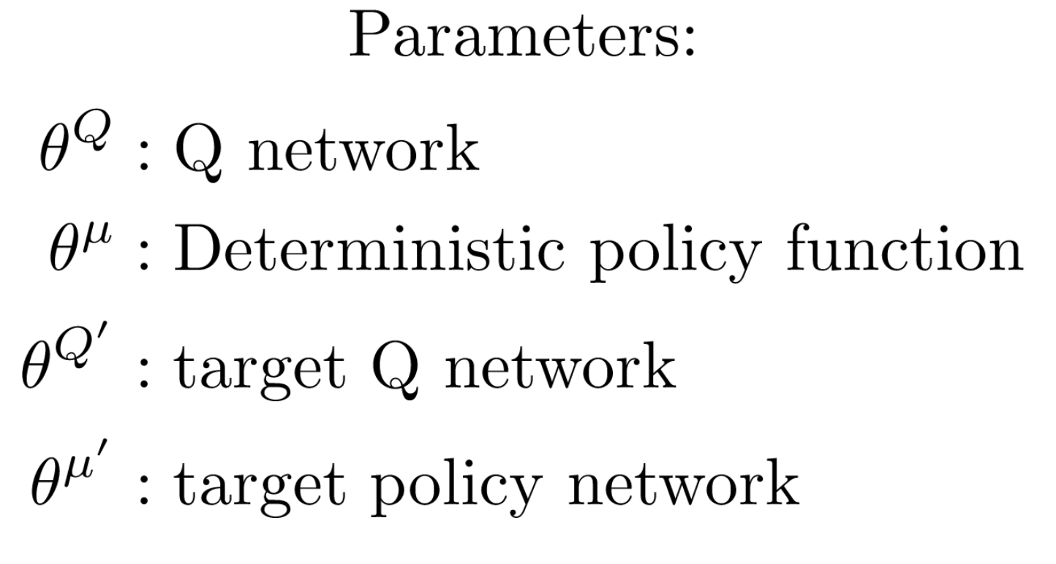

Figure 13: DDPG Parameters

The Q network and policy network are similar to basic Advantage Actor-Critic, except that in DDPG, the Actor performs direct mappings of states to actions, rather than producing the probability distribution along a discrete action space. A Q network, as defined by Zhang et al.(2022)is the agent upon which the optimal state-action value is derived upon training. The figure below is the pseudocode implementation of the DDPG algorithm used in this project

.

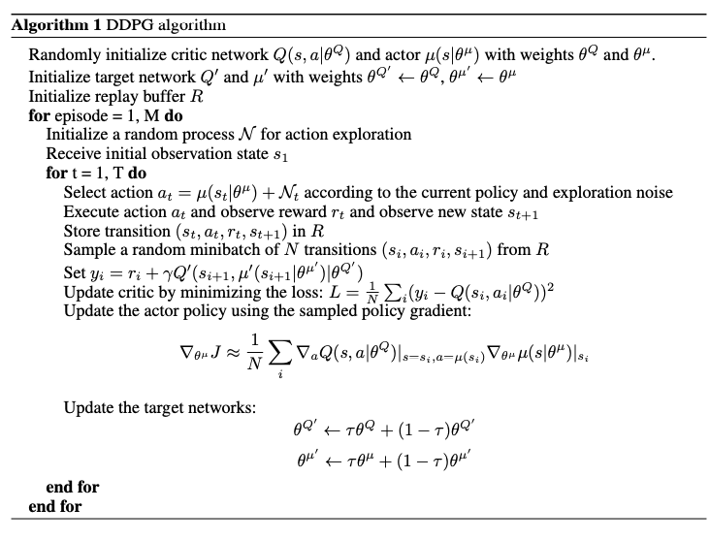

Figure 14: A pseudocode implementation of the DDPG algorithm (

### **2.2.6 Proximal Policy Optimization**

According to Bingol (2022), in recent years, there has been a great deal of study on policy gradient approaches, with algorithms like TRPO, GAE, and A2C/A3C outperforming older methods like Q-learning. The Proximal Policy Optimization Algorithm, is one of the most important algorithms in the policy gradient/actor-critic field(Zhao et al., 2022). The objective which PPO aims to maximise is defined as;

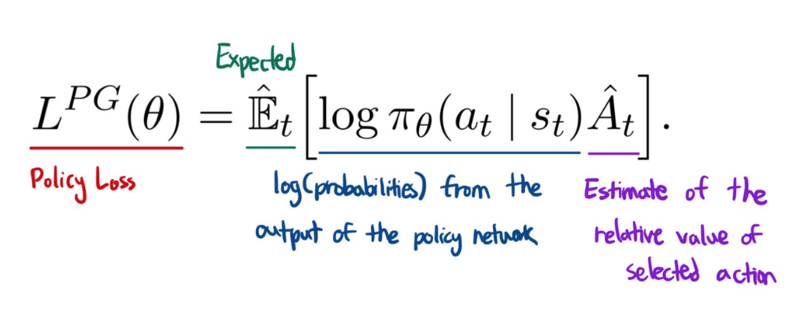

Figure 14: PPO formula

Where, At is the advantage at time t, an estimation . It's calculated using a discounted reward(Q) — value function, with the value function essentially estimating the discounted total of rewards. At the current policy, L approximates the advantage function locally. However, according to Lyu et.al,(2022) this drift away from the previous policy, therefore, it becomes less accurate. Hence, there is a limit to this inaccuracy. The pseudocode of the PPO algorithm is as follows;

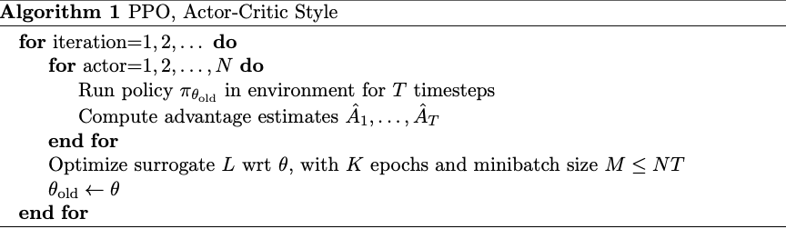

Figure 14: PPO pseudocode

# **2.3 Similar Systems**

The application of reinforcement learning to portfolio management is not a novel concept. In this subject we compare the results of different authors.

| **Authors** | **Research Topic** | **Algorithms Used** | **Findings and conclusions** |
| --- | --- | --- | --- |
| Angelos Filos(2018) | Reinforcement Learning for Portfolio Management | Sequential Markowitz Model (SMM) and Mixture of Score Machines (MSM) a | -The cumulative returns of the MSM and the SMM agents were correlated  -A risk-sensitive framework with transaction costs is explored for rigour, and its performance benefits are illustrated in a number of situations, including synthetic time-series. The results of the study and simulations show that universal model-free reinforcement learning agents outperform current portfolio management models in asset allocation methods, with an annualised cumulative return advantage of 9.2% and an annualised Sharpe Ratio advantage of 13.4%. |
| Qing Yang Eddy Lim, Qi Cao & Chai Quek | Dynamic portfolio rebalancing through reinforcement learning | LSTM | Dynamic rebalancing with risk adjustment may be used by a well tuned RL agent with and without an LSTM price prediction model to centralise technical indicators to optimise portfolio returns. |
| Gang Huang, Xiaohua Zhou and Qingyang Song | Deep Reinforcement Learning for Portfolio Management | Deep Soft Recurrent Q-Network (DSRQ) and Mixture of Score Machines (MSM)), | The optimised agent only altered certain asset weights once or twice throughout the trading periods, and then kept the new asset weights until the back-testing was completed, showing that the optimised agent did not change asset weights frequently.  -On most criteria, including the Sharpe ratio, the optimised stochastic portfolios have been able to outperform the CSI300 in back-testing periods. We've even observed a Sharpe ratio of roughly 2.8 in past studies. |
| Eric Benhamou, David Saltiel, Jean Jacques Ohana, Jamal Atif & Rida Laraki | Deep Reinforcement Learning (DRL) for Portfolio Allocation | Dynamic Markovitz  Deep policy gradient | In terms of net performance and Sharpe ratio, DRL outperforms not only traditional methods like static Markovitz or even dynamic Markovitz, but also the best portfolio (Naive winner), with a final annual net return of 9.49 percent compared to 4.40 percent and 5.27 percent for static and dynamic Markovitz methods, respectively. |

**Figure 1.0: Similar systems**

**2.4 Summary**

In summary, our domain research discusses that Adjustments in strategy allocation should be uncommon since structural shocks occur less frequently than business cycle changes.. Unskilled investors now have more investing possibilities than they had in the past. With the expanding availability of investment opportunities. Understanding one's options when determining where to put one's hard-earned money is becoming increasingly important. In the Bitcoin business, this is especially true. We also argue that if markets are inefficient, portfolio managers can produce alpha. Due to its low correlation with other traditional assets, Bitcoin also provides a variety of intriguing investment opportunities. A Markov Decision Process is a type of mathematical model that allows computers and agents to choose the best course of action in a given situation. Finally, there are three key steps to a DRL portfolio allocation approach. To begin, a list of potentially dangerous assets is compiled. Second, the deep reinforcement learning agent's state space, action space, and reward function are defined. Finally, the model is put through its paces. Upon analysing the findings of the previous authors, it can be seen that reinforcement, specifically DDPG, is suitable for the portfolio allocation problem.

# **CHAPTER 3: TECHNICAL RESEARCH**

## **3.1 Programming language chosen**

The choice of a programming language to use in a project is critical

since it is at the heart of the development process. A good programming language has a number of advantages. Saving time, for example, or boosting the program's performance are among the notable adavantages.As a result, a good programming language is one that may improve the overall quality of the development process. ..... stated that even though the selection of the right programming language is important for a project, each programming language possesses its own advantages and disadvantages. Therefore, given that the developer aims to perform data analytics tasks, three of the most commonly used programming languages in the industry are compared within this section.

| Element | R | Python | SAS |
| --- | --- | --- | --- |
| History and origin | R was developed in 1995 by Ross Ihaka and Robert Gentleman() | Guido Van Rossem invented python in 1991 ()  Python is a high-level object-oriented programming language that's interactive and interpretable(). | SAS institute developed SAS in 1976  SAS is primarily used to perform statistical analysis. |
| Speed | R is said to be the slowest of the three languages() | The high-level nature of python makes it faster than R () | SAS is arguable the fastest of the three |
| Ease of use and learning | R is a low-level programming language, thus understanding and learning to code in it takes time. | Python is a very simple and versatile programming language that is extremely easy to learn and comprehend. | SAS is the easiest of the three languages. This is mainly due to the drag and drop nature of SAS |
| Community support | Python and R are both open source languages | | SAS requires a licence on the user's behalf. |
| Data visualisation and Graphical capabilities | Because of packages like Lattice, ggplot, and RGIS, R offers the finest graphical capabilities. | Python competes with R in terms of graphical capabilities, thanks to graphical programmes like VisPy and Matplotlib. | SAS is limited to the basic default graphics |
| Data handling and preprocessing | R computations are performed in the RAM of the computer , hence making it slower than the other two. | Packages such as numpy and panda make it easier to handle dara | SAS has the ability to efficiently handle data |
| Machine learning | Random forest, dplyr, caret, and other machine learning libraries are available in R | Sklearn, pandas and scikit make it easier to perform ML tasks in python | SAS has ML capabilities, but are very limited. |
| Deep Learning | R is able to compete with python because R and Keras were since added | With the introduction of TensorFlow and Keras, Python has made significant progress in the field of deep learning. | SAS has just lately adopted deep learning, which is still in its early stages of development. |

Table 2.0 : Comparison of programming language

### **3.1.2 Justification of Programming Language Chosen**

Python was selected as the ideal programming language in this project upon analysing several aspects such as machine learning, deep learning, and cost, as shown in Table 1.0 This research will employ machine learning and deep learning methods to construct a portfolio allocation model, therefore, the aforementioned benefits of python's reinforcement learning libraries can be leveraged, with these factors taken into consideration,, adopting Python as the main programming language for this project would boost the performance and speed of the development. Python is also free and may be used for both personal and business reasons. As a result, operational costs can be reduced. Furthermore, Python has a vast community where developers may discover solutions to their challenges. Overall, Python is the most appropriate programming language to implement this project. The majority of this project makes use of Ipython, an interactive shell that is based on python.

## **3.2. IDE chosen**

Visual studio has a plethora of available extensions which allow for faster development. In collaboration with google colab, Visual studio code was chosen for the implementation of this project.

## **3.3. Implementation tools And Libraries**

### 

| **Library** | **Purpose** |
| --- | --- |
| **OpenAGym** | Custom DRL trading environments |
| **Stablebaselines3** | DRP algorithms: PPO, DDPG |
| **FinRl** | Reinforcement learning and environment configuration  -FinRl has a pre-implemented DDPG and PPO algorithms  -Data Acquisition and preprocessing |
| Pandas | Data preprocessing |
| Numpy | For extensive mathematical operations |
| TA-LIB | Technical trading indicators |
|  |  |

**3.5 Summary**

To summarise, Python is by far the best programming language for this project. This is mainly due to its open source nature, from which a myriad of libraries have been developed. FinRL is a library that makes it easy to implement DRL models (DDPG & PPO) in the financial industry. Finally, visual studio code will be used as the Integrated development environment.

### **CHAPTER 4: METHODOLOGY**

## **4.1 Introduction**

As noted by Marks & Rychener(2021) , the success of a project is directly correlated to its management. Due to the aforementioned statement, the analyst aims to find the optimal methodology that addresses the needs of the decentralised finance industry.It is the job of the developer or project manager to assess the attributes of a given methodology. Every methodology has its own set of advantages and disadvantages.The different methodologies are compared in the figure below;

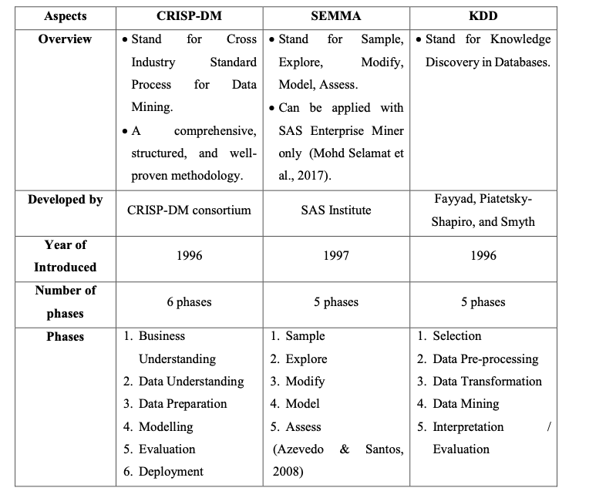

Of the myriad of available options,CRISP-DM provides an industry agnostic approach to data science. The CRoss Industry Standard Process for Data Mining (CRISP-DM) is a six-phase process model that outlines the data science life cycle. It functions as a series of guidelines to assist the analyst in planning, organising, and implementing a data analytics project using the scientific approach.The six phases required when using the CRISP-DM are outlined below;

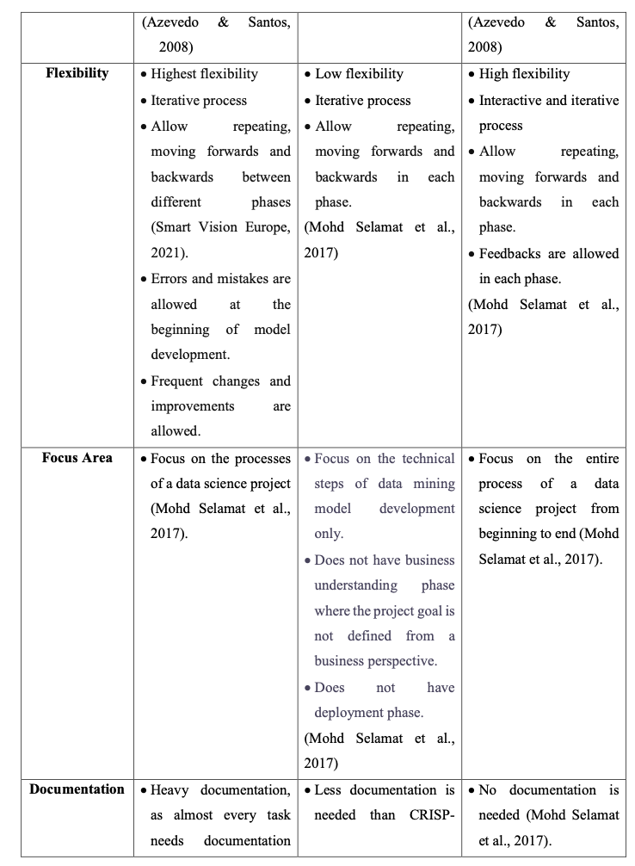

## **4.2 Business Case Understanding**

The respective business case should be evaluated in order to have an understanding of the available and necessary resources. It is at this stage that the developer is required to translate and understand the project aims and objectives.The type of data science techniques to be used in the project are outlined at this phase.Prediction problems for example have different requirements from classification problems.

**4.3 Data understanding**

Collecting decentralised financial data from data sources, studying and characterising it, and ensuring data quality are the main activities involved in this phase.Predominantly, data exploration, is done at this phase, the analyst must deploy statistical techniques to verify the quality and usability of the open, high, low close market data obtained from an API.Methods such as data visualisation help the analyst have a visual representation of the data.A better understanding of the data ensures that the analyst accomplishes the project goal

**4.4 Data Preparation**

Data selection should begin with the establishment of inclusion and exclusion criteria. Cleaning data can help with poor data quality. Derivative characteristics must be built based on the utilised model (specified in the first phase). Different approaches are available to the analyst and are model dependent for each process().The initial step is cleaning the data. Missing data, noisy data, and inconsistent data are common in real-world datasets. All of these tainted data will be eliminated since they will have an impact on the final outcome. As a result, the developer will use data pre-processing procedures to clean the data. The analyst will subsequently perform data transformation to convert the information into a usable and legitimate format. In addition, the developer will decrease the data by deleting the project's irrelevant qualities and data records. For example, the developer will perform forward filling to handle missing values, leaving only the useful record for future research. The developer will then Perform feature engineering to create the trading environment simulation using technical indicators

## **4.5 Data modelling**

The data modelling process comprises choosing a modelling approach, creating a test case, and creating the model. All data mining techniques are applicable at this phase. In general, the decision is influenced by the business challenge and the facts. What is more crucial is how to explain the decision. It is at this stage that the analyst identifies specific parameters in relation to the decentralised financial markets, and subsequently examines the model against assessment criteria and chooses the best ones when assessing it.

## **4.6 Evaluation**

The model evaluation phase considers the project in its entirety. The two implemented models(PPO and DDPG) are compared in terms of returns, maximum drawdown, and sharpe ratio. The best performing of the two are evaluated against traditional benchmark portfolio allocation techniques. Based on the results of this phase, the developer will either proceed to deploying the model to a web application or make the necessary adjustments

## **4.7 Deployment Phase**

The deployment phase is concerned with managing and monitoring the project after successful project execution.The analyst is required to document finding and changes made to the prior implementation.The deployment phase is not necessarily the end of the project, instead, the analyst is required to constantly monitor and tune the model.

## **4.3 Summary and Justification of Data mining methodology**

CRISP-DM is the data mining approach chosen for this project based on the comparison above. Because CRISP-DM provides a systematic framework and advice for planning, organising, and executing data mining projects, this is the case (). Because CRISP-DM is a cross-industry standard, it may be utilised and applied in any data science project from any domain or industry (). CRISP-DM is also the only technique that includes a Deployment step. The prediction model will be installed and its effectiveness will be evaluated during the deployment phase of the present project.

# **CHAPTER 5: DATA ANALYTICS**

## **5.1 Introduction**

Time series data is a successive collection of data observations with respect to time. Thus, in the context of the financial markets, the closing price, for example, would be the periodically recorded observation. Time series analysis attempts to answer the question of “Given an independent variable *Y,* how does it change with respect to the dependent (*X*) time variable?”. Thus, applying deep reinforcement learning algorithms to historical time series data is analogous to travelling back in time with the goal of learning patterns that are too complex for the human brain to fathom. It should then become apparent to the reader that an abundance of time-series data is preferable ​​as it ensures that the DRL agent, when trained upon, is reliable and consistent.

### **5.1.1 Implementation Overview**

Since this project aims to leverage the latest technological advancements, the developer used and therefore recommended the freely available cloud computing resources provided by google. With a free gmail account, google gives users access to remote computing resources with 15gb of free storage. DRL is known to be a resource-hungry process, hence, the free cloud based GPUS allows for optimised, uninterrupted training. Upon landing on the *drive.google.com* page, users will see the following layout;

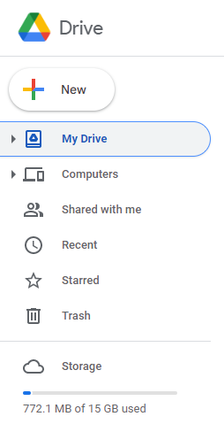

Clicking the ‘*+NEW* icon will display more options for cloud based applications that are available to the user.

Clicking the *‘folder upload’* option will allow the user to upload the project in its entirety;



The user will then be prompted to locate the folder in their local storage. Once uploaded, the following directories will be visible;

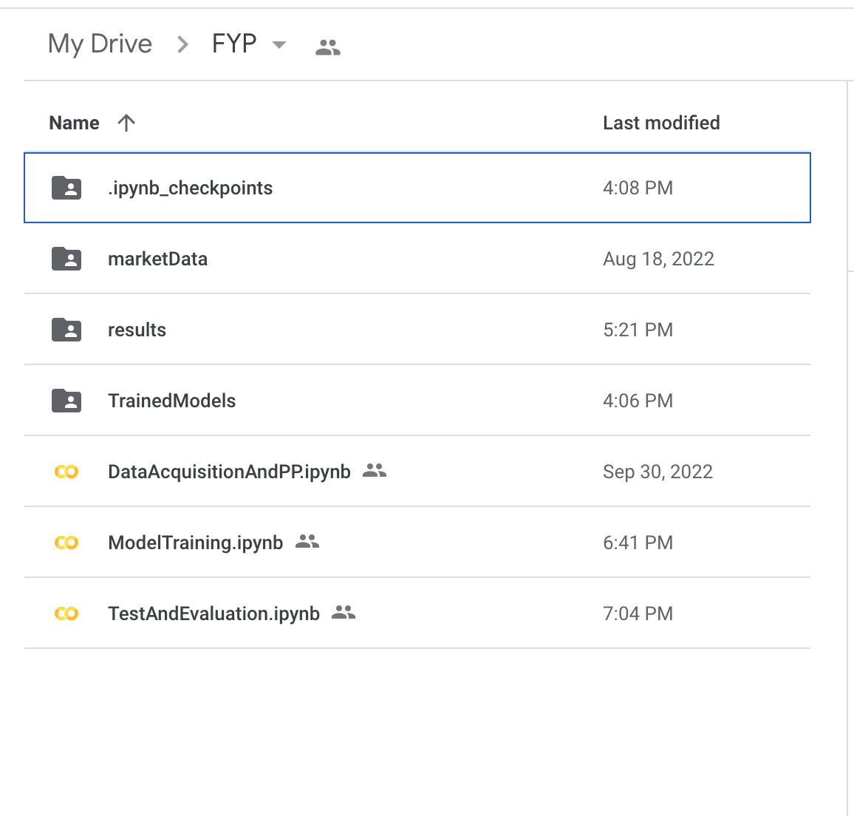

As the name implies, the *dataAcquisitionAndPreprocessing.ipynn* file was used for the sole purpose of acquiring and preprocessing the OHLCV data using API calls. The acquired data was then extracted and stored in the ‘market data’ folder. The train data, after the data split is used in the *Modeltraining.ipynb* file to carry out the data modelling procedures. Finally, the file named *Evaluation.ipynb* contains the model evaluation procedures that were performed post model training. It should also be noted that *Evaluation.ipynb* depends on the output of both the *dataAcquisitionAndPreprocessing.ipynb*  and the *Modeltraining.ipynb* file. The market data folder also contains the csv and pickle output files from the different phases

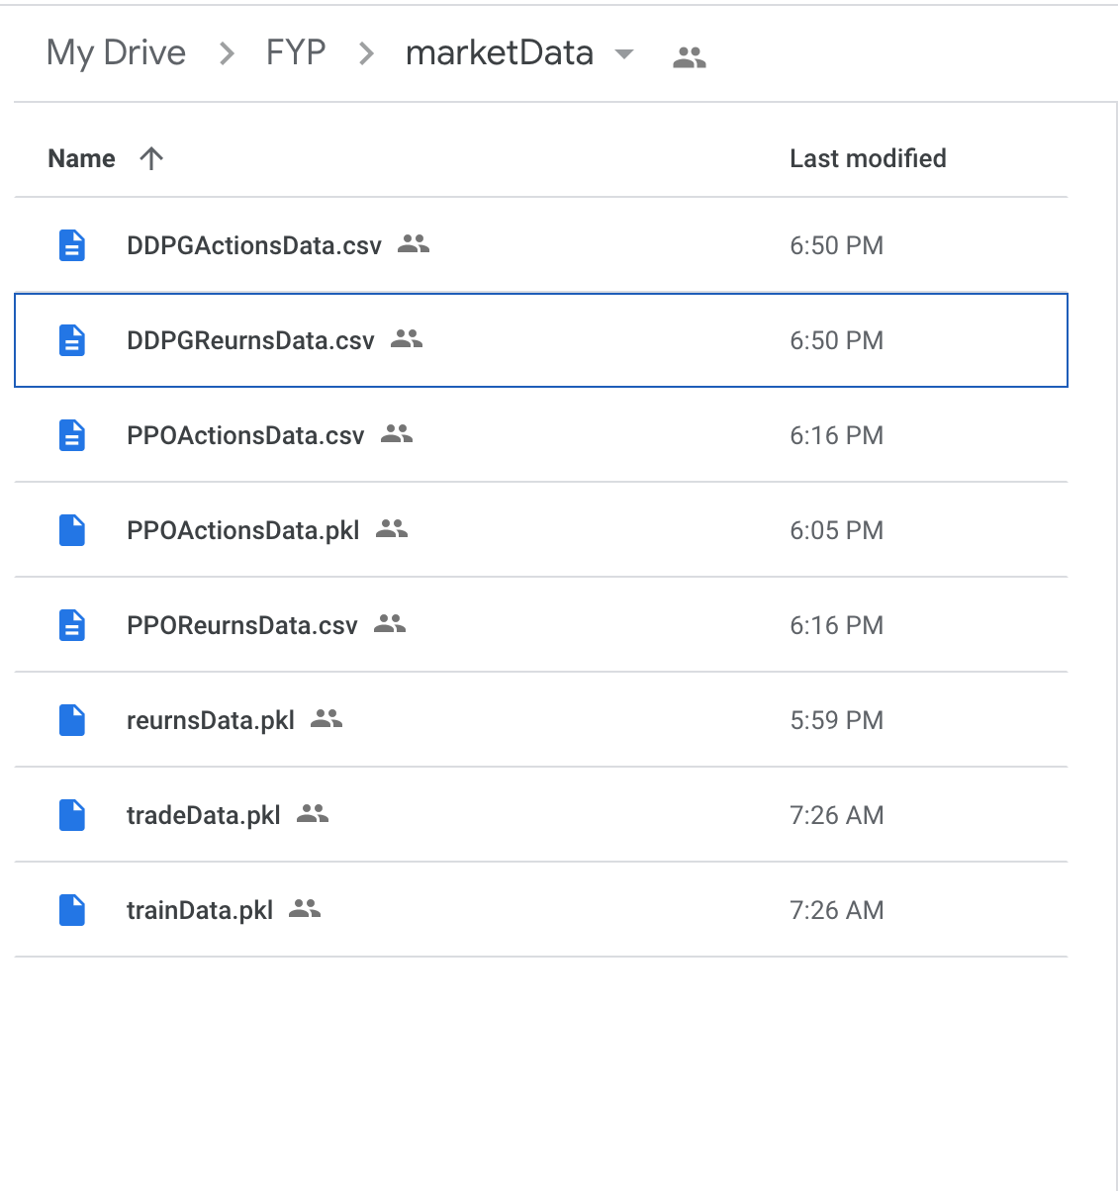

## 

## **5.2 Initial Data Exploration**

Within this section, the analyst provides a summary of the dataset in terms of its source and structure.Furthermore, the analyst discusses the result of the preliminary analysis that was done on the dataset. An initial exploration of the dataset in its entirety will determine the appropriate preprocessing operations that should be performed on the dataset. By exploring the data, the analyst will have a better understanding of the behaviour and relationship of the different cryptocurrencies throughout the duration of the stipulated period.

### **5.2.1 Data Summary**

#### **5.2.1.2 Data Acquisition and loading**

The dataset used in this project was acquired from the Binance cryptocurrency exchange using API calls (Application programming interface). Within the dataset were 7,812 records of open, high, low, close, volume (OHLCV) data of 14 of the highest ranked cryptocurrencies by market capitalization (at the time of writing). In order to ensure data integrity, the Fin-RL library was used to abstract some of the intricate financial data integrity requirements. Updating the existing dataset of OHLC data, for example, merely requires the input of parameters such as the time interval, start-end period and a list of technical indicators. The data was read as a pandas dataframe and stored in a variable called ‘frame’. Calling the .head() method on the ‘frame‘ variable, which stored the raw dataset, displays the first 5 observations;

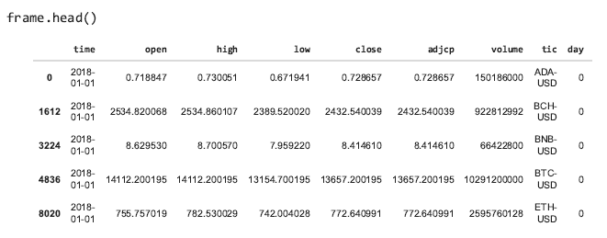

Getting the first 5 rows of the dataset using .head() method

From the first five rows, the analyst was able to verify the fact that the first recorded observation in the dataset was from january of 2018, where we see, for example, that the open price of ADA-USD was $0.72.

#### **5.2.1.3 Metadata**

| **Column Name** | **Description** |
| --- | --- |
| index | The dataframe index number of the tickers |
| tic | Ticker symbol |
| time/date | Time/date of observation |
| open | The price of the asset at the beginning of each day |
| high | The highest price of the asset during the day |
| low | The lowest price of the asset during the day |
| close | Closing price of the asset during the day |
| adjcp | Closing price after dividends |
| volume | Number of daily traded shares |
| boll_ub | upper bollinger band indicator |
| boll_lb | lower bollinger band indicator |
| rsi | RSI indicator |
| cci | CCI indicator |
| macd | macd indicator |
| dx | dx indicator |
| close_20_sma | 20 period closing rolling average |
| close_60_sma | 60 period closing price rolling average |

All fields in the dataset were assumed to be relevant, therefore were all included in the analysis and modelling phases.

### 

#### **5.2.1.4 Attribute Data Types**

The operations performed on a single datum must be in accordance with its respective data data type, hence, it is essential that the developer takes all the existing data types into consideration. Logic states that text data for example, cannot be used for simple mathematical operations such as addition. This subsection explores the data types of the attributes contained in the dataset. Broadly speaking, data types can be categorised into two distinct categories; Qualitative or Quantitative. In the context of the dataset, an example of the former is ticker names of the cryptocurrencies, whereas an example of the latter would be the numerical open price. The table below summarises the different attribute types contained in the data;

| **Variable Name** | **Type** |
| --- | --- |
| index | Interval |
| tic | Nominal |
| Date | Interval |
| open | Ratio |
| high | Ratio |
| low | Ratio |
| close | Ratio |
| adjcp | Ratio |
| volume | Ratio |
| boll_ub | Ratio |
| boll_lb | Ratio |
| rsi | Ratio |
| cci | Ratio |
| macd | Ratio |
| dx | Ratio |
| close_20_sma | Ratio |
| close_60_sma | Ratio |

#### **5.2.1.5 Data Summary**

Summary statistics allow for a summary of the nature of variables that are contained in the dataset. The mean, for example, tells us the average value of the attribute, hence, it can be used to analyse the skewness of the data. Furthermore, the difference between the minimum (min) and maximum (max) provides a range by which we can determine validity. For example, It can be observed, using summary statistics, that the minimum and maximum close prices are in the range of $0.23 and $67,566 (respectively). With that, the analyst was able to determine, more reliably, the ‘peak’ and ‘bottom’ close price for all the cryptocurrencies, for the period of January 2018 to June 2022. In the context of heart pacemaker data for example, it would be fatal to consider such a range as valid.

Using the pandas library, the developer was able to obtain simple summary statistical information through various methods. The ‘shape()’ function, for example, confirmed the number of rows and columns contained in the dataset. Running .shape() on the data frame showed that there were a total of 16, 080 rows and 17 columns in the dataset.

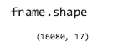

Furthermore, summary statistics about the dataset were generated using the .describe() method, the resulting output statistics such as the mean, min, max, standard deviation and the different percentiles;

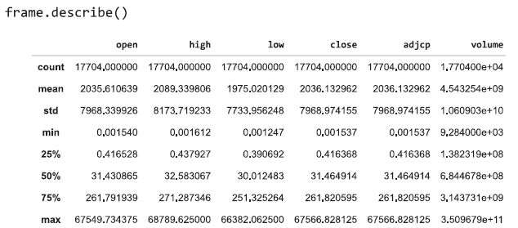

As can be observed in the above figure, the global average closing price was much lower than the standard deviation, which is typically an indication that the attribute may contain outliers.However, since the bitcoin price fluctuations were marginally greater than that of the other cryptocurrencies, the statistical properties of the global close attribute are distorted. That is, the mean closing price of $1975.02, for example, is skewed towards that of the higher (bitcoin) close price. Hence the different cryptocurrencies may require independent analysis and plotting on different axes. To demonstrate this, two dataframes were created, filtering only the two ticker symbols BTC-USDT and LTC-USDT(Bitcoin and Litecoin).

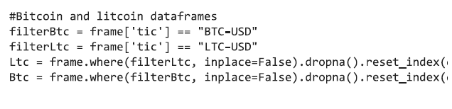

The output, as shown below, indicates that the lowest (minimum) closing price (for the given period) of litecoin was $23.46,and the highest closing price was $385.45.

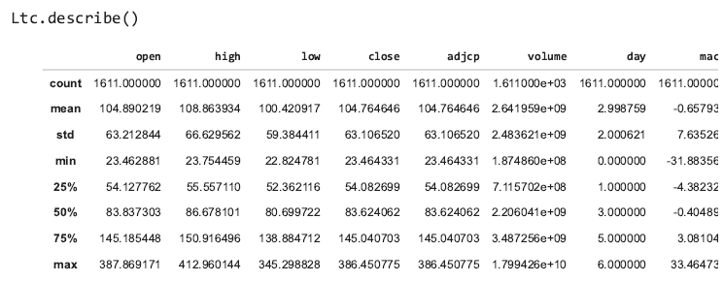

Contrarily, in the case of bitcoin, the lowest and highest recorded prices were $1602 and $66,222.4; a massive difference, which is likely to distort the distribution of the data.

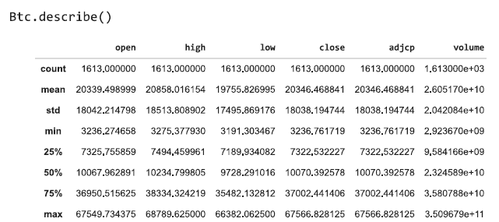

The datatype of each column was identified using the pandas frame.dtypes() ;

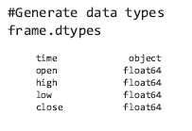

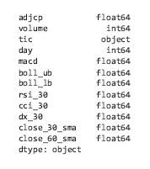

Additional information about the data frame was obtained using .info() method;

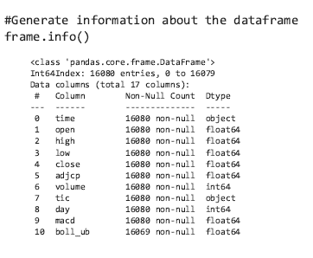

A primarily notable aspect is that the ‘date‘ attribute was of object data type, when, in fact, ‘datetime’ is a more suitable data type for date and time data. Within the ‘tic’ attribute are the ticker symbols/names of the cryptocurrencies, hence it is of object type.The remaining 15 variables (besides the index) in the dataset are of the type ‘float64 .

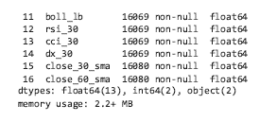

The proceeding phases of the project required that the number of observations for all ticker values are the same, hence, it was essential that the developer checked and corrected the number of observations per ticker symbol in the dataset. This was achieved by calling the .*valuecounts()* pandas method on the ‘tic’ column of the dataset;

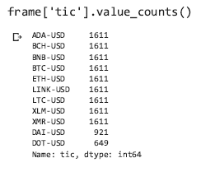

Imbalance of observations per ticker symbol

## **5.3 Data cleaning and Preprocessing**

To enhance the quality of the data, data cleansing entails identifying and correcting any potential anomalies and inconsistencies that may exist in the dataset. A value is said to be anomalous if it deviates significantly from its expected range. The expected range depends on the business case. In the context of a dataset pertaining to human temperature readings , for example, a data value of 1000 degrees celsius would be far beyond the expected range of normal human temperature, hence, it would be logical to consider it as an anomaly. Since, as stated in the aims objectives section, the analyst aims to use the data for DRL, it is essential that the data is of high quality. As a matter of fact, it may be argued that the accuracy of the model depends on the quality of the input data. By training the model on erroneous data, the DRL agent would learn incorrect information about the market environment.

The absence of data values is another primary factor that could potentially result in erroneous model learning, hence, it is essential that the developer checks for missing values that may exist in the dataset, prior to training. It is crucial that the developer decides how missing values are to be handled. The appropriate data cleaning technique depends on the nature of the dataset. For example, common is the case that missing values in a static datasets are merely replaced with values of some measure of central tendency such as the global mode, mean or median. Assuming that the data was recorded per nano second, for example, mere replacing missing values with the global mean is likely to result in erroneous learning since, practically, the price of an asset is more likely to fluctuate as time changwa, hence using the mean or mode as a replacement for missing values is likely to distort the statistical nature of the data observations, hence, biassed model learning.This is especially true if there are many missing values in the dataset. Depending on the number of missing values, it sometimes makes sense to simply drop the missing values The following section explores the methods used to clean the data in preparation for the modelling phase

**5.3.1 Missing Values**

Upon checking the sum of missing values in the dataset, it was discovered that 4 of the 17 rows contained 11 missing values each.

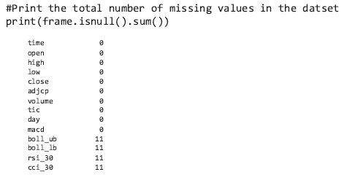

As can be observed in the figure below, the analyst simply dropped the null values by applying the dropna() method to the dataframe ;

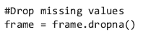

Verifying that the dataset no-longer contains missing values;

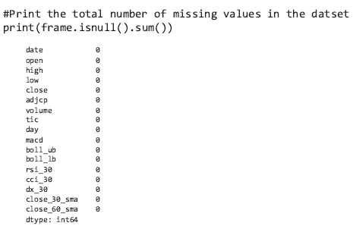

### **5.3.2 Data Type conversion and Variable Renaming**

As noted in the data summary, the ‘date’ column needed to be of datetime type. The pd.to_datetime method allows for this to happen in one line of code, as shown below;

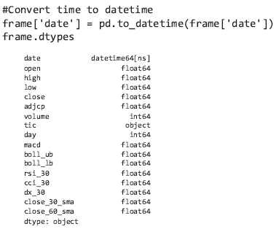

Using the.dtypes method again on the dataset verified that the ‘time’ column was converted to the appropriate type (datetime64[ns]). Furthermore, since the observations were recorded on a daily basis, it made more sense to rename the ‘time’ column to ‘date’. This was achieved using the rename() method, which takes a dictionary containing old and new column names. In the below figure , by re-instantiating the .columns method, it was observed that the change took effect;

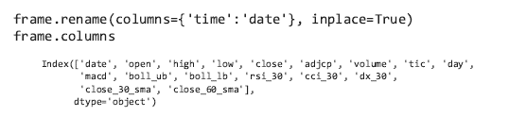

The imbalance of observations per ticker symbol is primarily because the conception dates of the cryptocurrencies in the dataset were not the same. For example, the earliest recorded observations for the polkadot close price are from the end of august 2019, whereas ADA-USD, BNB-USD BTC-USD, ETH-USD , LTC-USD, XLM-USD have observations from beyond this point. The figure is a visual depiction of the aforementioned

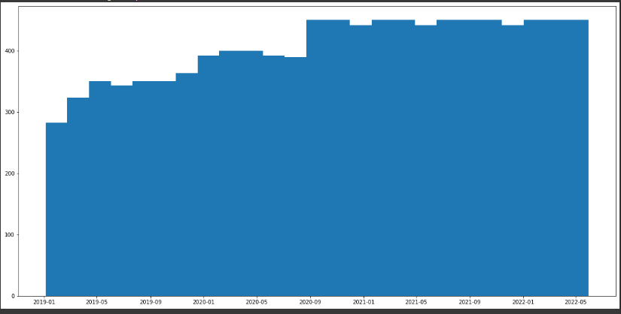

As depicted in the histogram above, there was an imbalance in the number of recorded monthly observations per ticker in the dataset. Therefore, the analyst decided to include the aforementioned ticker symbols for the remainder of the analysis. The isin() method was used to filter out only the aforementioned ticker symbols;



**5.3.3 Feature Engineering (Covariance Matrix)**

With the goal of increasing the overall efficiency and accuracy of the model training process, feature engineering was performed. Any measurable input that the analyst can use to achieve the predictive tasks is a potential feature. This was done by initially sorting the dataset so as to ensure that the feature extraction is with respect to time (date column) . To further increase training efficiency, the date column was factored using the .factorise() pandas method. A for loop was used to iterate through the entire data set in groups of the specified lookback range (365 =1 year), calculating the returns of each cryptocurrency at each step and dropping any null values that may be computed in the process. The covariance of each cryptocurrency was calculated by calling the .covs pandas method on the list of returns and stored (along with the list of returns) in a dataframe ‘covFrame’.By using the covariance as a feature, the model would (in theory) be able to take the variability of the different cryptocurrency into account during the learning process. The code snippet of the feature extraction process is shown in the figure below;

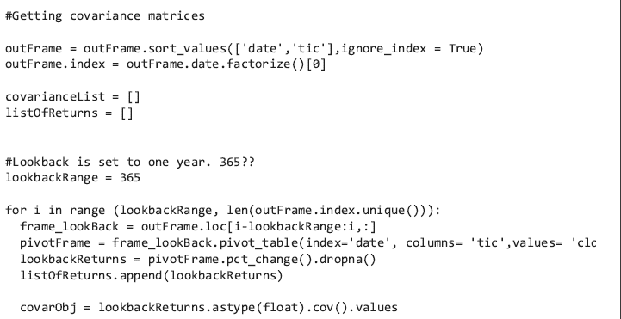

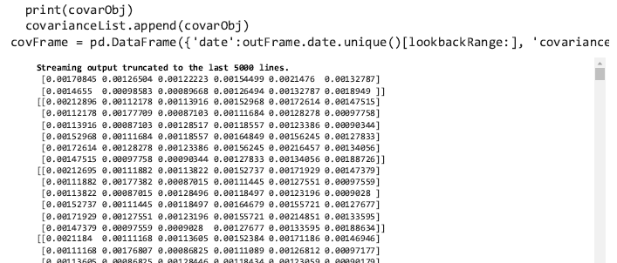

The (12,6) feature matrix consists of the covariance of the variance of the close price of the different symbols in the dataset. The covariance dataframe was then merged with the main dataset and sorted again with respect to the date column. The new ‘covarianceList’ and ‘Listofreturns’ columns are shown in the figure below;

## **5.4 Data Visualisation**

A visual representation of the date aids the analyst in observing the nature of the data and attributes therein. Furthermore the appropriate preprocessing techniques will depend on the frequency distributions of the variables. Data visualisation allowed the analyst to represent the data in a graphical format. The obvious benefit is that it simplifies the analysis process. With the help of the pandas_profiler and the .hist() matplotlib function, a high level visualisation of the dataset was performed, followed by a more detailed time-series based analysis of the different cryptocurrencies .

Both univariate and multivariate data visualisation were performed. Performing univariate data visualisation entails that the analysis of (at most) one variable is performed , whereas multivariate analysis attempts to analyse multiple variables in relation to each other. Since this project makes use of time series data, it was necessary to get a visual sense of the trends that occurred during the span of the period ranging from 2018-01-01 until 2022-06-01. Furthermore, the interpretation of the visualisations are to be supported by the descriptive statistics of each filtered cryptocurrency OHLC dataset. The close price is what the RL agent will attempt to predict, hence, the factors that influence the close price were also examined.The matplotlib and seaborn libraries were used to ease the **visualisation process** while simultaneously leveraging the flexibility that these python packages offer.

### **5.4.1 Univariate Analysis/Visualisation (Global)**

Within the following section, the attributes are analysed on an individual basis. That is, the distribution , location and dispersion of the data observations are analysed

**Variable 1: tic**

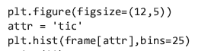

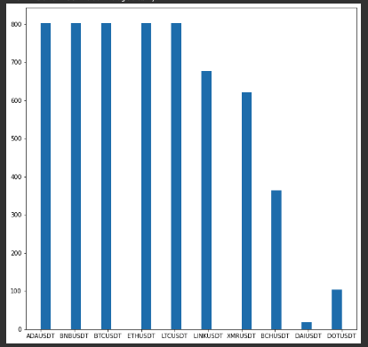

As can be seen in the histogram plot above, the majority of the observations in the dataset are for ADA-USDT, BTC-USDT,ETH-USDT, LTC-USDT . This is supported by the fact that the aforementioned cryptocurrency ticker symbols are of the earliest of the blockchain/cryptocurrencies to be conceived. The histogram plot also shows that DAI-USDT has marginally less observations than the other variables and therefore, was secluded

**Variable 3: Open**

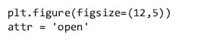

Plot the open price attribute

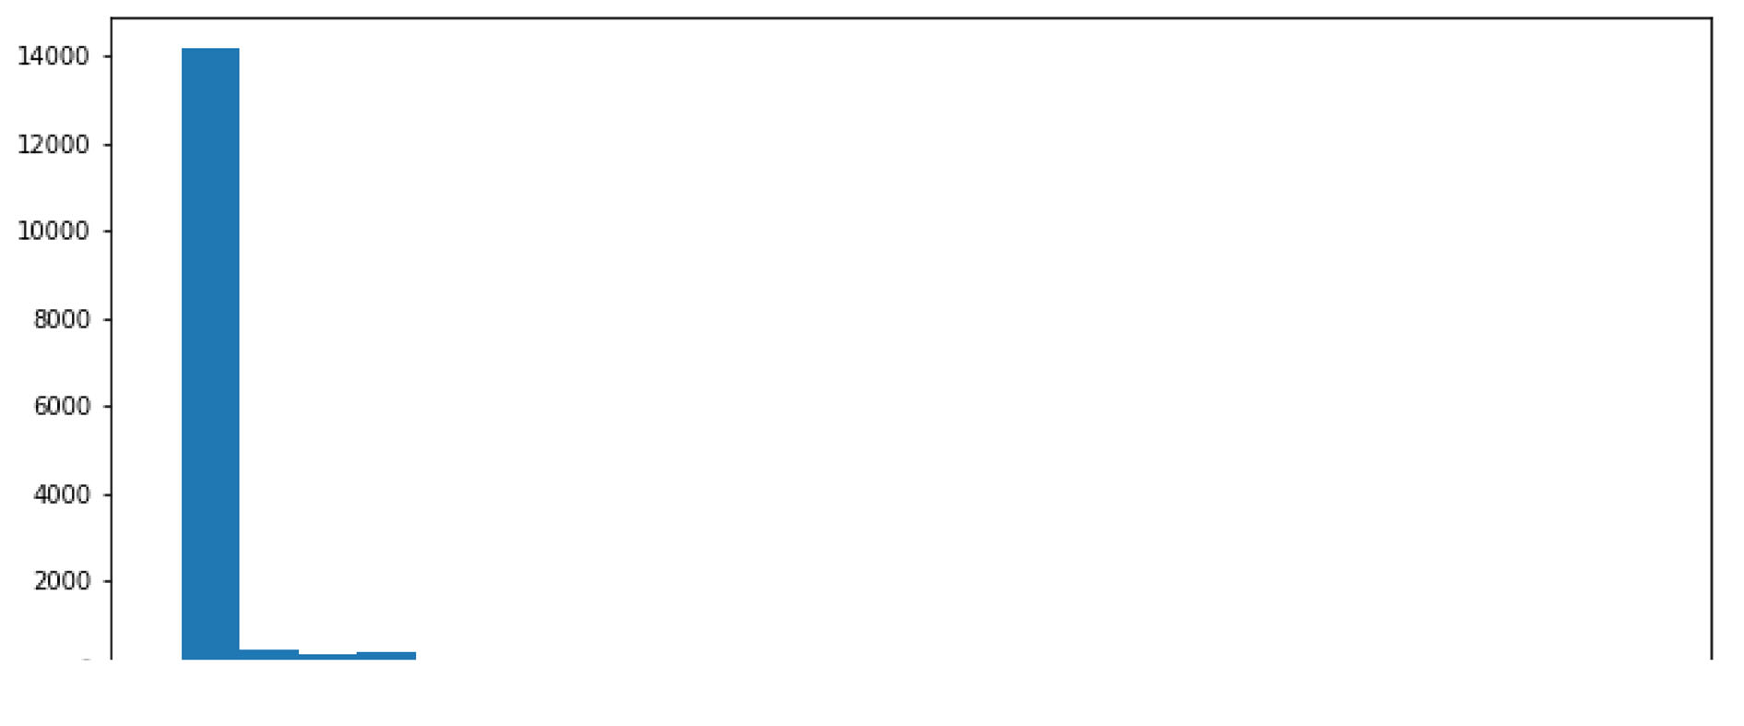

The frequency distribution of the open variable, as shown in the above figure, is right skewed. This was further supported with the fact that the standard deviation of 9567.2 is marginally greater than the average open price of $2979. This indicates that on average, the open rice observations contained in the dataset were $9567.2 away from the average $2979. This can be used to further illustrate the need for individual analysis of the cryptocurrencies.

**Variable 5: High**

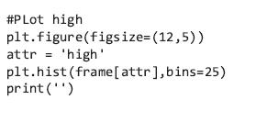

Plot the ‘high’ attribute

The daily high price is the maximum price value of a given asset. Hence, as shown in the histogram below, there was a tendency for the daily high price of the cryptocurrencies to be rightly skewed towards $0. It could thus be argued that the different cryptocurrencies had different levels of demand.

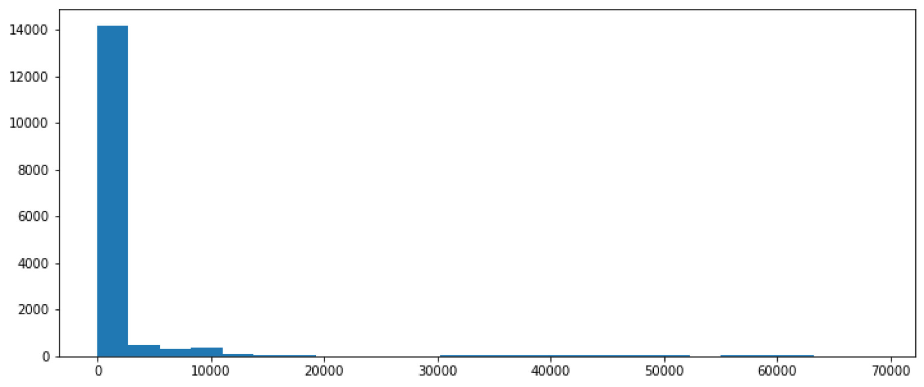

Plot the histogram of the high variable

As with the open price, the high , low,close,and adjusted close price variables were positively skewed.

**Variable 6: Low**

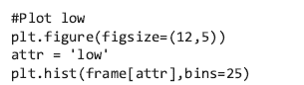

Plot the histogram of the ‘low’ attribute

As shown in the figure above, the low daily price was also right skewed, hence the same was assumed about the demand of the cryptocurrencies



Histogram plot of the low price attribute

**Variable 7: Close**



Plot histogram of closing price

Since the close is the price of the cryptocurrency that was recorded at the end of each day, the close price is a more accurate measure of the past daily prices. As can be observed from the above figure, the observations had a tendency to be in the range of $0 to $1000

**Variable 8: Adjcp**

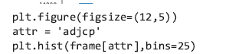

The adjusted close is typically a measure of the close price after dividends or splits have been distributed, hence, was assumed to be irrelevant to the case of cryptocurrencies since there are no dividends to be split.

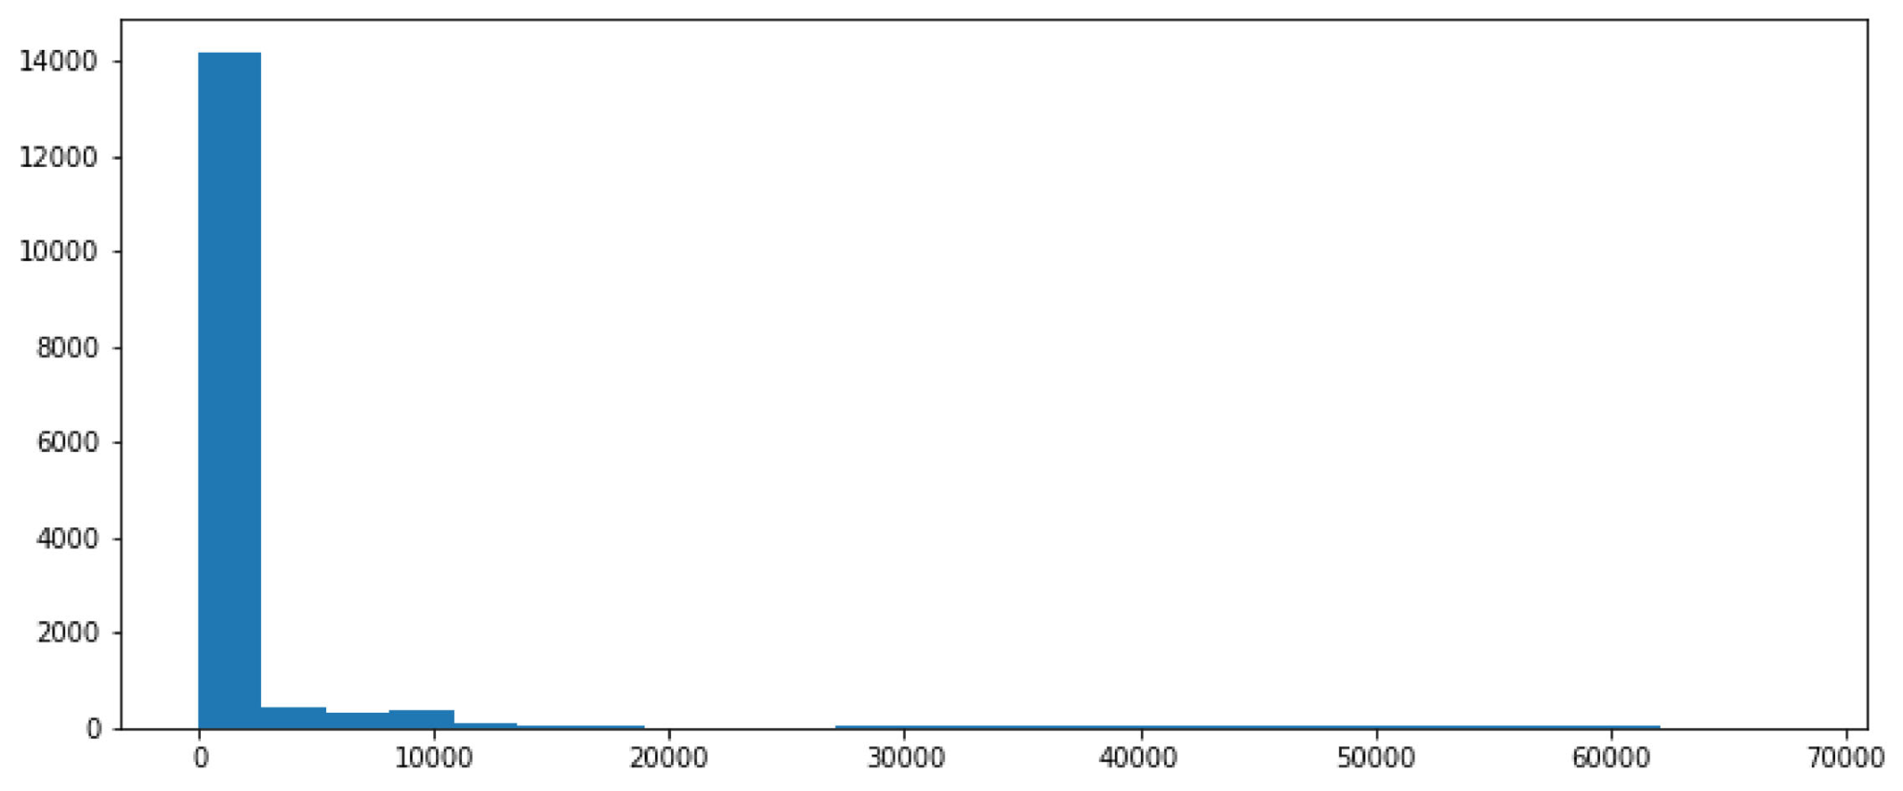

**Variable 9:Volume**

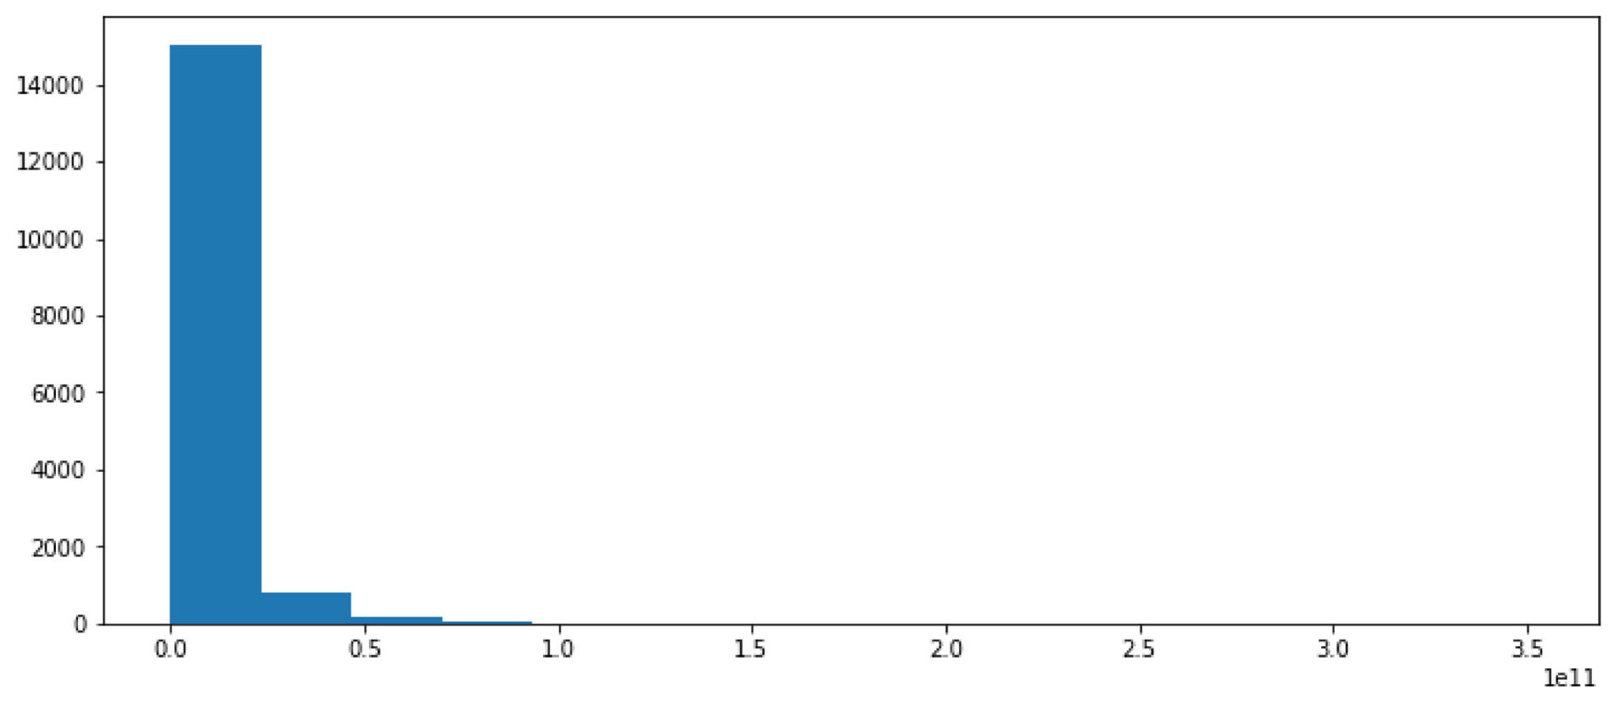

The volume variable is right skewed, with the highest recorded volume at 5000. Since the volume is the daily number of trades, the above figure shows that during the stipulated period, $5000 was the highest amount of cryptocurrency purchased per day. Furthermrre, The descriptive statistics indicate that the average volume of cryptocurrency traded per day was 3.765867e+07

**Variable 10: Boll_ub (Bollinger Band )**

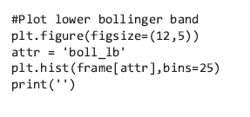

**Plot the histogram of the lower bollinger band**

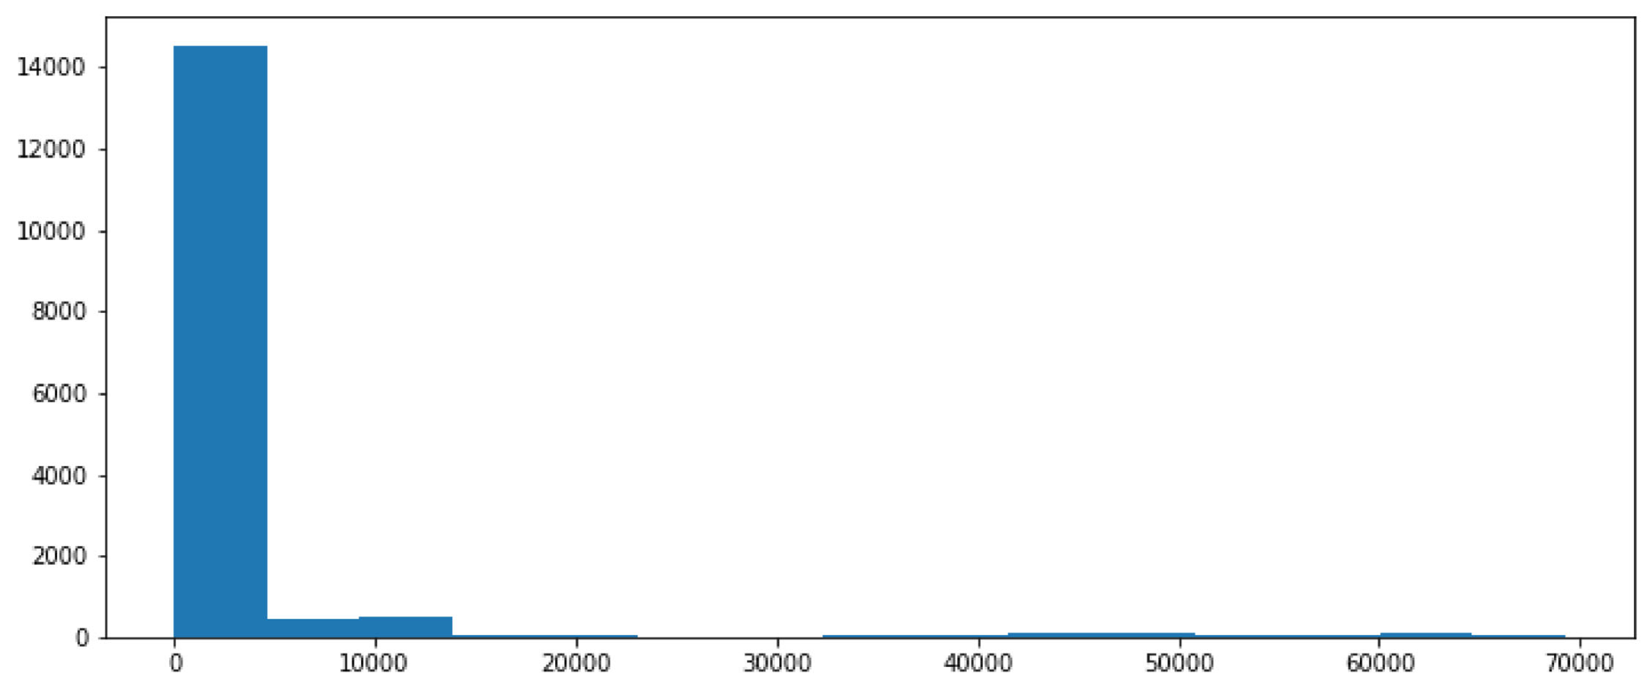

From the above figure, it can be observed that the upper bollinger band variable is right skewed, with the highest recorded observation as approximately $69080.6 and a standard deviation of $10779.6.

**Variable 11:Boll_lb**



From the above figure, it can be observed that the upper bollinger band variable is right skewed, demonstrating that the majority of the time, the lower bollinger band was closer to 0. The reader should be reminded that this attribute is in relation to all cryptocurrencies in the dataset.

**Variable 12:Rsi**

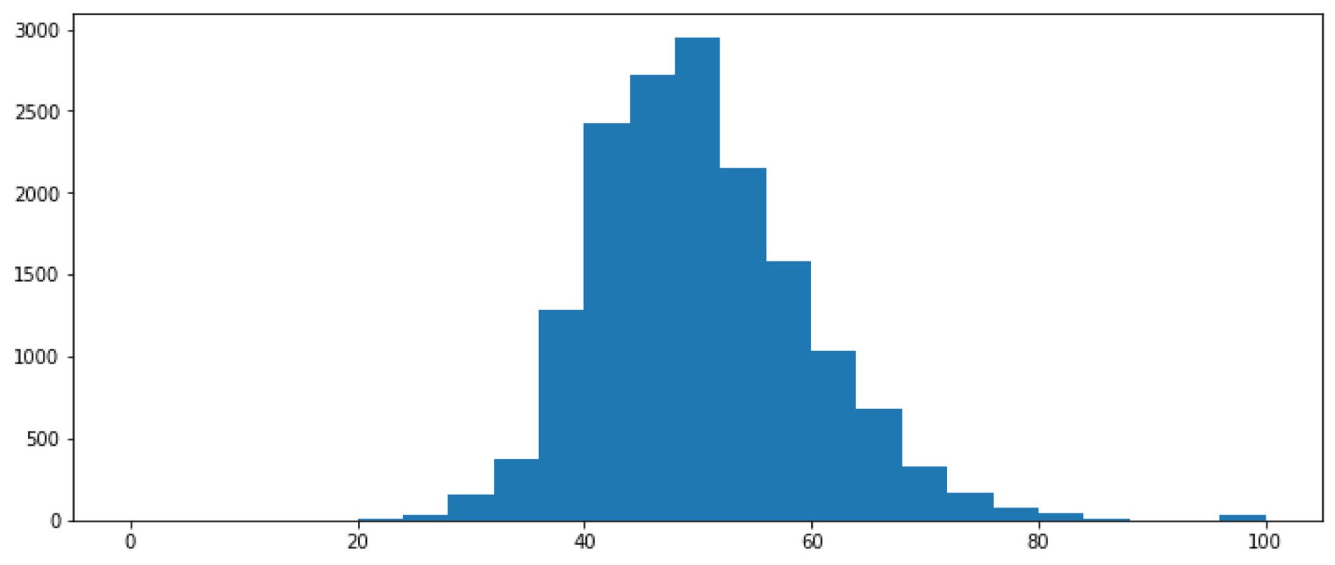

The Rsi calculations were based on the closing price.The rsi formula essentially normalises the closing price values to values within the range of 0 to 100. For example, an RSI value of 0 would indicate that there was no change in price, whereas an RSI value of 100 would mean that upward the price trend is strong. The bell shaped(normally distributed) frequency distribution in the above figure was evidence to the aforementioned**.** Furthermore, the descriptive statistics confirm that the minimum and maximum RSI values were 0 and 100 (respectively).

**Variable 13: MACD**

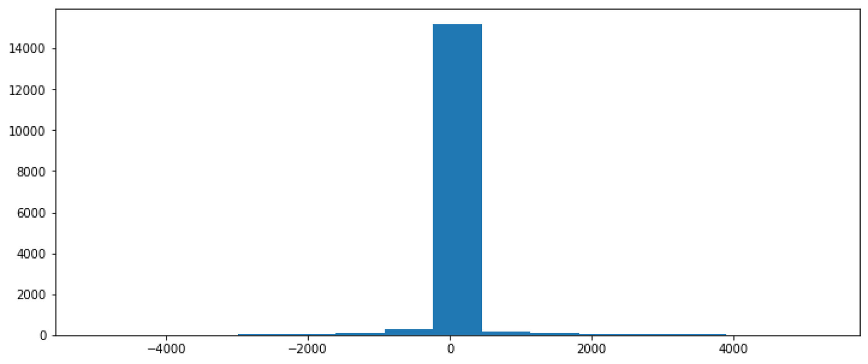

As its name implies, the moving average convergence divergence indicator uses the rolling mean in its calculation, hence, the output histogram is normally distributed.The average recorded macd value for the period was $11.9, while the highest was $5248.1.

**5.4.2 Multivariate Analysis**

Multivariate analysis was used to provide insight into the nature of the relationships that exist among the different variables in the dataset.

**Correlation Heatmap Plot**

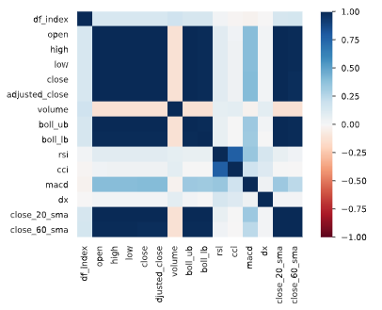

The correlation between each variable in the dataset was calculated using the pandas .corr() method. The output was a dataframe that consisted of the correlations between the individual variables in relation to each other. The correlations are then plotted using seaborn as shown in the figure above. From the figure we see that the close_Sma20, bb_lb, bb_ub, adjusted close, low, high and open had a very strong positive correlation (1)with the . close price. Furthermore, the closing price and volume variable show a neutral relationship. That is, an increase or decrease in one of the two variables, did not result in a positive or negative change in the other. Like the aforementioned indicators, the macd is derived from the closing price, hence the high correlation to the close price.

### **5.4.2 Univariate Time-series Analysis**

As stated in the data visualisation section, the different cryptocurrencies needed to be analysed individually. The purpose of doing so was to analyse the price trend for the specified time range. The different cryptocurrencies were plotted on the same axis as shown below;

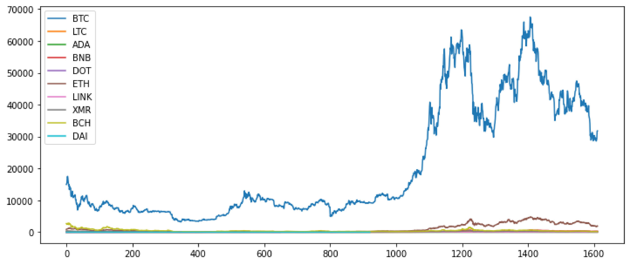

It can be observed from the figure that we are unable to see the price fluctuation of other ticker symbols since that of the bitcoin price was marginally greater than the other cryptocurrencies. By filtering out the individual tickets into separate datasets, the analyst was able to plot the individual cryptocurrency close prices. Passing the filters to the pandas .where() method returns the data frames for the individual ticker symbols . By passing the inplace argument as false, we ensure that the original data frame is not modified after the filtering process. Furthermore, reset index ensured that the dataset was reorganised by the date index after the filtering process.

**Bitcoin**

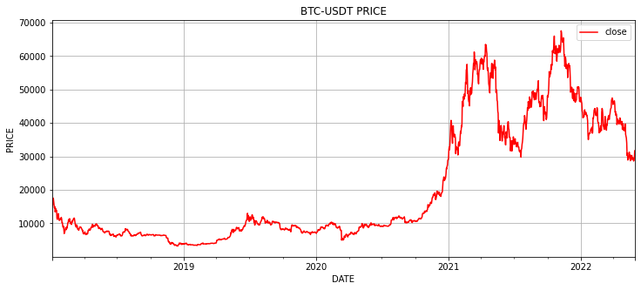

From the beginning of the period (2018-01-01), the bitcoin price was in a steady down trend for approximately 1 year (until 2019-01-01). A strong uptrend was observed in the following 6 months of the year; a 150% increase from $500 to 12,500. In july of 2019, a strong downtrend was observed to have begun, resulting in a -60% increase within the span of 3 months as the downtrend persisted until the end of march of 2020. From roughly the end of march 2020 onwards, an even stronger uptrend was observed,with a staggering %250 increase to $17,500.

The daily close price of bitcoin ( as supported by the box plot) was in the range of approximately $10,000 to $36,000. The combination of uptrend and downtrend provide the DRL agent with more scenarios to learn from. If for example, the training were only done using data from a bull market (upward trending) then the DRL agent will learn the biassed up-trend pattern.

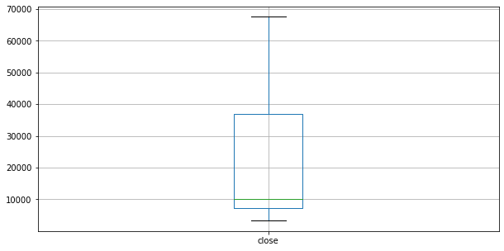

The frequency distribution of the closing price is shown in the histogram plot of the bitcoin price below;

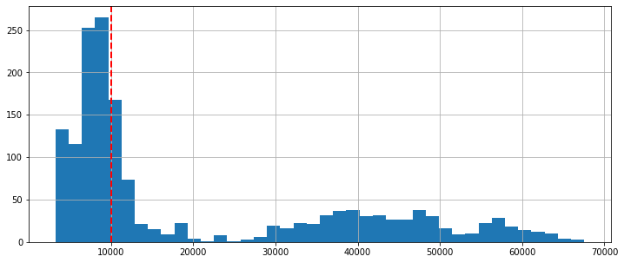

The red line highlights the median price of bitcoin for the stipulated period. It is visible from the figure that the median price of bitcoin was approximately $8000 for the period of 2018-01-01 to '2022-06-0.

**Litecoin**

As with the bitcoin price, the price of litecoin was in a minor downward trend at the beginning of the stipulated period. The price trend, just like with the bitcoin price, shifted in january of 2019. Similar price action was observed throughout the remaining months.

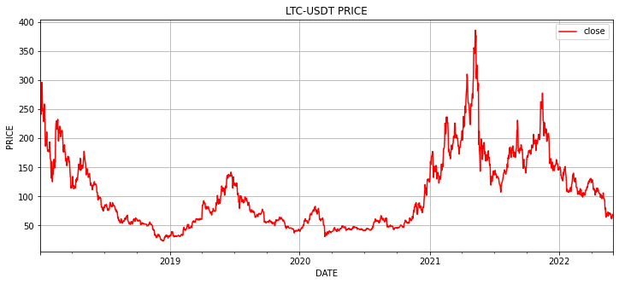

In the above figure, we can observe that the price of litecoin was in the range of $40 to $60 on average. The box plot diagram below is used to support this analysis

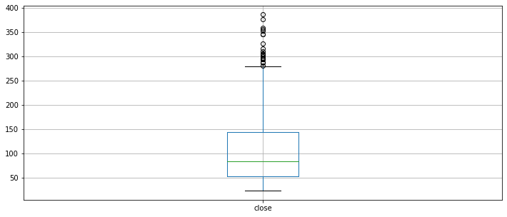

It can be observed clearly from the green line of the boxplot above that on average, the price of litecoin was in the range of $50 to $150. The volatility of litecoin is made more evident in the above image .That is, the 250% price increase from $40 in february of 2019 to $140 in july of the same year was followed by an almost 100% decrease. The positively skewed distribution plot is shown below;

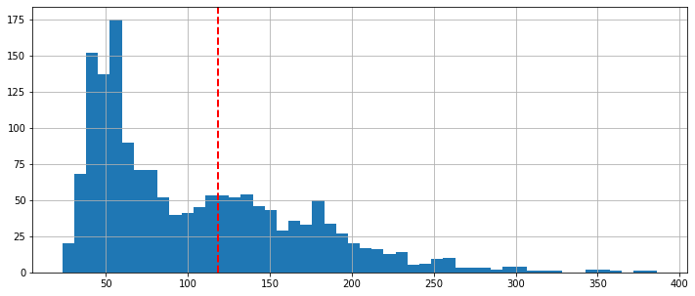

The frequency distribution of the closing price of litecoin is observed in the histogram plot above. The positive skew is an indication that the close price of litecoin had a tendency of being approximately $50.

**Binance coin**

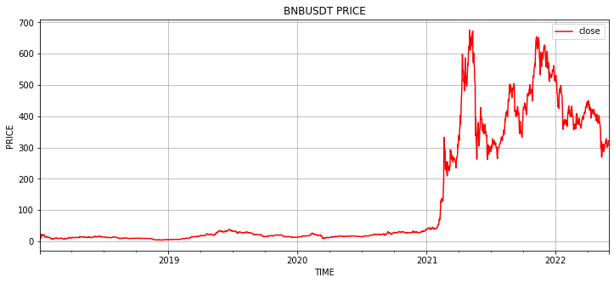

A similar price trend is observed in the price action of the BNB-USDT pair. The price of BNB-USDT, however, was observed to have piqued at approximately $35 towards the end of june 2019. A strong continuous downtrend is observed to have persisted until the end of march 2020,where the price reverted to its $10 price before the bullish markets. As with the close price of bitcoin, that of binance coin began to strongly trend upwards toward the end of april 2020. The following 200% price increase from $10 to $30 was greater than that of litecoin, but less than the bitcoin price increase. Theories of finance continued to increase rapidly from 2021 onward;from approximately $30 to $600; a 1900% increase.The price of BNB decreased to $300 in the following months; a 50% decrease.This goes to demonstrate the volatility of BNB coin. The box plot tells the same story, but from a different perspective. We can see from the box plot, that the close price of BNB-USD crypto trading pair had been in the range of $37 to $300 for the majority of the stipulated period

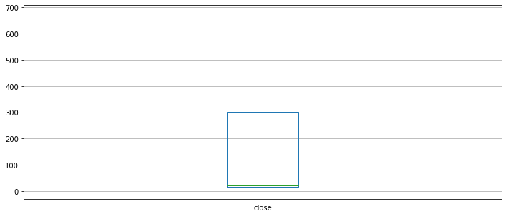

**Polkadot**

Starting from mid-august 2020, the closing price of polkadot was observed to be in an uptrend. The uptrend was observed to have peaked at $60 toward the end of august 2018; a 100% increase.For the remainder of the trading days, the price was bounded by the range of $40 to $60.

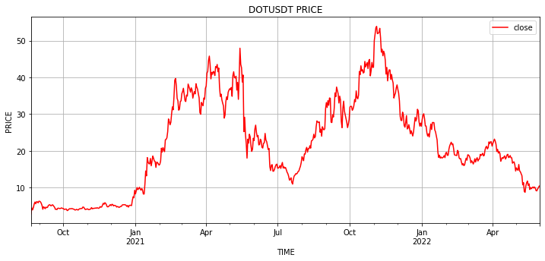

A more detailed perspective of the close price action is shown in the boxplot below. From the green highlighted line in the figure, it can be observed that on average, the closing price of polkadot was approximately $44.



It could, thus, be argued that for the period of (approximately) september 2018 to December 2018, the fair-value price of polkadot was approximately $45.

**Ethereum**

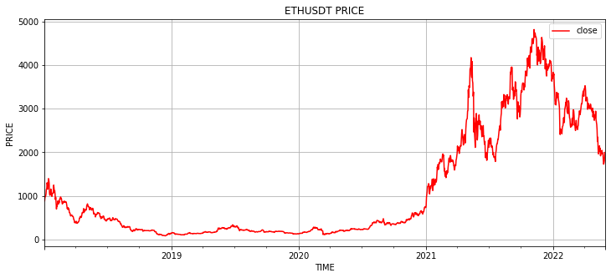

From the generated time-series plot above, it can be observed that the closing price of ethereum trended in a similar way to that of bitcoin and the other cryptocurrencies. With a minor downtrend beginning at the end of September, until $100, the close price of ethereum had a similar minor peak of $300.As with bitcoin, the 200% price increase was nearly reversed by the following -66.6% price decrease in the following months. Shortly after reaching the all-time low price of $100 however, the price of ethereum increased by a staggering %500 increase to $600. The following months we observed to have followed a similar pattern of volatility.

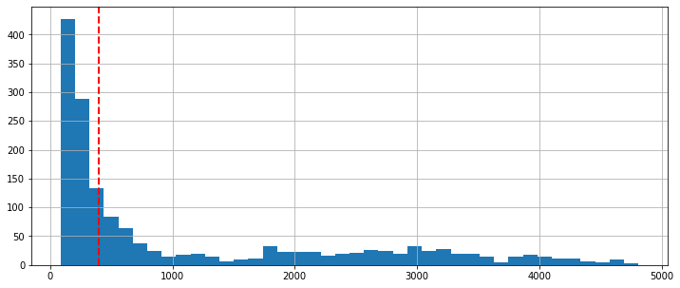

The frequency distribution of the ethereum close price is shown in the above figure.The frequency distribution is observed to be right skewed. Furthermore, the boxplot below was used to provide more insight into the nature of the ethereum close price trend over the stipulated period. From the figure, it can be observed that the median price of ethereum was approximately $500(highlighted by the green line). The minimum price was roughly below $100 while the maximum was approximately $3,800.

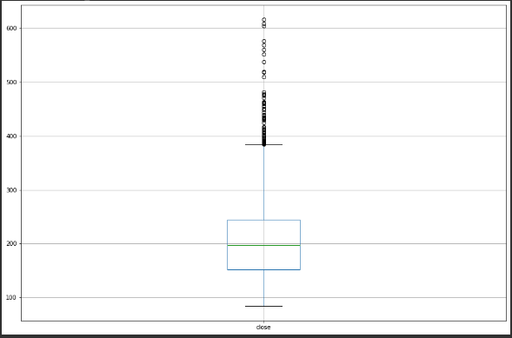

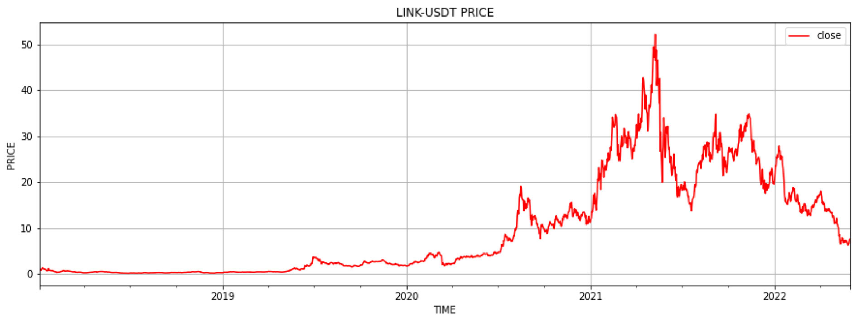

The close price trend of chain link was unlike the other cryptocurrencies. In the beginning of 2019, little to no price fluctuations are observed in the close price of LINK-USDT. Towards the beginning of 2021, however, athe price of LINK reached its all time high values of approximately $50

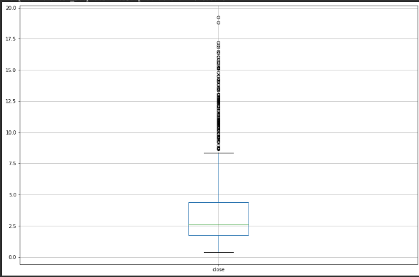

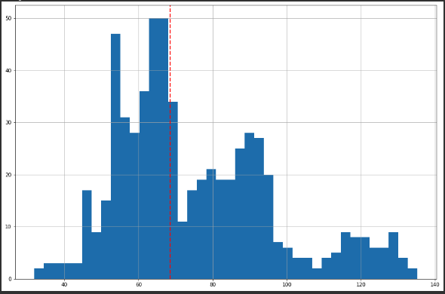

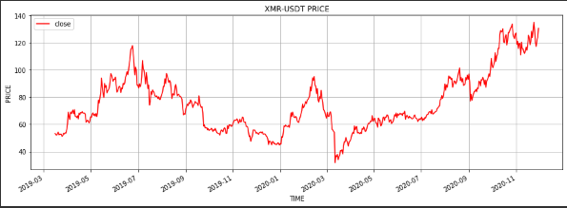

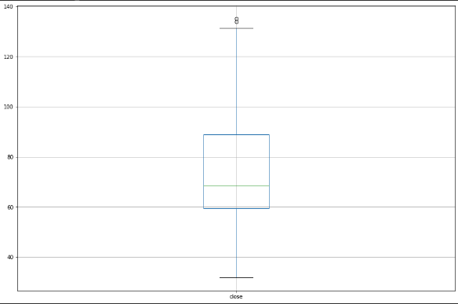

The generated box plot confirms that the average close price of Monero (XRM) was in the range of $60 to approximately $85. The more recent recorded observations that were above the minor peak price of $1

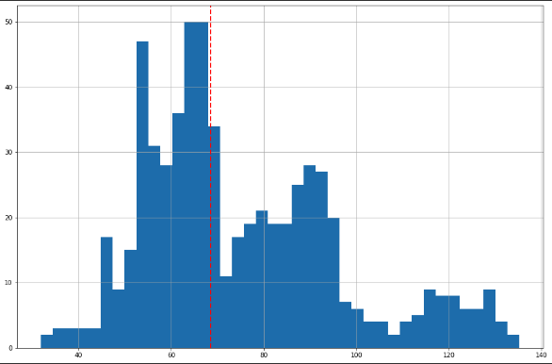

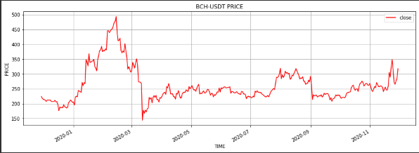

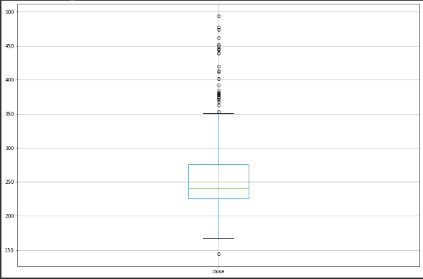

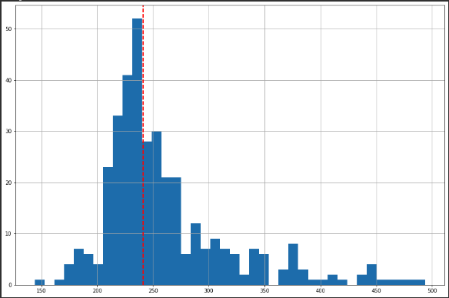

### **5.4.3 Multivariate Time Series Analysis**

Attempting to plot the clos price of each cryptocurrency on the same axis resulted in the following plot;

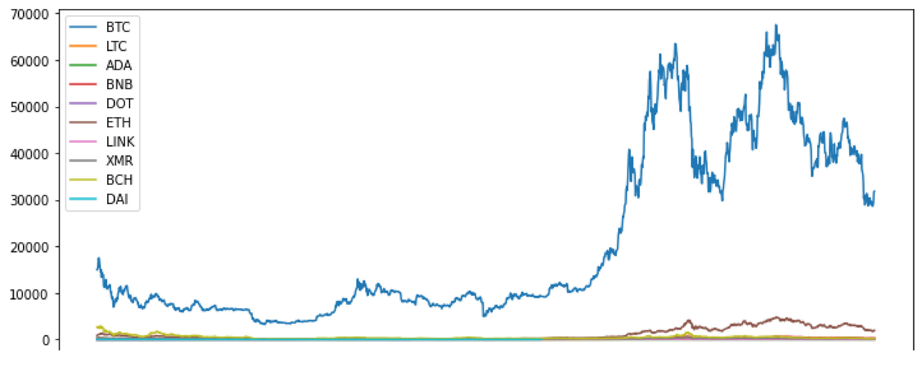

As stated in the earlier portions of this document, this is mainly because the price of bitcoin has experienced fluctuations of greater magnitude in comparison to the other cryptocurrencies, hence there was a need for performing an independent analysis of each cryptocurrency. To achieve this, a filter was applied to the dataframe, selecting only the closing price of each;

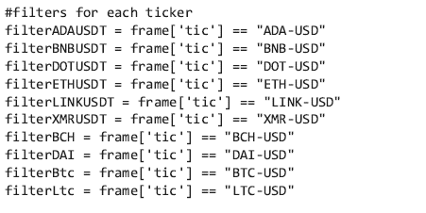

By applying the filters to the respective tickets, the analyst was able to create a data frame consisting of only the close prices of the cryptocurrencies. The filtered data frames were then plotted on 3 different axes

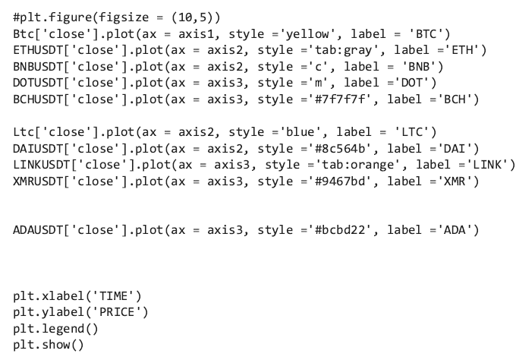

Its observable, from the figure below that the daily close prices of the cryptocurrencies tend to fluctuate in synchrony

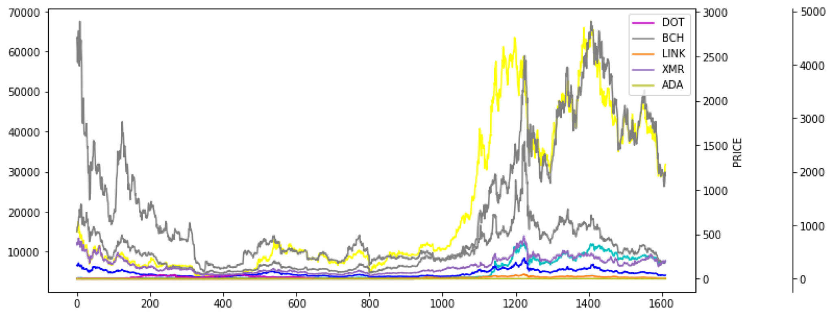

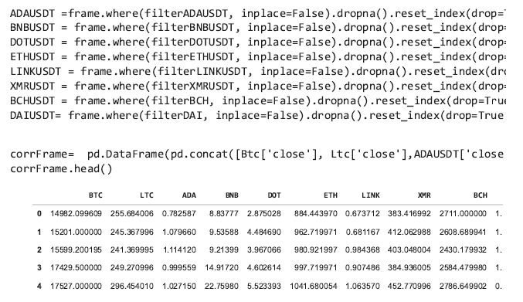

Creating a close price dataframe

The new dataframe, as shown in the above figure, consisted of only the close price with the respective ticker symbol as the column name.The correlation between the close price of each variable in the dataset was calculated using the pandas .corr() method.A visual representation of the correlations shows,more vividly, the correlations between the close prices of all the cryptocurrencies.The brighter colored regions represent very high correlations between the pairs. Furthermore, a correlation of 1 implies that the pair has a n extremely strong positive correlation. On the other extreme of the correlation scale was -6; a completely negative correlation.

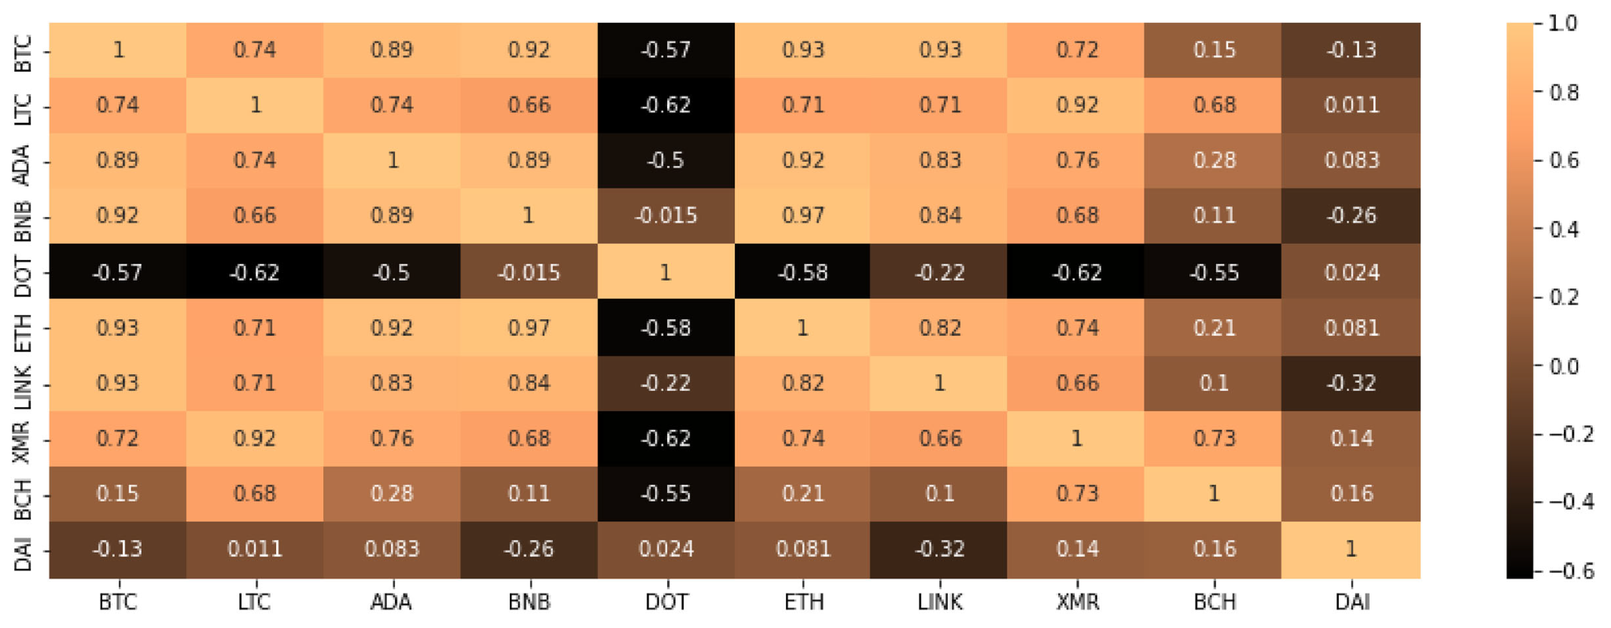

As is observable in the above figure, the majority of cryptocurrencies had a correlation more than 0.7, with the exception of DAI and BCH which had correlations of 0.13 ad 0.15(respectively). Another particularly significant observation was that DOT (Poolkadot) had a negative correlation (-0.57) with BTC(Bitcoin). Hence , based on the above correlation plot, the analyst concluded that when the price of bitcoin rose, that of the other cryptocurrencies, except DOT(Polkadot) rose. The negative correlation between bitcoin and polkadot implies that an increase in the bitcoin price followed a decrease in the price of polkadot. Plotting the different cryptocurrencies on different axes provides a more visual representation of this phenomenon;



## **5.5 Data Extraction**

Once the processing was complete, the data was split into train and trade data using the following parameters;

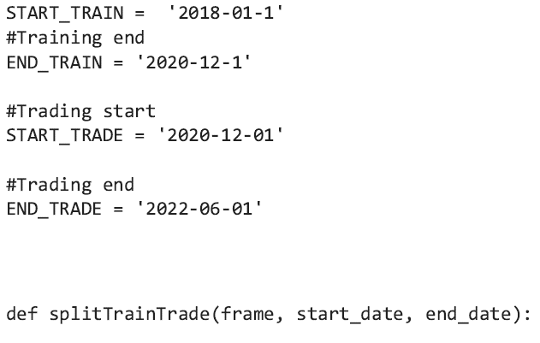

When passed to the defined splitTrainTrade method, the dataset was partitioned based on the input start and end date. That is, observations from 01-01-28, were designated to model training, whereas , the observations from 2020-12-01 to 2022-06-01, were used for model evaluation through simulated trading. The rationale behind the selected training and trading period will allow for more robust DRL learning, since, included in the environment were both uptrending and downtrending periods.The splitTrainTrade method was also used to sort and index the data based on the factored date

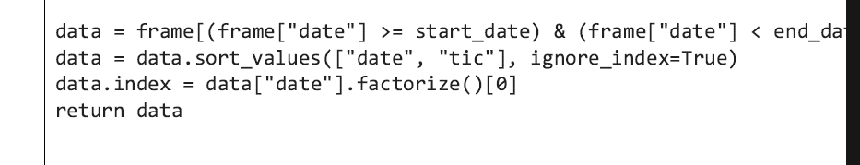

The cleaned data was then split into train and trade data and exported using the pandas .to_csv() method;

**5.6 DRL Environment Building**

A simulation of the environment was based on variables such as open price, close price, portfolio value et cetera, hence, the train data was imported;

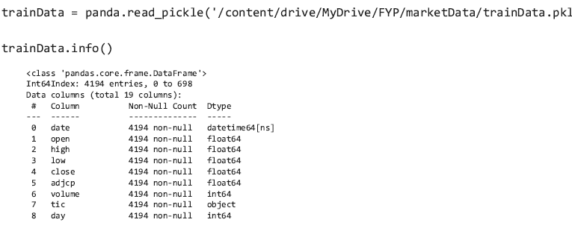

It is from this data that the different environment states, observations and rewards are to be generated by the DRL agents.

### **5.6.1 Cryptocurrency Portfolio Allocation Environment**

The portfolio allocation environment follows the openAI gym architecture, which requires a step() and reset() function. The environment was defined as a class that takes the train data as input in its constructor. Also included in the class constructor were variables such as the number of cryptocurrencies in the dataset( dimension), the maximum number of cryptocurrencies per allocation ( maxCryptos), the initial portfolio value (statingCapital), the transaction fee per buy/sell( transaction Percentage) , the state space size (state space), action space size (action_space), a list of technical indicators (indicator list), a lookback period (defaults to 365 for a cryptocurrency environment), as well as a value to control the increment of daily observations.

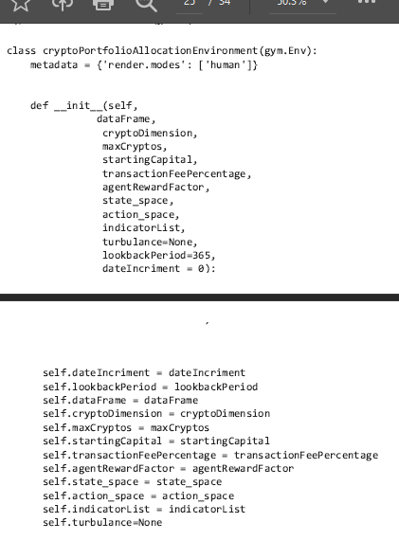

The environment is initialised by passing the data frame which contains the OHLC train data. Upon initialization, the reset() function is called by the agent class (to be discussed later), this initialises the environment to its initial state where the portfolio return history, state, date, action history et cetera are empty: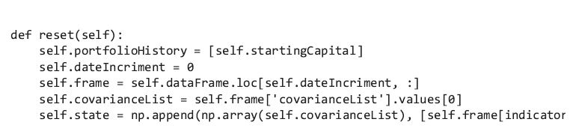

The renderMode function specifies how the gym environment should be rendered, which in this case, was set to ‘human’

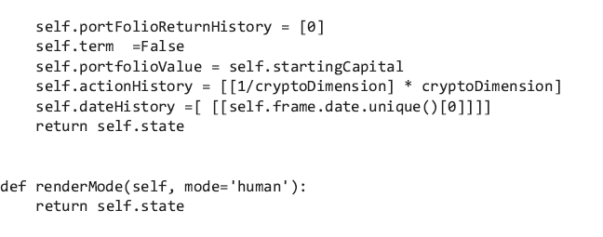

At each step, the agent calls the step function to perform the necessary action in the environment.The boolean class variable ‘term’ was returned by the agent upon training completion, this value was thus used to determine whether or not an action needed to be taken by the agent. The training process would also be halted once the entire database has been iterated through. In the case that an action is to be taken by the agent, the actions are normalised and used to represent the portfolio weight allocation. The actions and returns are then saved as history. The portfolio value is used as the reward, hence the reward was function was simply set as the new portfolio value after the action has been taken

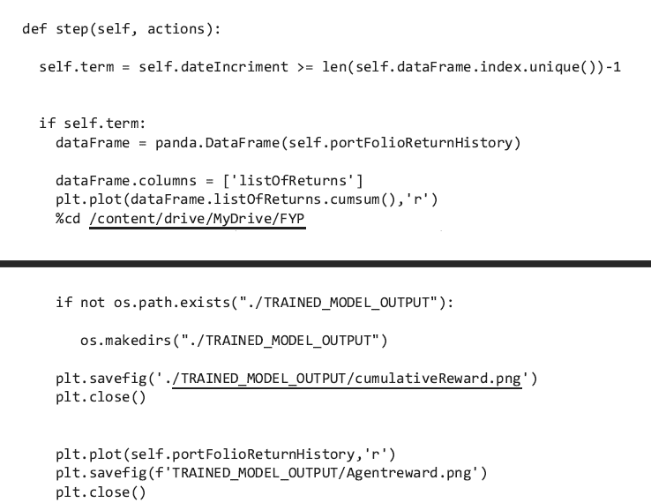

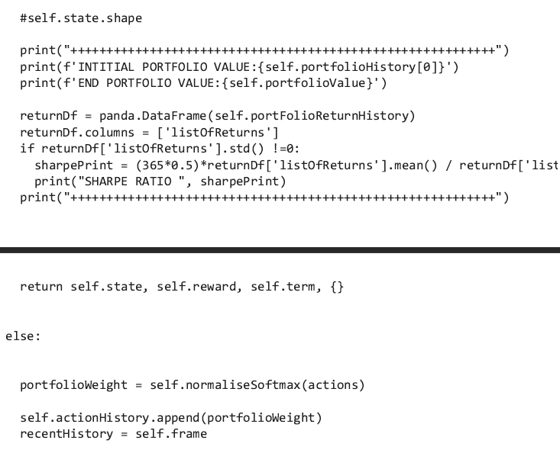

When the saveportfolioHist function is called, the portfolio history is returned as a dataframe 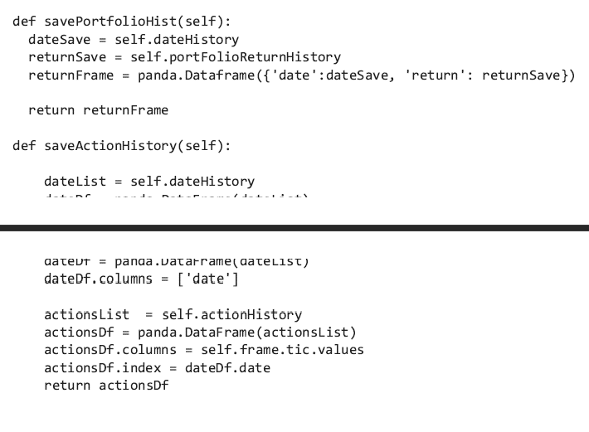

The same is true with the saveActionHistory function; it simply returns a dataframe containing the actions (portfolio weights) that were taken at each step, when called. Furthermore, the DummyvecEnv was used to vectorise the environment by calling the stableBaselineEnv method. It is in this function that the reset() method is called to get the initial observation of the environment.

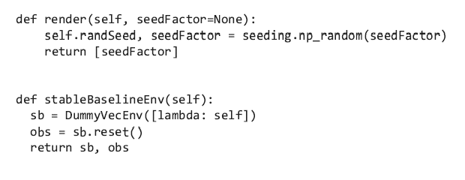

The aforementioned constructor variables were specified as a python dictionary as follows. It should be noted that the agentRewardFactor variable was not used in the reward reward function, but included for testing purposes.

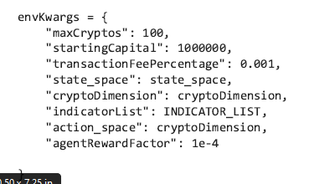

The environment was then initialised by passing the data frame and dictionary of key worded arguments;

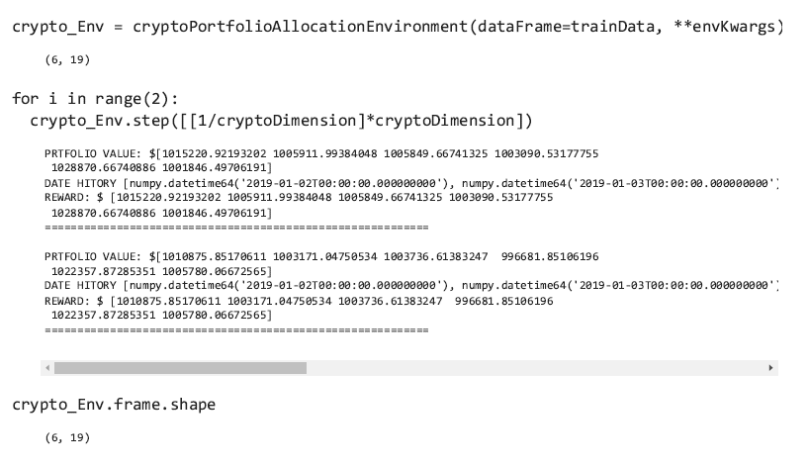

Thed developer ran a simple for loop to see what would result from taking 2 steps. Since the step method expects a list of actions, the developer passed a list to represents the portfolio weights. As demonstrated in the figure above, the portfolio value was initialised to the default starting capital ($1,000, 000), a sample reward was given, as well as the current date history. The agent’s observations, at each step consist of 6 close prices and 8 technical indicators, thus the developer verified that the observation space was shaped as such;

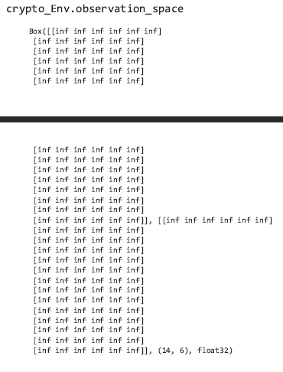

The observation was confirmed to be of shape(14,6). Furthermore, the developer confirmed that the shape and values of each state were in accordance with the observation space. This was achieved by calling the .state method on the environment class instance.

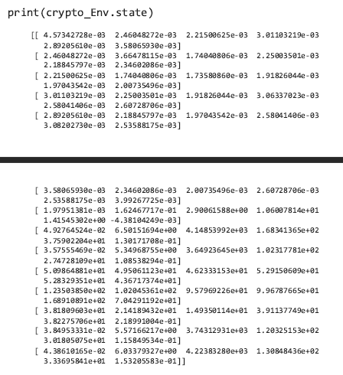

The shape and values of the sampled state were aligned with that of the observation space, thus, the developer proceeded to the model training phase.

**5.7 Modelling**

The PPO model algorithm from stablebaselines3 was used for the model implementation. Using the fin-rl Agent class, the developer specified the environment and input parameters of the PPO model;

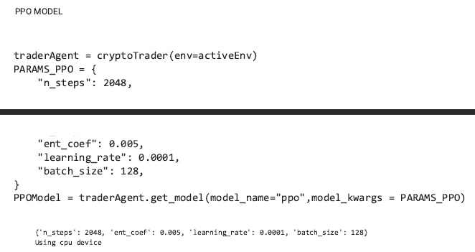

Because this is essentially an optimization problem, the learning rate was specified as one of the model hyoerparameters. The learning rate is the parameter that will determine the size of the steps that are taken by the agent as it progresses towards minimising the loss function. The learning rate was set to an arbitrary number (0.0001) which was assumed to be enough for the model to reduce the loss using stochastic gradient ascent. A summary of the model hyperparameters and their values is presented in the figure below;

| Model HyperParameter Name | Value | Descrition |
| --- | --- | --- |
| n_steps | 2048 | 1 step = 1 gradient update |
| enf_coef | 0.005 | Entropy coefficient: Measure of entropy |
| Learning_Rate | 0.0001 | Determines step size as learning happens |
| Bach Size | 128 | Number of training samples per iteration |

Ideally, hyper-parameter optimization would have been performed to find the model parameters that achieve the best results. Furthermore, to control the number of observations per iteration, the batch size is passed as an additional model hyper-parameter. The model was then trained by calling the .train_moddel of the agent instance. Upon doing so, the output of the training process is printed as the agent performs capital allocations.

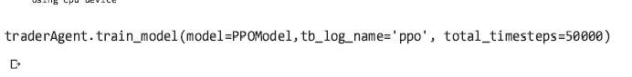

PPO Model Initialization And Training

The output of the training process is shown in the figure below;

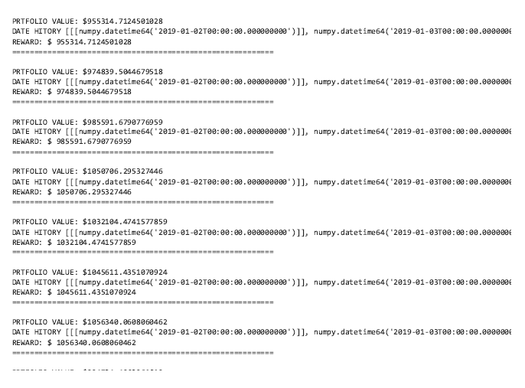

Similarly, the appropriate hyperparameters were passed to the DDPG model. A distinct DDPG model hyperparameter is the buffersize. The buffer size determines the maximum number of elements that are processed at once. Calling the train_model function begins the training process;

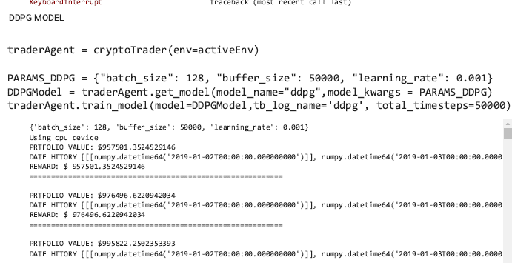

DDPG Model Initialization and Training

# **CHAPTER 6: RESULTS AND DISCUSSION**

# **6.1 Introduction**

This chapter contains a discussion on the results obtained from the experimental agent training process. Ideally, the 2 model implementations would have been deployed and optimised, but due to the time constraints, the developer was unable to do so. In this subsection, the results of the two models are evaluated and compared.

## **6.2 Model Evaluation**

The previously exported trade data was used to evaluate the model. If the model evaluation was based on the same data that was used to train the model, the evaluation results will be misleading. That is, to see how well a model generalises from the learning process, un-before seen data must be used for evaluation;

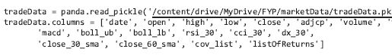

The model evaluation was performed by placing the trading agents in a new environment; using new data;

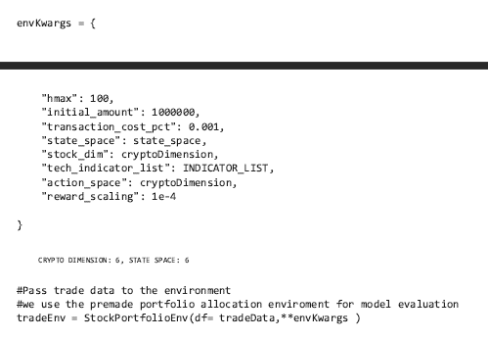

The pre-made environment was used for evaluation of the models. The output models from the training process were then imported for evaluation ;

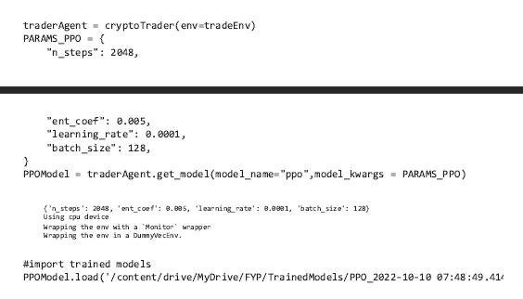Using the .DRL_prediction method returns the actions and returns data frames of the model throughout the test trading period. The two returned data frames were then exported as csv files for later analysis;

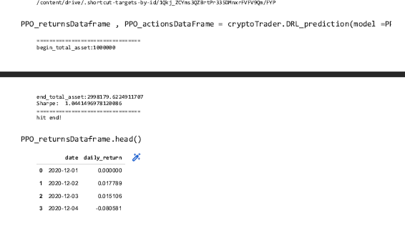

The model returns data frame was then used to generate the evaluation metrics such as sharpe ratio and maximum drawdown;

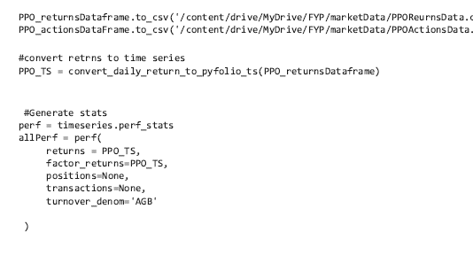

As seen in the figure below, the model was able to generate an annualised return of 65%, with a cumulative return of almost 200%. The sharpe ratio shows that the volatility adjusted return of the model was 1.004.

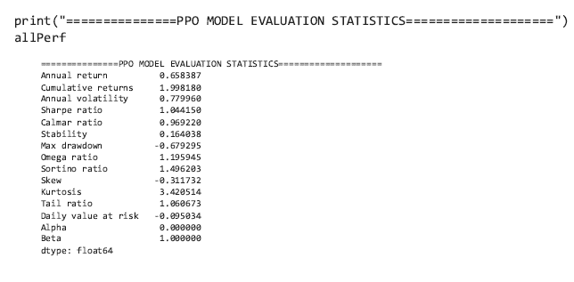

Similar steps were applied to evaluate the performance of the trained DDPG model;

The model was loaded, a prediction was made using the DRL_prediction method, and finally, the evaluation statistics we generated;

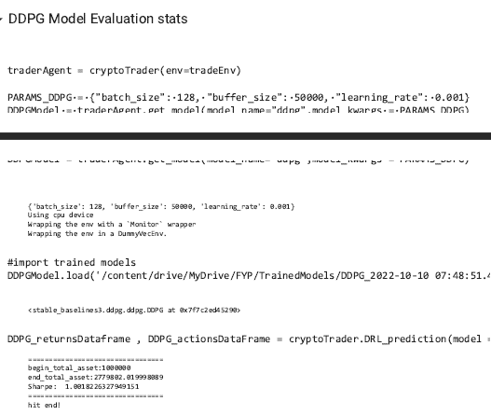

As seen in the figure below, the initial portfolio value of $1, 000, 000 increased to $2779802.0;

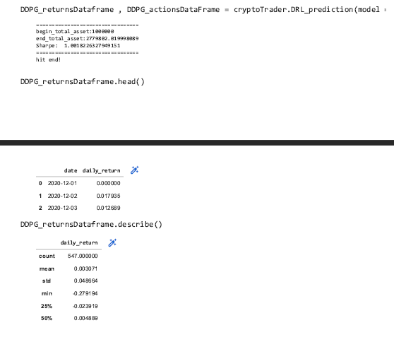

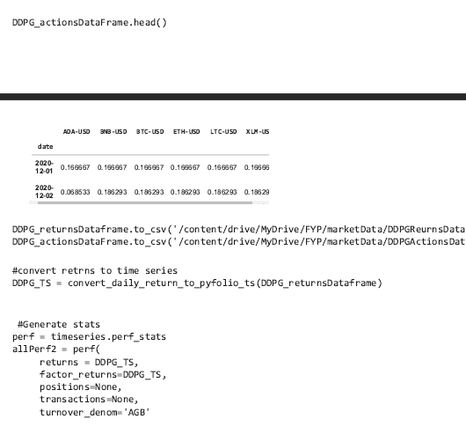

The generated evaluation statistics show that the model was able to produce a 60% annualised return, with a sharpe ratio of 1.00. Furthermore, he annualised volatility (0.7) was regarded as satisfactory since no optimisation has been carried out yet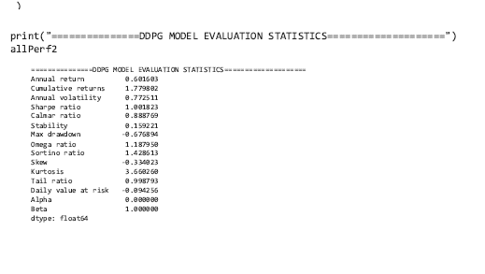

6.2 Results and discussion

The performance of the two models was not significantly different. For example, the sharpe ratio of the PPO model was 1.04, whereas that of the DDPG model was 1.001. Furthermore, the PPO model produced a slightly higher maximum drawdown of -0.679 than the DDPG model (-0.676).This signifies that even though the PPO model had greater returns, the volatility of the DDGP portfolio was less than that of the PPO model. Based on the obtained results, it was observed that if an investor were to allocate $1,000,000 to the DDPG model in january of 2018, their portfolio value would have increased to $2,998,171 by June of 2022.Furthermore, the results of the DDPG model indicate that an allocation of $1,000,000 would have resulted in a return of $2,779,602 using the trained DDPG model. The rewards and cumulative rewards of the two model implementations are compared in the figure below;

| **Model/Agent Name** | **Rewards** | **Cumulative reward** | **Sharpe Ratio** | **Max Drawdown** |
| --- | --- | --- | --- | --- |
| **PPO** |  |  | **1.04** | -0.679 |
| **DDPG** |  |  | 1.0018 | -0.68 |

Since the portfolio value was defined as the reward, the cumulative reward can be used to visualise the performance of the two models while allocating funds to a basket of cryptocurrencies. It can be observed, from the cumulative rewards of the two model training processes, that the DRL based portfolio had marginally less periods of drawdown.

**CHAPTER 7: CONCLUSIONS AND REFLECTIONS**

The term "decentralised finance" is neither legal nor technical. On the other hand, it is increasingly being used in discussions about the future of finance and its regulation. Decentralised finance was born as a result of cryptocurrencies such as Ethereum, which have since developed an ecosystem of decentralised applications. We propose the use of decentralised finance in the project due to its open nature. Furthermore, several researchers have disproved the validity of the efficient market hypothesis. It was also concluded, using the correlation heatmap, that although most of the cryptocurrencies had a strong positive correlation with bitcoin, there were some cryptocurrencies such as polkadot that had a strong negative correlation. The aforementioned is evidence that cryptocurrencies can in fact be used for portfolio diversification. The two model implementations were then evaluated in terms of the max drawdown and shape ratio. Of the two model implementations, the PPO model had produced greatest returns, but with less stability than the DDPG model.It was concluded from the implementation results that a portfolio allocation of $1,000,000 to the DDPG model in january of 2018, their portfolio value would have increased to $2,998,171 by June of 2022.Furthermore, the results of the DDPG model indicate that an allocation of $1,000,000 would have resulted in a return of $2,779,602 using the trained DDPG model. The model hyper-parameters were, however, selected arbitrarily , hence, there is room for improvement in model accuracy through hyperparameter optimization. Furthermore, the model results can be improved by including more attributes in the state space. For example, the price of gold or a new announcement are two commonly used features. Another limitation was the number of records on the dataset. Perhaps a more granular approach, using smaller time frames would result in better model results

# REFERENCES

Bellman, R. (1957). A Markovian Decision Process. Indiana University Mathematics Journal, 6(4), 679-684. https://doi.org/10.1512/iumj.1957.6.56038

Benhamou, E., Saltiel, D., Ungari, S., & Mukhopadhyay, A. (2020). Bridging the Gap Between Markowitz Planning and Deep Reinforcement Learning. SSRN Electronic Journal, 1-10. https://doi.org/10.2139/ssrn.3702112

Boyd, S. (2017). Multi-Period Trading via Convex Optimization. Foundations And Trends® In Optimization, 3(1), 1-76. https://doi.org/10.1561/2400000023

Fundamentals of Reinforcement Learning: Markov Decision Processes .... Retrieved 29 May 2022, from https://medium.com/gradientcrescent/fundamentals-of-reinforcement-learning-markov-decision-processes-policies-value-functions-94f7389e1e82.

Grinblatt, Mark, Titman, Sheridan and Wermers, Russell, (1995), Momentum Investment Strategies, Portfolio Performance, and Herding: A Study of Mutual Fund Behaviour, American Economic Review, 85, issue 5, p. 1088-1105, https://EconPapers.repec.org/RePEc:aea:aecrev:v:85:y:1995:i:5:p:1088-1105

Guan, M., & Liu, X. (2022). Explainable Deep Reinforcement Learning for Portfolio Management: An Empirical Approach. SSRN Electronic Journal, 1-9. https://doi.org/10.2139/ssrn.4061958

Guan, M., & Liu, X. (2022). Explainable Deep Reinforcement Learning for Portfolio Management: An Empirical Approach. SSRN Electronic Journal. https://doi.org/10.2139/ssrn.4061958

Jarvis, S., Lawrence, A., & Miao, S. (2009). Dynamic Asset Allocation Techniques. British Actuarial Journal, 15(3), 573-655. https://doi.org/10.1017/s1357321700005742

Jones, C. (2017). Modern Portfolio Theory, Digital Portfolio Theory and Intertemporal Portfolio Choice. SSRN Electronic Journal. https://doi.org/10.2139/ssrn.2956060

Li, Q., Chen, Y., Jiang, L., Li, P., & Chen, H. (2016). A Tensor-Based Information Framework for Predicting the Stock Market. ACM Transactions On Information Systems, 34(2), 1-30. https://doi.org/10.1145/2838731

Markov Decision Process - an overview | ScienceDirect Topics. Retrieved 29 May 2022, from https://www.sciencedirect.com/topics/computer-science/markov-decision-process.

Markov decision process - Cornell University Computational Optimization .... Retrieved 29 May 2022, from https://optimization.cbe.cornell.edu/index.php?title=Markov_decision_process.

Markov Decision Processes — Learning Some Math - Medium. Retrieved 29 May 2022, from https://medium.datadriveninvestor.com/markov-decision-processes-learning-some-math-b82448169927.

Markov Decision Processes. (An Introduction to Reinforcement… | by .... Retrieved 29 May 2022, from https://studentsxstudents.com/markov-decision-processes-1faa3f4c94ab.

Muralidhar, A. (2014). Modern Prospect Theory: The Missing Link Between Modern Portfolio Theory and Prospect Theory. SSRN Electronic Journal. https://doi.org/10.2139/ssrn.2492603

Pinelis, M., & Ruppert, D. (2020). Machine Learning Portfolio Allocation. SSRN Electronic Journal. https://doi.org/10.2139/ssrn.3546294

Platanakis, E., & Urquhart, A. (2018). Portfolio Management with Cryptocurrencies: The Role of Estimation Risk. SSRN Electronic Journal, 1-80. https://doi.org/10.2139/ssrn.3287176

Reinforcement Learning : Markov-Decision Process (Part 1). Retrieved 29 May 2022, from https://towardsdatascience.com/introduction-to-reinforcement-learning-markov-decision-process-44c533ebf8da.

Sutton, R. (1997). On the significance of Markov decision processes. Lecture Notes In Computer Science, 273-282. https://doi.org/10.1007/bfb0020167

Understanding Markov Decision Process (MDP) - Medium. Retrieved 29 May 2022, from https://towardsdatascience.com/understanding-the-markov-decision-process-mdp-8f838510f150.

Sadriu, L. (2022, January). Deep Reinforcement Learning Approach to Portfolio Optimization. https://lup.lub.lu.se/luur/download?func=downloadFile&recordOId=9071680&fileOId=9071681

).

Boyd, S. (2017). Multi-Period Trading via Convex Optimization. Foundations And Trends® In Optimization, 3(1), 1-76. https://doi.org/10.1561/2400000023

https://www.emerald.com/insight/content/doi/10.1108/MEDAR-11-2017-0241/full/html

Markowitz, H.: Portfolio selection. J. Finance 7, 77–91 (1952)

Reyes, A., Sucar, L. E., Ibargüengoytia, P. H., & Morales, E. F. (2020). Planning Under Uncertainty Applications in Power Plants Using Factored Markov Decision Processes. Energies, 13(9), 2302. MDPI AG. Retrieved from http://dx.doi.org/10.3390/en13092302

https:

https://link.springer.com/book/10.1007/978-3-658-29779-4?noAccess=true

Platanakis, Emmanouil, Charles Sutcliffe, and Andrew Urquhart. 2018. Optimal vs naive diversification in cryptocurrencies. Economics Letters 171: 93–96.

Recent Advances in Reinforcement Learning in Finance

https://arxiv.org/pdf/2112.04553.pdf

Sutton, R. (1997). On the significance of Markov decision processes. Lecture Notes In Computer Science, 273-282. https://doi.org/10.1007/bfb0020167

Portfolio Optimalization on Digital Currency Market - MDPIhttps://www.mdpi.com › pdf

Platanakis, E., & Urquhart, A. (2018). Portfolio Management with Cryptocurrencies: The Role of Estimation Risk. SSRN Electronic Journal, 1-80. https://doi.org/10.2139/ssrn.3287176

Burns, T. (2001). Effective unit testing. Ubiquity, 2001(January), 1. https://doi.org/10.1145/358974.358976

Chan, E. Quantitative trading (pp. 10-50). Wiley.

Derbentsev, Vasily & Datsenko, Natalia & Stepanenko, Olga & Bezkorovainyi, Vitaly. (2019). Forecasting cryptocurrency prices time series using machine learning approach. SHS Web of Conferences. 65. 02001. 10.1051/shsconf/20196502001.

Galar, Zbigniew. (2018). Distributed ledger technology (blockchain) as an instrument of decentralized management.

Mary L. Cummings and Songpo Li. 2021. Subjectivity in the Creation of Machine Learning Models. Data and Information Quality 13, 2,. https://doi.org/10.1145/3418034

Aliyev, N., Huseynov, F., & Rzayev, K. (2021). Does algorithmic trading impact investment? Algorithmic trading and investment-to-price sensitivity. SSRN Electronic Journal.

Bellman, R. (1957). A Markovian Decision Process. Indiana University Mathematics Journal, 6(4), 679-684. https://doi.org/10.1512/iumj.1957.6.56038

Guide to Project Integration Management (7 Step Process) • Asana. Asana. (2022). Retrieved 25 March 2022, from https://asana.com/resources/project-integration-management.

https://techcrunch.com/2021/12/08/how-should-we-regulate-defi/

Inmon, W. (2015). Big Data. MarketLine, a Progressive Digital Media business.

Jarvis, S., Lawrence, A., & Miao, S. (2009). Dynamic Asset Allocation Techniques. British Actuarial Journal, 15(3), 573-655. https://doi.org/10.1017/s1357321700005742

Lewis, R., Graham, D., Watson, J., & Lunniss, P. (2012). Learning the hard way: the importance of accurate data. Colorectal Disease, 14(8), 1015-1018. https://doi.org/10.1111/j.1463-1318.2012.02981.x

Millea, A. (2021). Deep Reinforcement Learning for Trading—A Critical Survey. Data, 6(11), 119. https://doi.org/10.3390/data6110119

Niszczota, P., & Kaszás, D. (2020). Robo-investment aversion. PloS one, 15(9), e0239277. https://doi.org/10.1371/journal.pone.0239277

https://www.mdpi.com/2306-5729/6/11/119

Reilly, F. Investment Analysis & Portfolio Management (1st ed., pp. 4-10).

Objective vs Subjective Trading. Corporate Finance Institute. (2022). Retrieved 28 March 2022, from https://corporatefinanceinstitute.com/resources/knowledge/trading-investing/objective-vs-subjective-trading/.

Saito, S., Yang, W., & Shanmugamani, R. (2018). Python reinforcement learning projects. Packt Publishing Ltd.

Robinson, K. (2013). Technical Analysis: Does Recent Market Data Substantiate the Efficient Market Hypothesis?. SSRN Electronic Journal. https://doi.org/10.2139/ssrn.3093251

Wamba SF, et al. Big data analytics and firm performance: effects of dynamic capabilities. J Bus Res. 2017;70:356–65.

Liu, X., Yang, H., Gao, J., & Wang, C. (2021). FinRL: Deep Reinforcement Learning Framework to Automate Trading in Quantitative Finance. SSRN Electronic Journal, 1-8. https://doi.org/10.2139/ssrn.3955949

​​Aliyev, N., Huseynov, F., & Rzayev, K. (2021). Does algorithmic trading impact investment? Algorithmic trading and investment-to-price sensitivity. SSRN Electronic Journal.

Bellman, R. (1957). A Markovian Decision Process. Indiana University Mathematics Journal, 6(4), 679-684. https://doi.org/10.1512/iumj.1957.6.56038

Guide to Project Integration Management (7 Step Process) • Asana. Asana. (2022). Retrieved 25 March 2022, from https://asana.com/resources/project-integration-management.

https://techcrunch.com/2021/12/08/how-should-we-regulate-defi/

Inmon, W. (2015). Big Data. MarketLine, a Progressive Digital Media business.

Jarvis, S., Lawrence, A., & Miao, S. (2009). Dynamic Asset Allocation Techniques. British Actuarial Journal, 15(3), 573-655. https://doi.org/10.1017/s1357321700005742

Lewis, R., Graham, D., Watson, J., & Lunniss, P. (2012). Learning the hard way: the importance of accurate data. Colorectal Disease, 14(8), 1015-1018. https://doi.org/10.1111/j.1463-1318.2012.02981.x

Millea, A. (2021). Deep Reinforcement Learning for Trading—A Critical Survey. Data, 6(11), 119. https://doi.org/10.3390/data6110119

Niszczota, P., & Kaszás, D. (2020). Robo-investment aversion. PloS one, 15(9), e0239277. https://doi.org/10.1371/journal.pone.0239277

https://www.mdpi.com/2306-5729/6/11/119

Reilly, F. Investment Analysis & Portfolio Management (1st ed., pp. 4-10).

Objective vs Subjective Trading. Corporate Finance Institute. (2022). Retrieved 28 March 2022, from https://corporatefinanceinstitute.com/resources/knowledge/trading-investing/objective-vs-subjective-trading/.

Saito, S., Yang, W., & Shanmugamani, R. (2018). Python reinforcement learning projects. Packt Publishing Ltd.

Robinson, K. (2013). Technical Analysis: Does Recent Market Data Substantiate the Efficient Market Hypothesis?. SSRN Electronic Journal. https://doi.org/10.2139/ssrn.3093251

Wamba SF, et al. Big data analytics and firm performance: effects of dynamic capabilities. J Bus Res. 2017;70:356–65.

Liu, X., Yang, H., Gao, J., & Wang, C. (2021). FinRL: Deep Reinforcement Learning Framework to Automate Trading in Quantitative Finance. SSRN Electronic Journal, 1-8. https://doi.org/10.2139/ssrn.3955949

Hambly, Ben M. and Xu, Renyuan and Yang, Huining, Recent Advances in Reinforcement Learning in Finance (November 24, 2021). Available at SSRN: https://ssrn.com/abstract=3971071 or http://dx.doi.org/10.2139/ssrn.3971071

Jones C. Modern Portfolio Theory, Digital Portfolio Theory and Intertemporal Portfolio Choice. American Journal of Industrial and Business Management. 2017;07(07):833-854. doi:10.4236/ajibm.2017.77059

Muralidhar A. Modern Prospect Theory: The Missing Link Between Modern Portfolio Theory and Prospect Theory. SSRN Electronic Journal. 2014:2-32. doi:10.2139/ssrn.2492603

Petukhina A, Trimborn S, Härdle W, Elendner H. Investing With Cryptocurrencies – Evaluating the Potential of Portfolio Allocation Strategies. SSRN Electronic Journal. 2018:2-19. doi:10.2139/ssrn.3274193

Mazzoni T. Modern Portfolio Theory. A First Course in Quantitative Finance.:100-119. doi:10.1017/9781108303606.006

Asawa Y. Modern Machine Learning Solutions for Portfolio Selection. IEEE Engineering Management Review. 2022;50(1):94-112. doi:10.1109/emr.2021.3131158

Schneider P, Xhafa F. Machine learning. Anomaly Detection and Complex Event Processing over IoT Data Streams. 2022:149-191. doi:10.1016/b978-0-12-823818-9.00019-5

Shen Y, Liu T, Liu W, Xu R, Li Z, Wang J. Deep Reinforcement Learning for Stock Recommendation. Journal of Physics: Conference Series. 2021;2050(1):012012. doi:10.1088/1742-6596/2050/1/012012

Ghasemieh A, Kashef R. Deep Learning Vs. Machine Learning in Predicting the Future Trend of Stock Market Prices. 2021 IEEE International Conference on Systems, Man, and Cybernetics (SMC). 2021. doi:10.1109/smc52423.2021.9658938

Qiu Y, Liu R, Lee R. The Design and Implementation of Quantum Finance-based Hybrid Deep Reinforcement Learning Portfolio Investment System. Journal of Physics: Conference Series. 2021;1828(1):012011. doi:10.1088/1742-6596/1828/1/012011

Lyu L, Shen Y, Zhang S. The Advance of Reinforcement Learning and Deep Reinforcement Learning. 2022 IEEE International Conference on Electrical Engineering, Big Data and Algorithms (EEBDA). 2022. doi:10.1109/eebda53927.2022.9744760

Benhamou E, Saltiel D, Ohana J, Atif J, Laraki R. Deep Reinforcement Learning (DRL) for Portfolio Allocation. Machine Learning and Knowledge Discovery in Databases Applied Data Science and Demo Track. 2021:527-531. doi:10.1007/978-3-030-67670-4_32

Kim H. Reinforcement Learning. Artificial Intelligence for 6G. 2022:183-246. doi:10.1007/978-3-030-95041-5_5

Bergel A. Reinforcement Learning. Agile Visualization with Pharo. 2021:203-232. doi:10.1007/978-1-4842-7161-2_14

Teoh T, Rong Z. Getting Started. Machine Learning: Foundations, Methodologies, and Applications. 2022:9-26. doi:10.1007/978-981-16-8615-3_2

Lyu L, Shen Y, Zhang S. The Advance of Reinforcement Learning and Deep Reinforcement Learning. 2022 IEEE International Conference on Electrical Engineering, Big Data and Algorithms (EEBDA). 2022. doi:10.1109/eebda53927.2022.9744760

Benhamou, E., Saltiel, D., Ohana, J., Atif, J., & Laraki, R. (2021). Deep Reinforcement Learning (DRL) for Portfolio Allocation. Machine Learning And Knowledge Discovery In Databases. Applied Data Science And Demo Track, 527-531. https://doi.org/10.1007/978-3-030-67670-4_32

Calvo-Pardo, H., Oliver, X., & Arrondel, L. (2021). Subjective Return Expectations, Perceptions, and Portfolio Choice. Journal Of Risk And Financial Management, 15(1), 6. https://doi.org/10.3390/jrfm15010006

Carr, A. (2022). Emotional intelligence. Positive Psychology, 161-205. https://doi.org/10.4324/9781003082866-5

DePamphilis, D. (2022). Applying financial models. Mergers, Acquisitions, And Other Restructuring Activities, 393-426. https://doi.org/10.1016/b978-0-12-819782-0.00015-0

El-Chaarani, H. (2016). Exploring the impact of emotional intelligence on portfolio performance. Humanomics, 32(4), 474-497. https://doi.org/10.1108/h-02-2016-0012

Humayun, M., & Belk, R. (2018). “Satoshi is Dead. Long Live Satoshi”: The Curious Case of Bitcoin’s Creator. Research In Consumer Behavior, 19-35. https://doi.org/10.1108/s0885-211120180000019002

Mohamadi, F. (2021). Asset and Portfolio Management. Introduction To Project Finance In Renewable Energy Infrastructure, 179-192. https://doi.org/10.1007/978-3-030-68740-3_14

Nicolás, C. (2018). The 2008 financial crisis. Monetary Equilibrium And Nominal Income Targeting, 89-107. https://doi.org/10.4324/9781315444604-7

Pinelis, M., & Ruppert, D. (2022). Machine learning portfolio allocation. The Journal Of Finance And Data Science, 8, 35-54. https://doi.org/10.1016/j.jfds.2021.12.001

Sacharny, D., & Henderson, T. (2022). Agent Based Modeling and Simulation. Lane-Based Unmanned Aircraft Systems Traffic Management, 121-134. https://doi.org/10.1007/978-3-030-98574-5_8

Sak, H., Huang, T., & Chng, M. (2018). Rise of the Machine-Learning Portfolio. SSRN Electronic Journal. https://doi.org/10.2139/ssrn.3202277

Sibirskaya, E., Lyapina, I., Ushakova, I., Makarova, T., & Lebedeva, O. (2017). Statistical Modeling of Portfolio Profitability. Contributions To Economics, 367-373. https://doi.org/10.1007/978-3-319-55257-6_48

Srivastava, A. (2021). A Study on the Impact and Potential of Cryptocurrency. https://doi.org/10.14293/s2199-1006.1.sor-.pp86nln.v1

Wang, C. (2020). On Objectivity, Subjectivity, and Probability. Sense And Nonsense Of Statistical Inference, 137-184. https://doi.org/10.1201/9781003067016-7

Zhang, Z., Zohren, S., & Roberts, S. (2020). Deep Reinforcement Learning for Trading. The Journal Of Financial Data Science, 2(2), 25-40. https://doi.org/10.3905/jfds.2020.1.030

References

Al-Aradi, A., & Jaimungal, S. (2018). Outperformance and Tracking: Dynamic Asset Allocation for Active and Passive Portfolio Management. Applied Mathematical Finance, 25(3), 268-294. https://doi.org/10.1080/1350486x.2018.1507751

Al-Aradi, A., & Jaimungal, S. (2021). Active and passive portfolio management with latent factors. Quantitative Finance, 21(9), 1437-1459. https://doi.org/10.1080/14697688.2021.1881598

Ang, C. (2020). Risk-Adjusted Portfolio Performance Measures. Springer Texts In Business And Economics, 185-195. https://doi.org/10.1007/978-3-030-64155-9_6

Fernández-Vázquez, S., Rosillo, R., De La Fuente, D., & Priore, P. (2021). Blockchain and Smart Contracts: A Revolution. Lecture Notes In Management And Industrial Engineering, 29-36. https://doi.org/10.1007/978-3-030-67708-4_4

Kabiri, Y., & Sharifzadeh, M. (2022). Blockchain and Smart Contracts. Industry 4.0 Vision For Energy And Materials, 59-72. https://doi.org/10.1002/9781119695868.ch2

Kondrat, I., & Drala, R. (2019). PORTFOLIO MANAGEMENT WITH CRYPTOCURRENCIES. Market Infrastructure, (33). https://doi.org/10.32843/infrastruct33-43

Ozili, P. (2018). Impact of digital finance on financial inclusion and stability. Borsa Istanbul Review, 18(4), 329-340. https://doi.org/10.1016/j.bir.2017.12.003

Ramachandran, N., Shiju, N., Suresh, S., & Jain, A. (2022). Blockchain. Blockchain Technology, 1-12. https://doi.org/10.1201/9781003138082-1

Schoenmaker, D., & Schramade, W. (2019). Investing for long-term value creation. Journal Of Sustainable Finance &Amp; Investment, 9(4), 356-377. https://doi.org/10.1080/20430795.2019.1625012

Schueffel, P. (2021). DeFi: Decentralized Finance - An Introduction and Overview. Journal Of Innovation Management, 9(3), I-XI. https://doi.org/10.24840/2183-0606_009.003_0001

Seneque, P. (1979). The relationship between portfolio theory and the efficient market hypothesis. Investment Analysts Journal, 8(13), 17-21. https://doi.org/10.1080/10293523.1979.11082621

Singh, G., Gautam, S., Prachi, Verma, A., & Kaushal, T. (2021). Analysis of Blockchain Induced Cryptocurrency: Regulations and Challenges of Cryptocurrencies. Advances In Intelligent Systems And Computing, 553-564. https://doi.org/10.1007/978-981-15-9927-9_54

Urquhart, A., & Yarovaya, L. (2020). Introduction to cryptocurrencies. Cryptocurrency And Blockchain Technology, 1-8. https://doi.org/10.1515/9783110660807-001

van Oorschot, P. (2021). Bitcoin, Blockchains and Ethereum. Information Security And Cryptography, 375-409. https://doi.org/10.1007/978-3-030-83411-1_13

Zetzsche, D., Arner, D., & Buckley, R. (2020). Decentralized Finance. Journal Of Financial Regulation, 6(2), 172-203. <https://doi.org/10.1093/jfr/fjaa010>

Bajtelsmit, V. (2015). Efficient Markets Hypothesis. Wiley Encyclopedia Of Management, 1-2. https://doi.org/10.1002/9781118785317.weom080243

BINGOL, M. (2022). Evaluatıon of DDPG and PPO Algorıthms for Bıpedal Robot Control. Osmaniye Korkut Ata Üniversitesi Fen Bilimleri Enstitüsü Dergisi. https://doi.org/10.47495/okufbed.1031976

Chen, R., & Chen, C. (2022). Reinforcement Learning. Artificial Intelligence, 231-236. https://doi.org/10.1201/9781003214892-33

Folkers, A. (2019). Deep Reinforcement Learning. Steuerung Eines Autonomen Fahrzeugs Durch Deep Reinforcement Learning, 15-31. https://doi.org/10.1007/978-3-658-28886-0_3

Izquierdo, L., & Izquierdo, S. (2012). Reinforcement Learning. Encyclopedia Of The Sciences Of Learning, 2796-2799. https://doi.org/10.1007/978-1-4419-1428-6_567

Izquierdo, L., & Izquierdo, S. (2012). Reinforcement Learning. Encyclopedia Of The Sciences Of Learning, 2796-2799. https://doi.org/10.1007/978-1-4419-1428-6_567

Jia, Z., Gao, Q., & Peng, X. (2021). LSTM-DDPG for Trading with Variable Positions. Sensors, 21(19), 6571. https://doi.org/10.3390/s21196571

Lin, F., Wang, M., Liu, R., & Hong, Q. (2020). A DDPG Algorithm for Portfolio Management. 2020 19Th International Symposium On Distributed Computing And Applications For Business Engineering And Science (DCABES). https://doi.org/10.1109/dcabes50732.2020.00065

Lyu, D., Yang, F., Liu, B., & Yoon, D. (2019). Logic-Based Sequential Decision-Making. Proceedings Of The AAAI Conference On Artificial Intelligence, 33, 9995-9996. https://doi.org/10.1609/aaai.v33i01.33019995

Odermatt, L., Beqiraj, J., & Osterrieder, J. (2021). Deep Reinforcement Learning for Finance and the Efficient Market Hypothesis. SSRN Electronic Journal. https://doi.org/10.2139/ssrn.3865019

Qiu, Y., Liu, R., & Lee, R. (2021). The Design and Implementation of Quantum Finance-based Hybrid Deep Reinforcement Learning Portfolio Investment System. Journal Of Physics: Conference Series, 1828(1), 012011. https://doi.org/10.1088/1742-6596/1828/1/012011

Shin, Y. (2008). Bellman Equation. The New Palgrave Dictionary Of Economics, 1-3. https://doi.org/10.1057/978-1-349-95121-5_2392-1

Yu, F., & He, Y. (2019). Reinforcement Learning and Deep Reinforcement Learning. Deep Reinforcement Learning For Wireless Networks, 15-19. https://doi.org/10.1007/978-3-030-10546-4_2

Zhang, H., Wang, P., Ni, C., & Cheng, N. (2022). Deep Q network algorithm based on sample screening. International Conference On Computer Application And Information Security (ICCAIS 2021). https://doi.org/10.1117/12.2637373

Zhao, W., Jiang, H., & Xie, J. (2022). Fast Proximal Policy Optimization. Lecture Notes In Computer Science, 73-86. https://doi.org/10.1007/978-3-031-02444-3_6

# **APPENDICES**

## **FYP Poster**

## 

## 

## 

## 

## **Project log sheets**

| **Meeting date** | **Time From** | **Time To** | **Item for discussion** | **Record of discussion** | **Action List** |  |
| --- | --- | --- | --- | --- | --- | --- |
| 10/11/22 | 8:30 am | 9am | Final Document review | Missing ABSTRACT page  Table of Contents required page numbers - you can kindly search/google how the table of contents should be.  There should number of page.  Missing List of Tables page  Missing List of Figures page  Chapter 5 - some screenshots without explanations, must explain each of your screenshot, graph, diagram, result, etc.  Chapter 6 - very brief, should move evaluation results to this chapter 6. And discuss in detail.  Chapter 7 Conclusion - very brief, kindly add:  Explain how did you achieve the THREE project objectives stated in Chapter 1.  What are the limitations of your project?  What are future improvements you would suggest to overcome the stated limitations?  Missing ETHICS FORM page.  Overall formatting of your documents still not neat, why there are many highlighted parts? Kindly Fix it - see the below pictures.  These highlighted seen since your IR.  Start each chapter on a new fresh page.  Double check writing and fix all grammatical errors. | Tried to correct as recommended |  |

### **First Meeting log (FYP semester 1)**

## 

| **Meeting date** | **Time From** | **Time To** | **Item for discussion** | **Record of discussion** | **Action List** |  |
| --- | --- | --- | --- | --- | --- | --- |
| 10/03/2022 | **2:00** | **2:20** | -Can I develop a dashboard for data analytics | It is not enough to simply have a dashboard, some analysis needs to be performed | -Tittle reviewed |  |

## 

## 

### **Second Meeting log (FYP semester 1)**

| **Meeting date** | **Time From** | **Time To** | **Item for discussion** | **Record of discussion** | **Action List** |  |
| --- | --- | --- | --- | --- | --- | --- |
| 29/03/2022 | **10:00** | **10:30** | **May I change** my topic to "DECENTRALISED FINANCIAL DATA ANALYTICS FOR PORTFOLIO MANAGEMENT"?  Can I build a system that performs analysis in real-time instead of performing the manual analysis myself? | I think it is not necessary, the additional 'for investment..' you can state in the PROJECT AIM  In the project aim you can mention that this analysis help in portfolio management | -Tittle maintained |  |

### **Third meeting log sheet (FYP semester 1)**

| **Meeting date** | **Time From** | **Time To** | **Item for discussion** | **Record of discussion** | **Action List** |  |
| --- | --- | --- | --- | --- | --- | --- |
| 10/03/2022 | **2:00** | **2:20** | -Can I develop a dashboard for data analytics | It is not enough to simply have a dashboard, some analysis needs to be performed | -Tittle reviewed |  |

### **First Meeting log (FYP semester 2)**

| **Meeting date** | **Time From** | **Time To** | **Item for discussion** | **Record of discussion** | **Action List** |
| --- | --- | --- | --- | --- | --- |
|  |  |  | Can the title be changed?  It seems a bit too vague | Ethics form and fast track form, both are needed.  Please justify the need to change your FYP title. | Title maintained |

### 

### **Second Meeting log (FYP semester 2)**

### 

| **Meeting date** | **Time From** | **Time To** | **Item for discussion** | **Record of discussion** | **Action List** |
| --- | --- | --- | --- | --- | --- |
| 20/9/2022 | 12:30 | 1:00 | Document progress review | CHAPTER 5 - Data Summary, Pre-processing: you have added many screenshots but no explanations. Please ensure you explain each screenshot/chart/graph/table.  Please continue your implementation and write the results on your FYP document. and keep updating me on your progress on a weekly basis. | Fixed recommended issued |

### 

### 

### 

### **Third meeting log sheet (FYP semester 2)**

## 

| **Meeting date** | **Time From** | **Time To** | **Item for discussion** | **Record of discussion** | **Action List** |  |
| --- | --- | --- | --- | --- | --- | --- |
| 29/03/2022 | 10:00 | 10:30 | Progress review | Provide comparison between CRISP-DM and another methodology such as SEMMA or KDD.  And then add more details on the CRISP-DM phases. For example, for data preparation/data pre-processing discuss in details some techniques can be used for each step:  Handling missing values – can use mean or median imputation.  Handling outliers?  Data transformation?  Data Normalisation?  Etc  Also add more details for modelling, evaluation and deployment.  For chapter 4, can include all formulas/equations, etc.  i | -Comparison provided  -Requirements complete |  |

## PPF



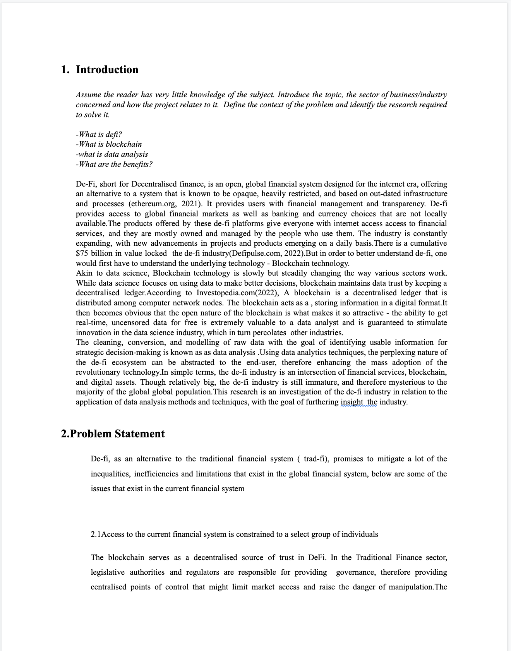

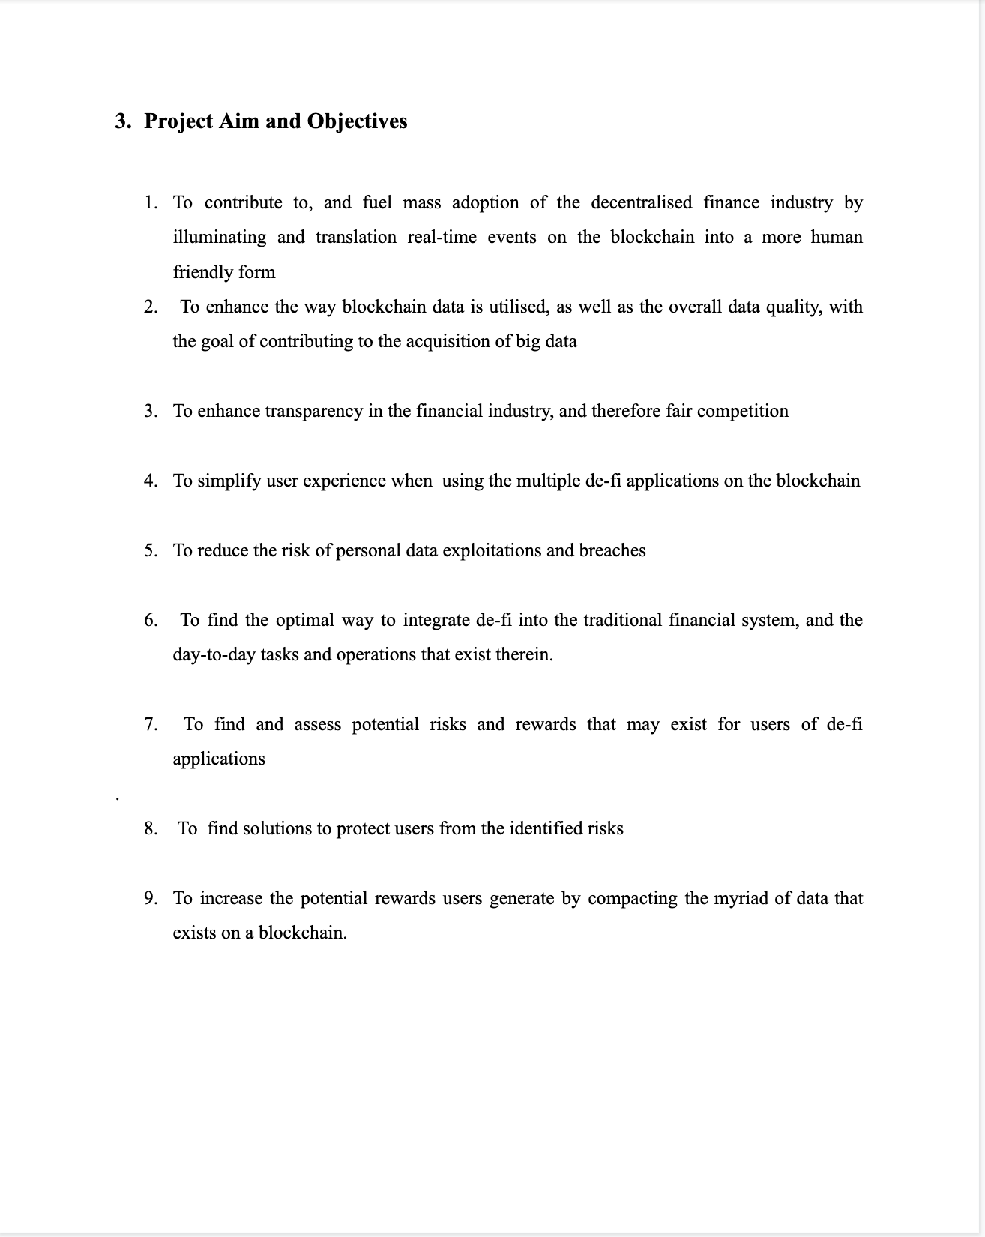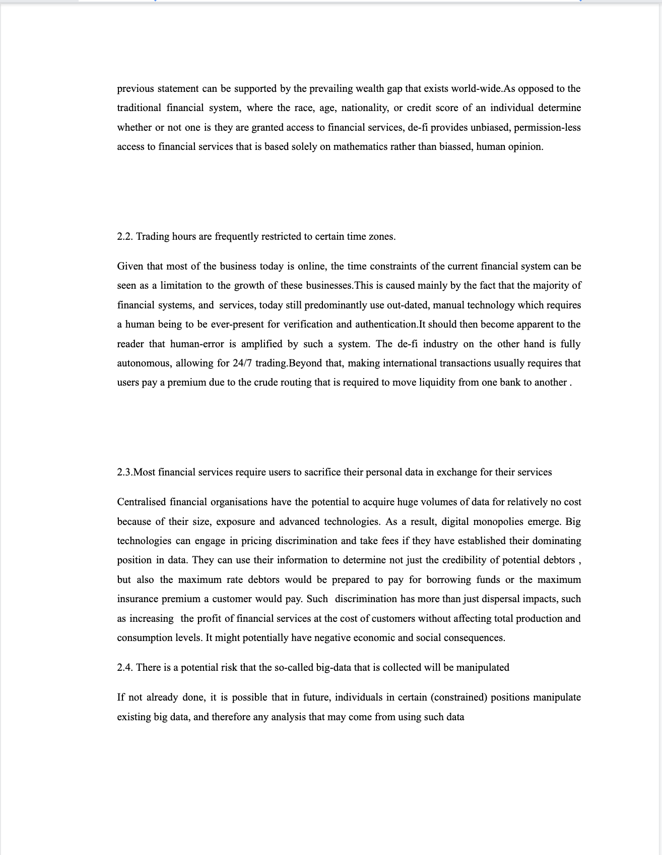

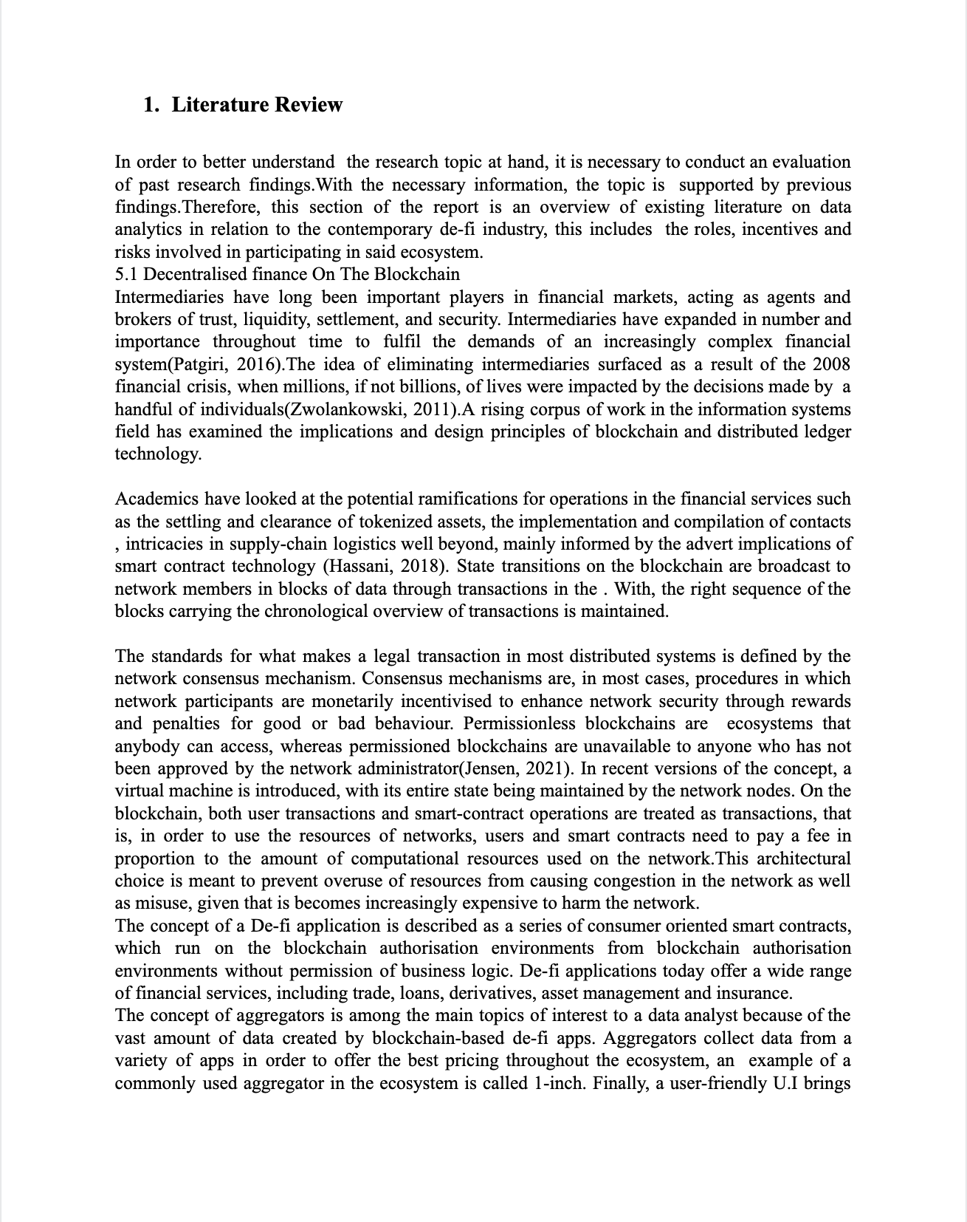

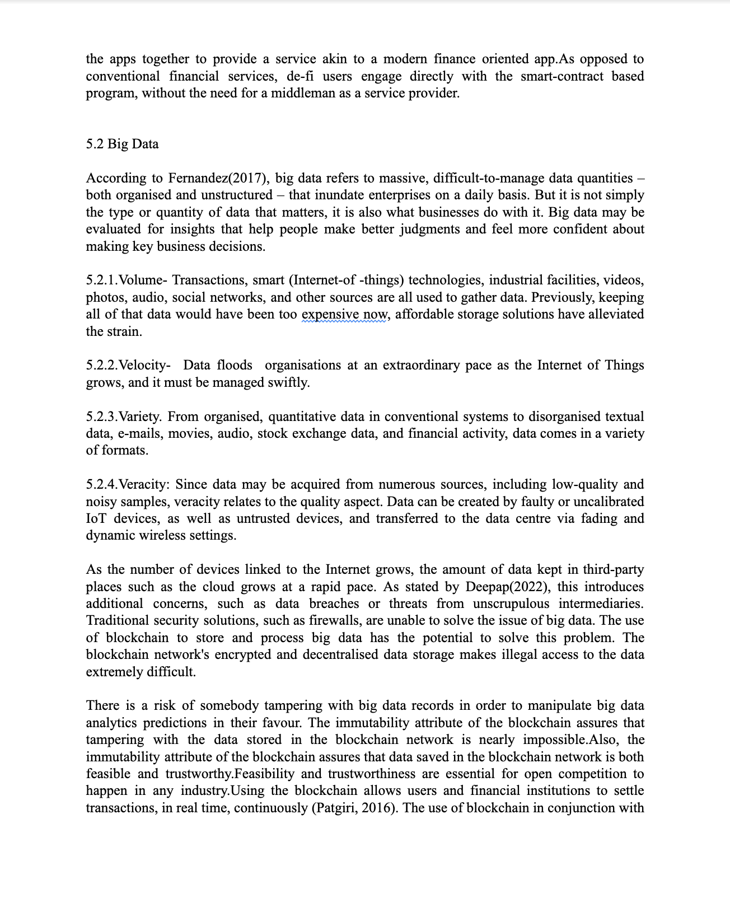

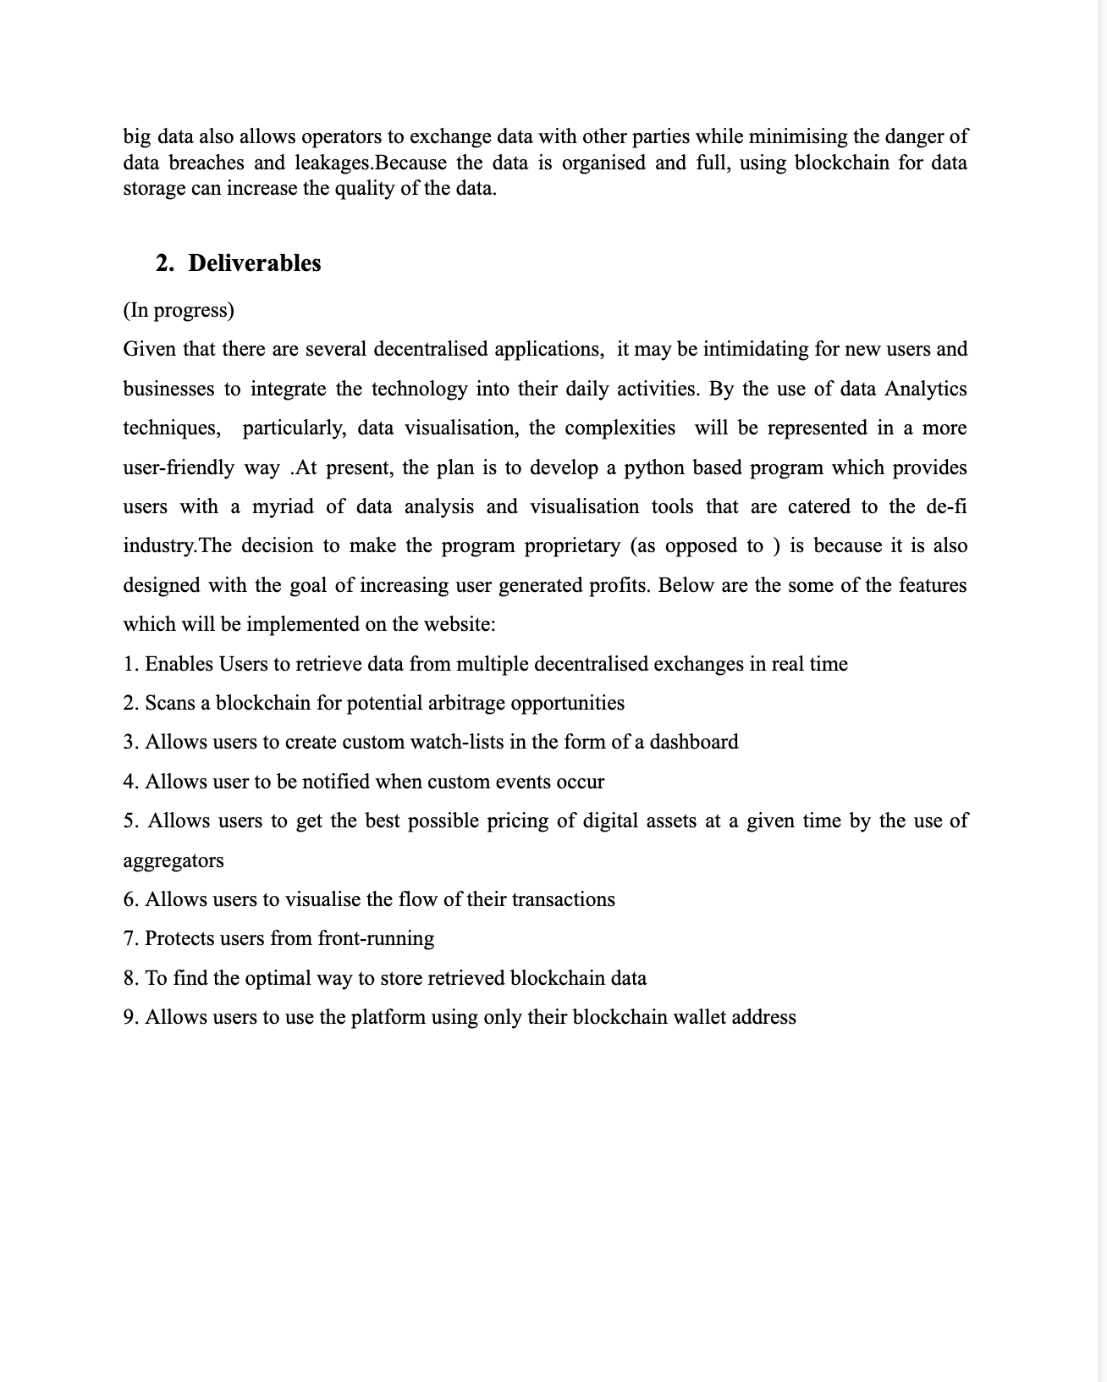

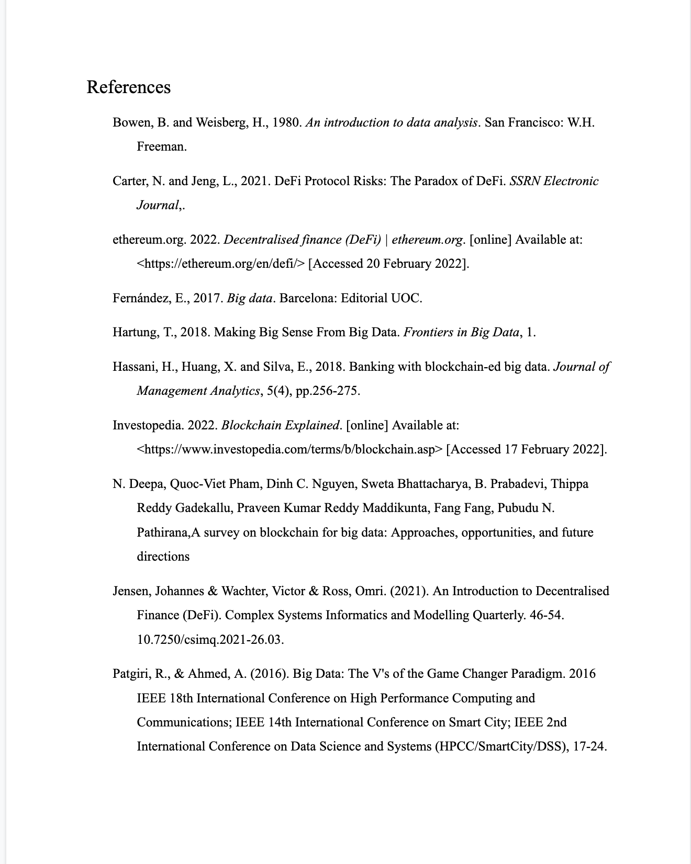



## **PSF**

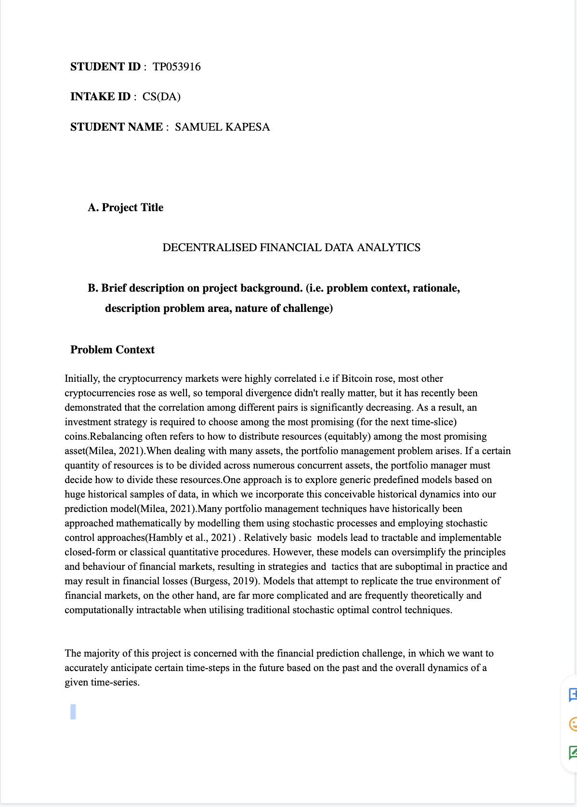

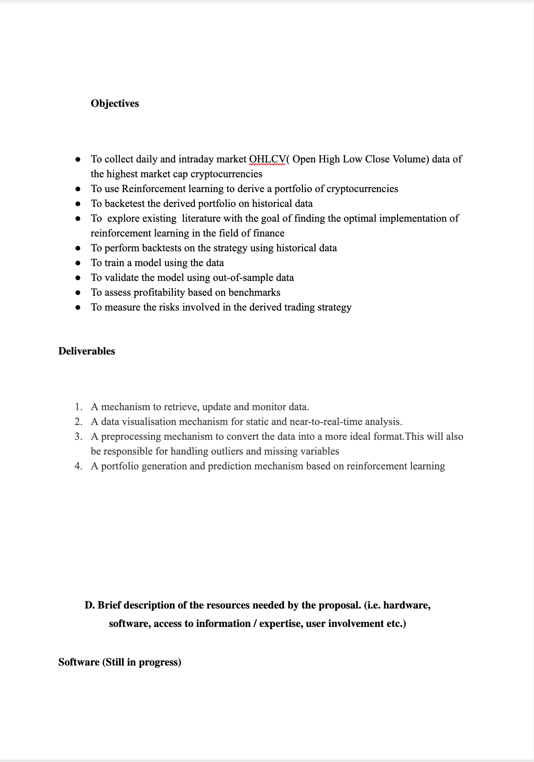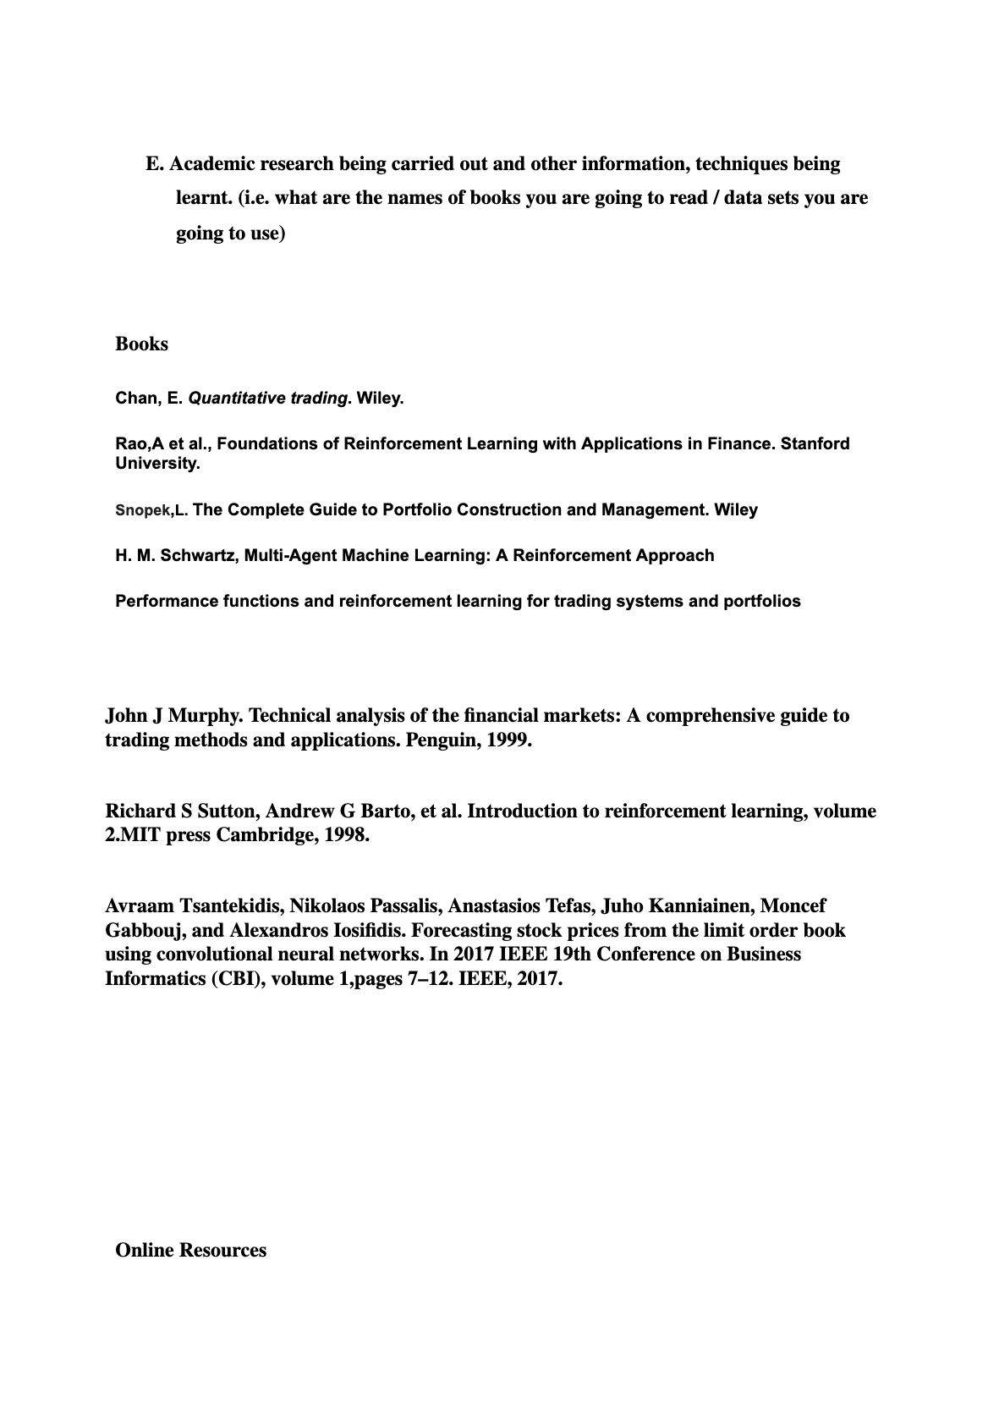

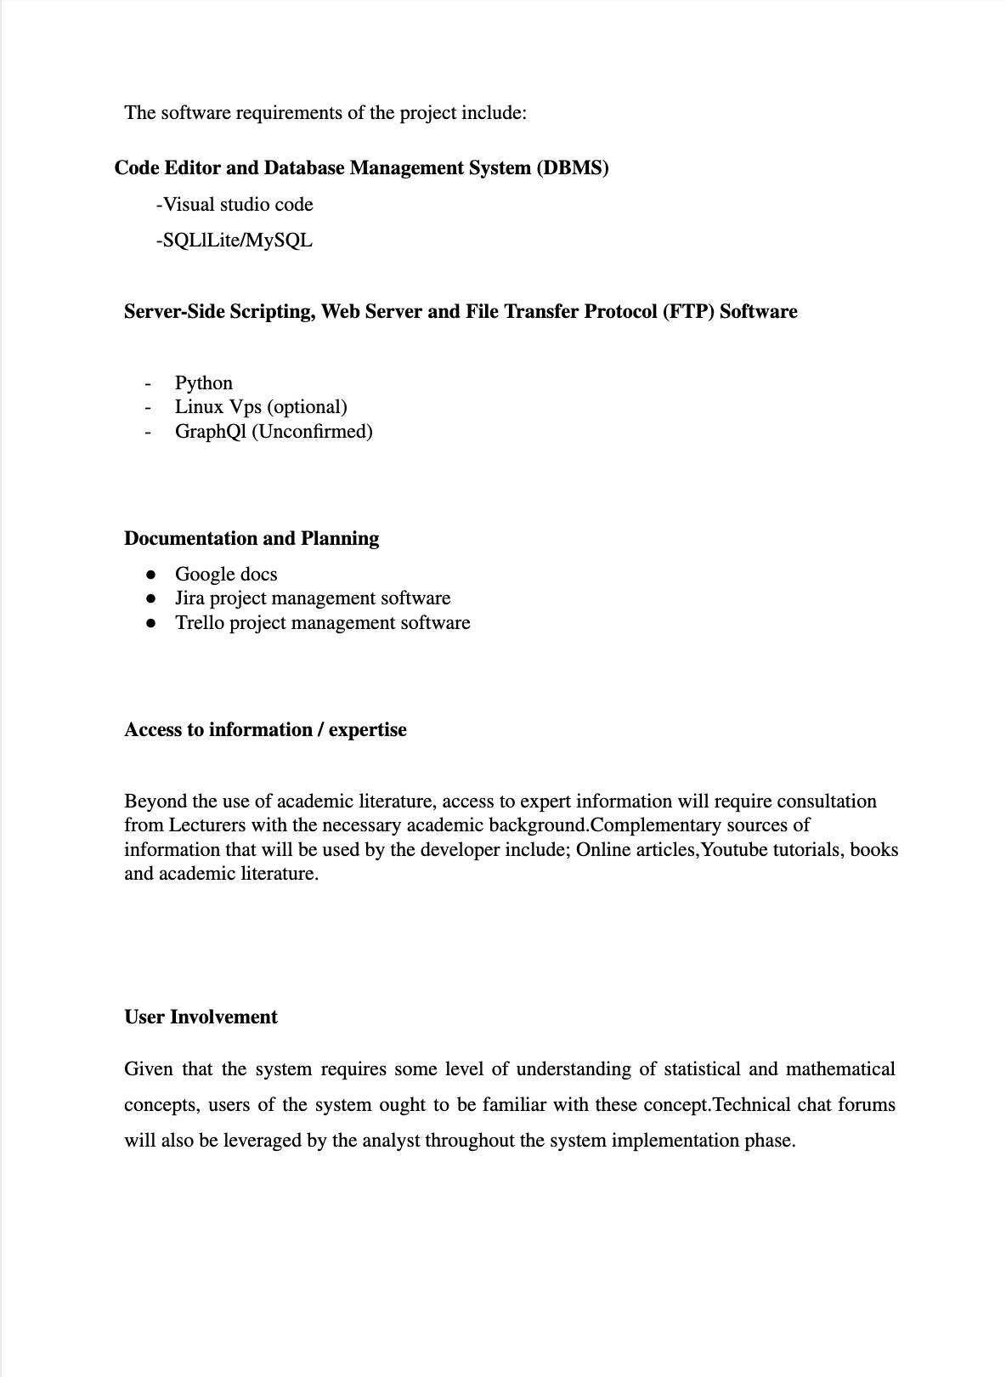

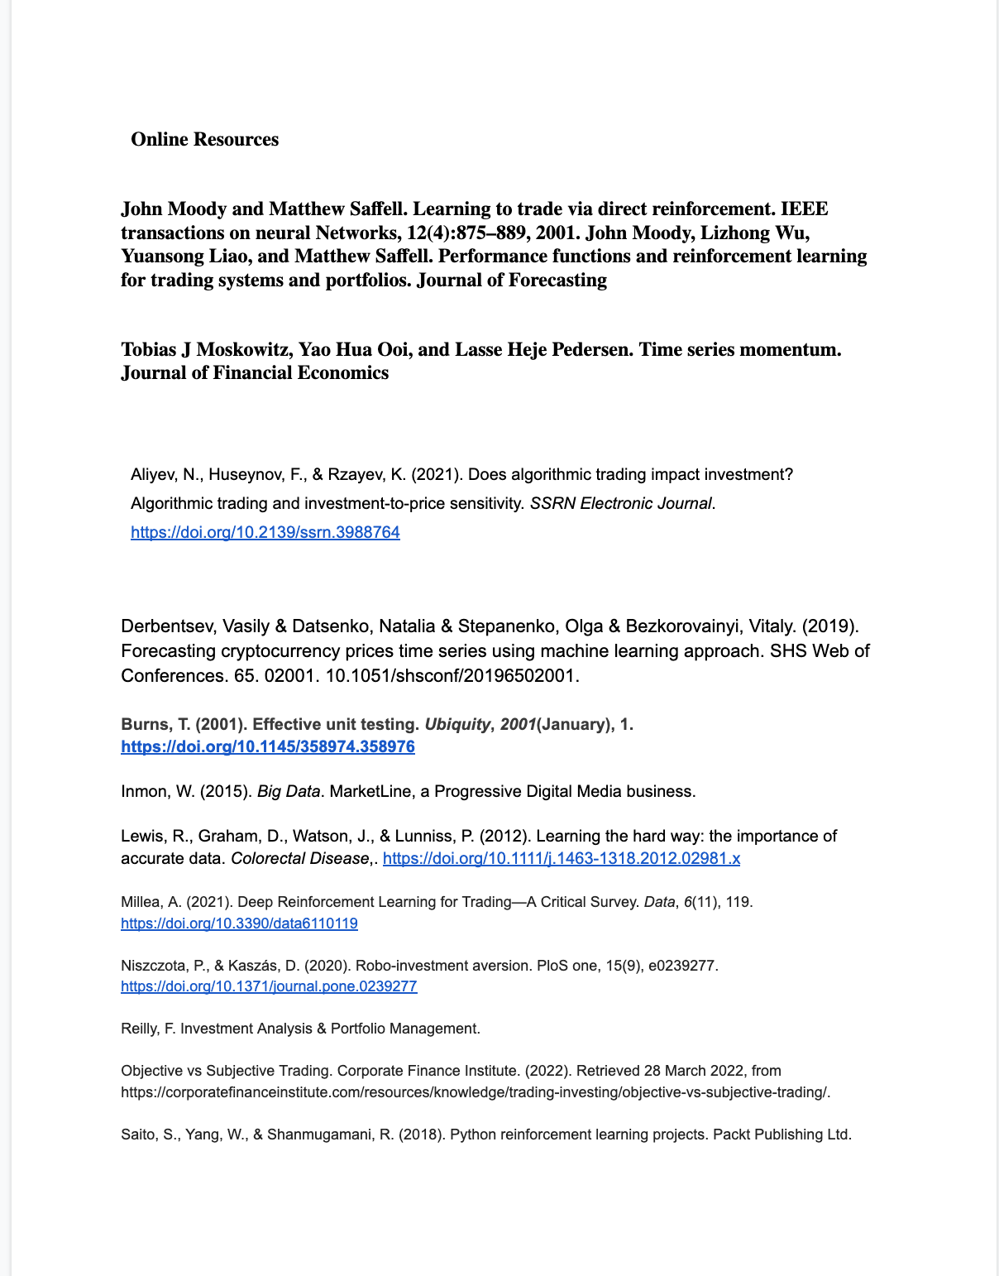

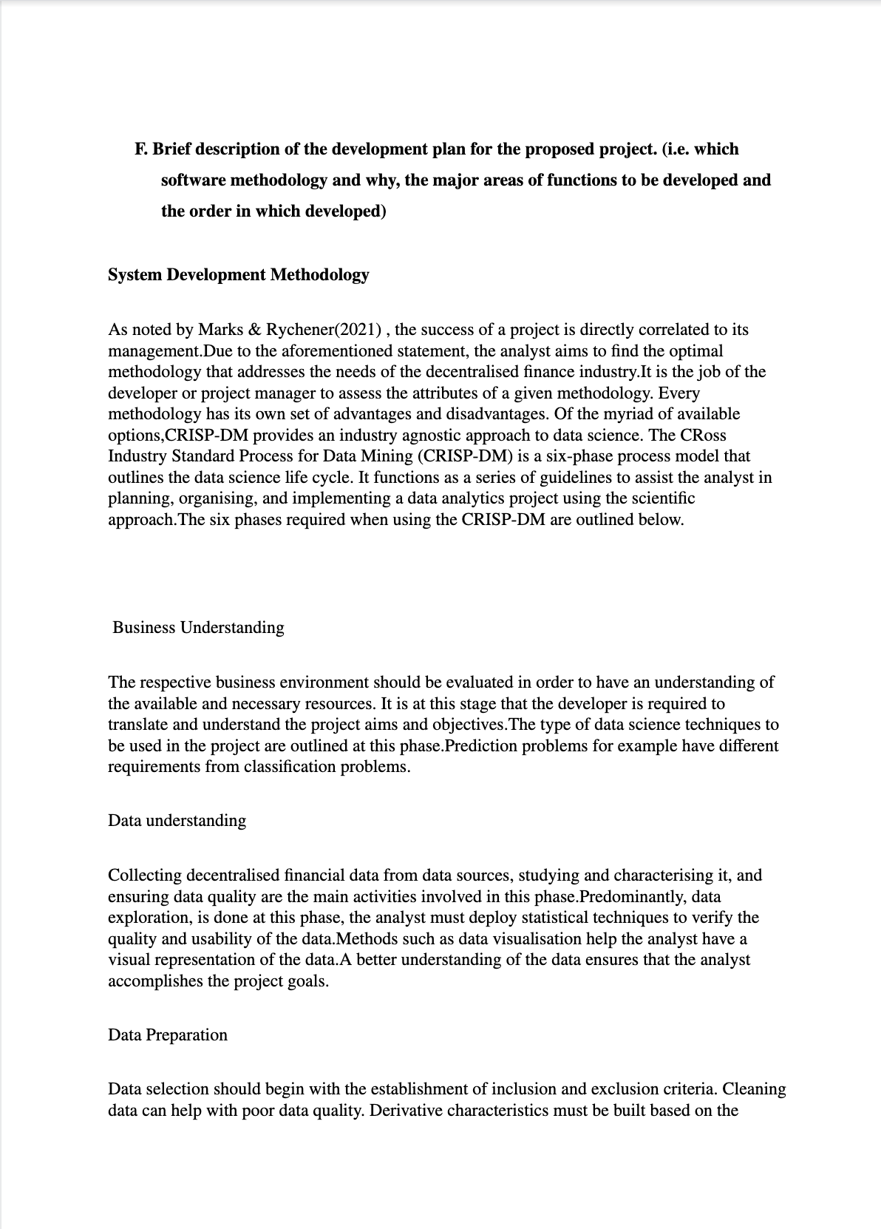

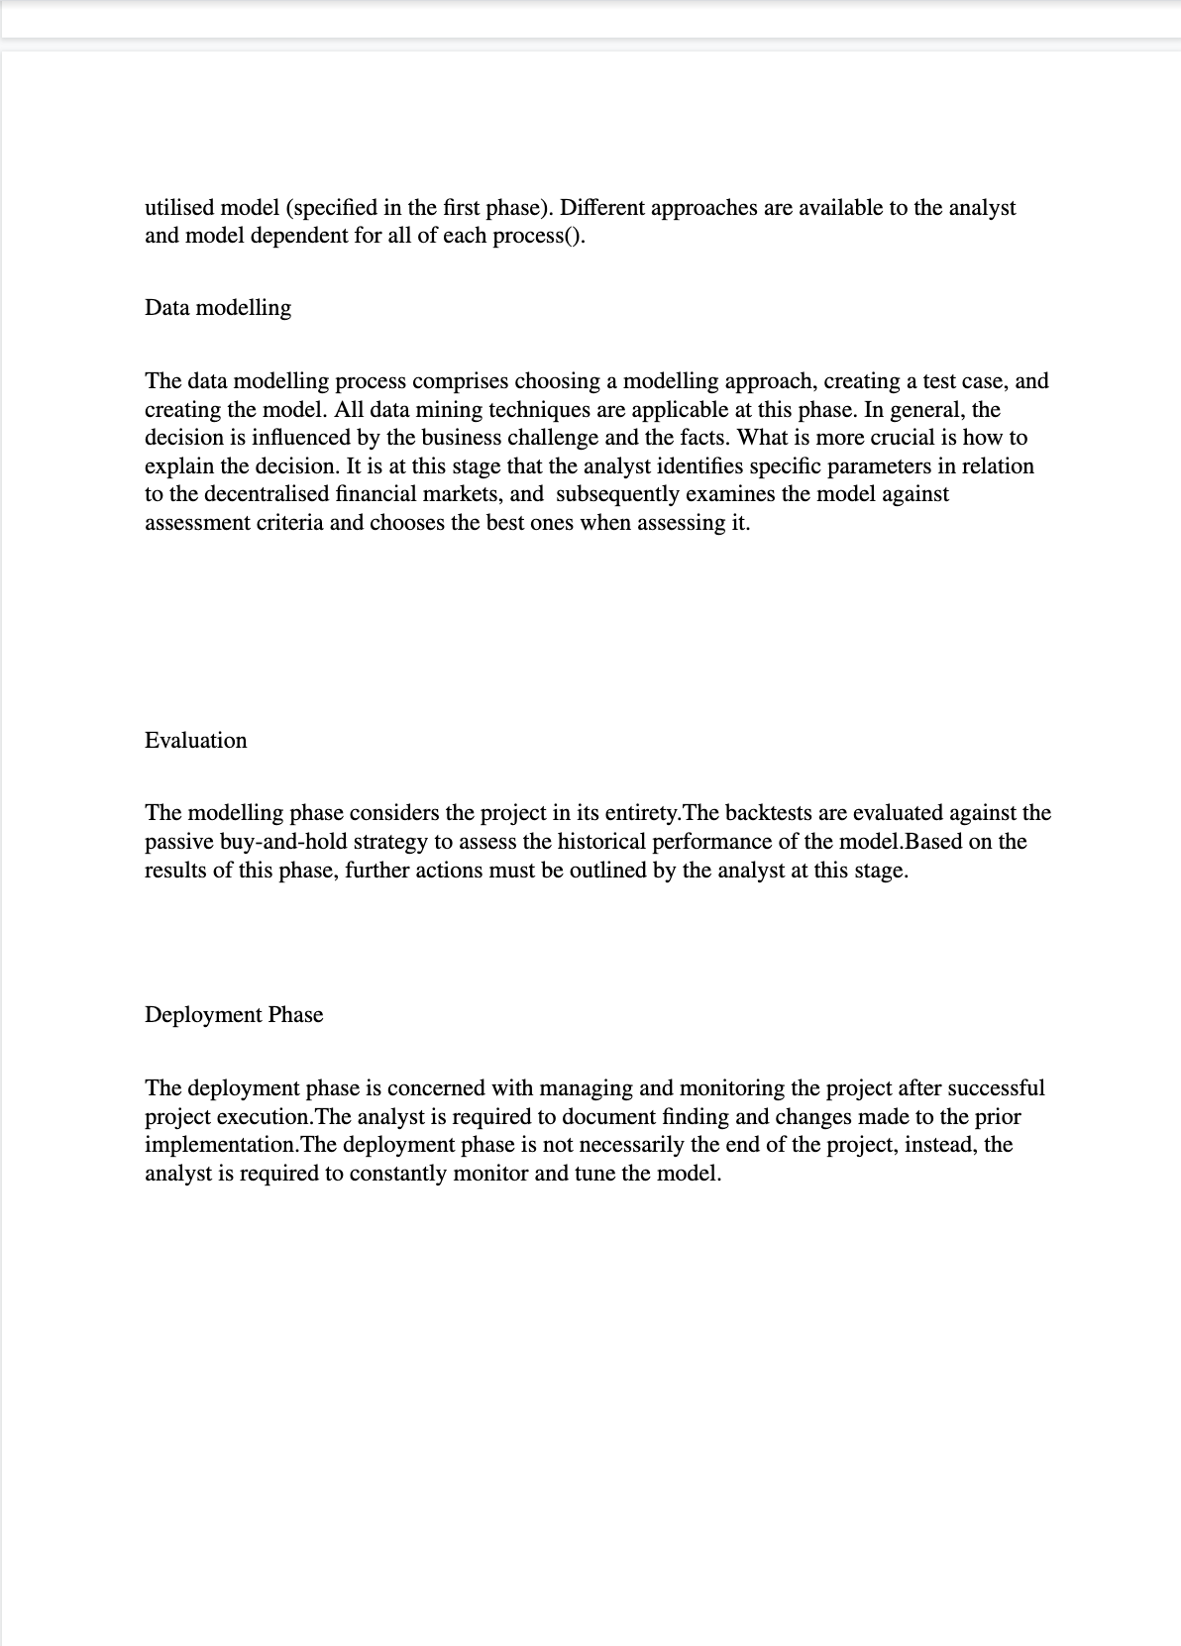

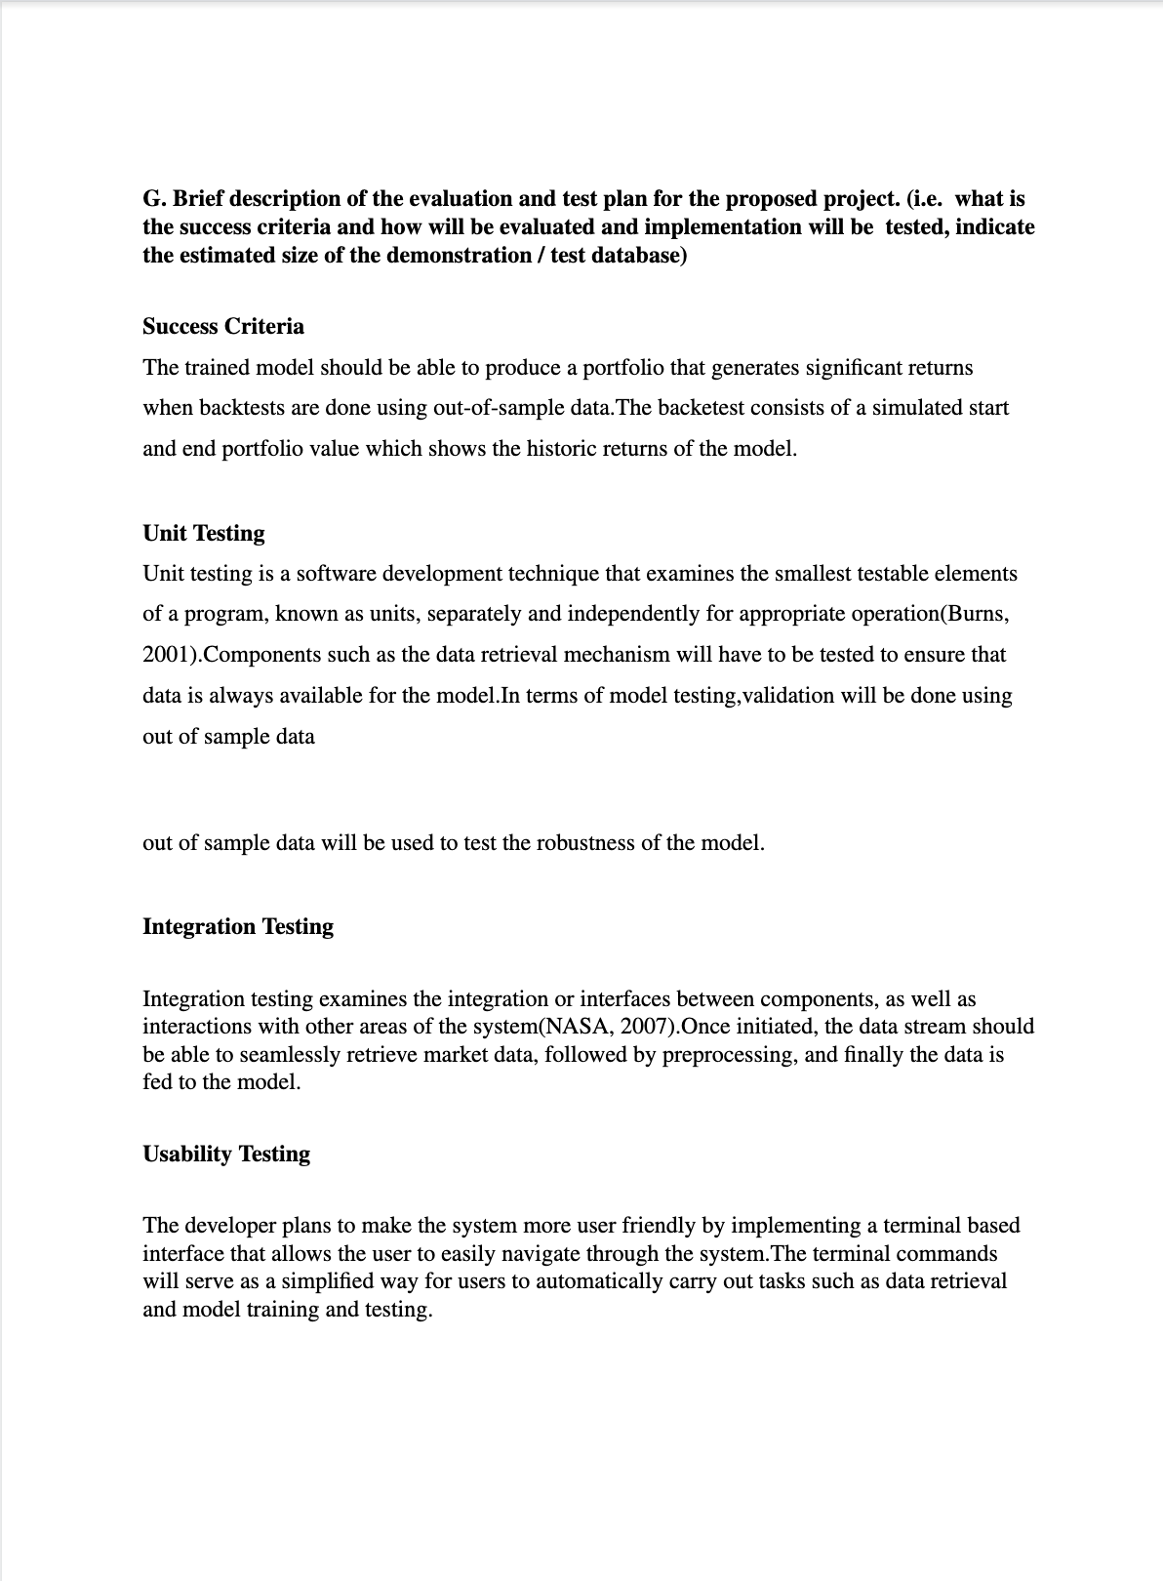

**ETHICS FORMS**



## 

## 

## 

## 

## 







## 

## 

## Project plan (Semester 1)

